Performance Evaluations – Instructions for Employees
- After an evaluation is released by HR, the employee will receive a notification and To Do Item in UKG.
- When the employee starts their self-evaluation, they will go to the Instructions screen. To start, they will click on the “Entry” tab at the top.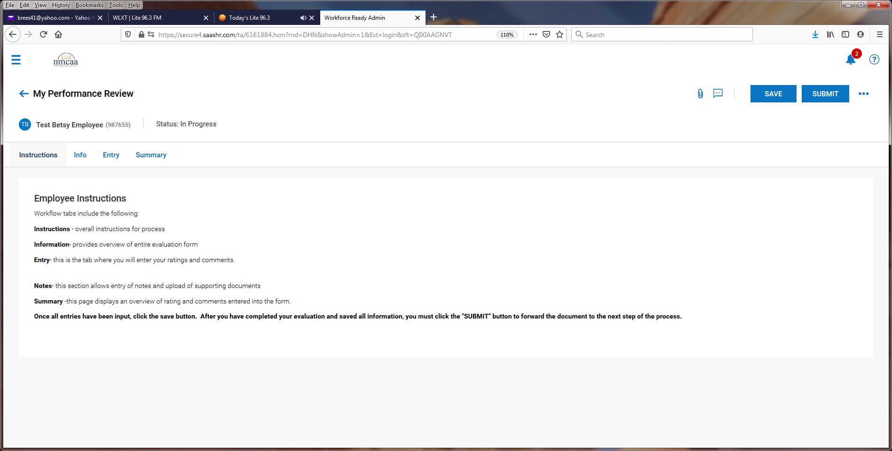

- The employee will start with the Cornerstones of Culture. They will select their rating “Competent” or “Focus Area” from the drop-down box and then add any comments pertaining to the area in the “Comment” box.
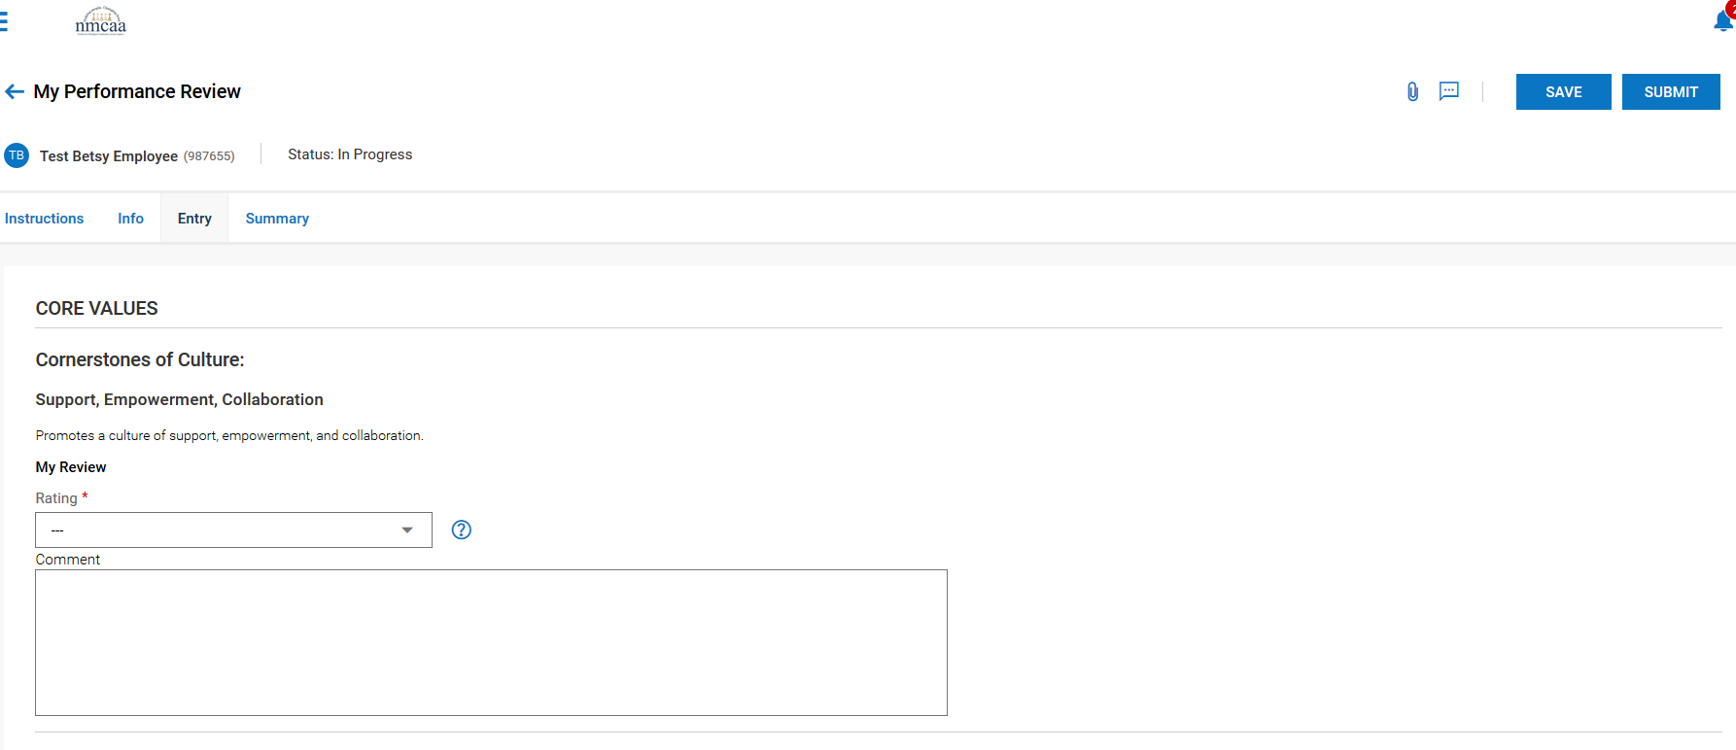

*** It is recommended to “SAVE” the progress after completing each section.
This process is repeated for each of the other four areas for the Cornerstones of Culture.

- The next section is on Competencies. The employee will rate themselves “Competent” or “Focus Area” and add comments to the “Comment” box.

*** It is recommended to “SAVE” the progress after completing each section. This process is repeated for each of the other two areas for the Working Habits.

- The last section is Job Performance. The employee will select Proficient, Competent, Developing, Needs Improvement, or Unacceptable in the rating drop down list and add comments to the “comment” box.
- After completing this last section, the employee will “Save” the evaluation and then “Submit” it.
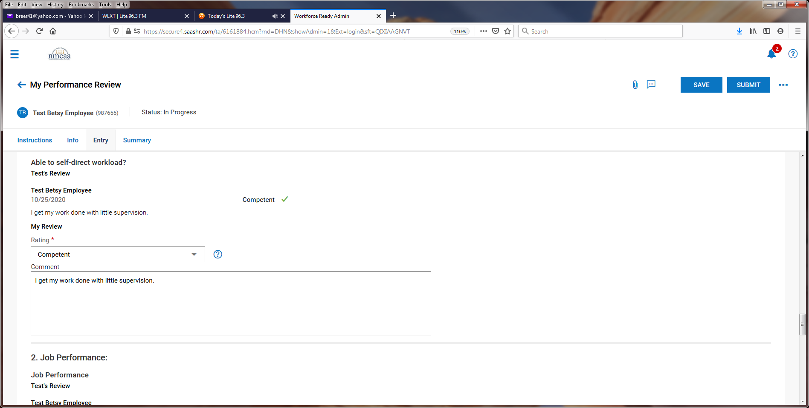

- Once submitted by the employee, the supervisor will be notified by email and by a notification in UKG to complete a To Do task in UKG for the evaluation. They will then proceed with their part of the review process. Once approved, they will present the review to the employee.

- Following the presentation of the review, the supervisor will enter employee goals, and then will save and submit the review. Once submitted, it will send the evaluation back to the employee to sign.

- The employee receives this notification and then clicks on their To Do Items:

- To sign the document, the employee will click on “Sign.”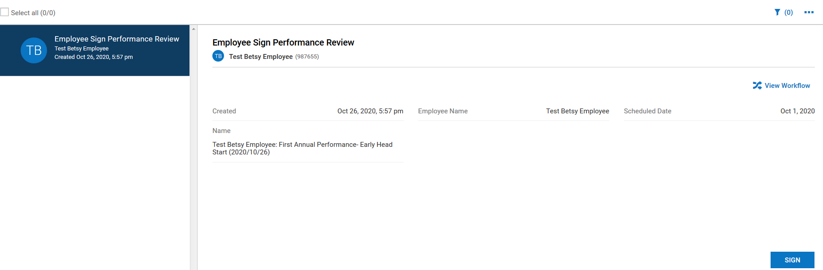

- From this screen the employee will click on “Summary.”
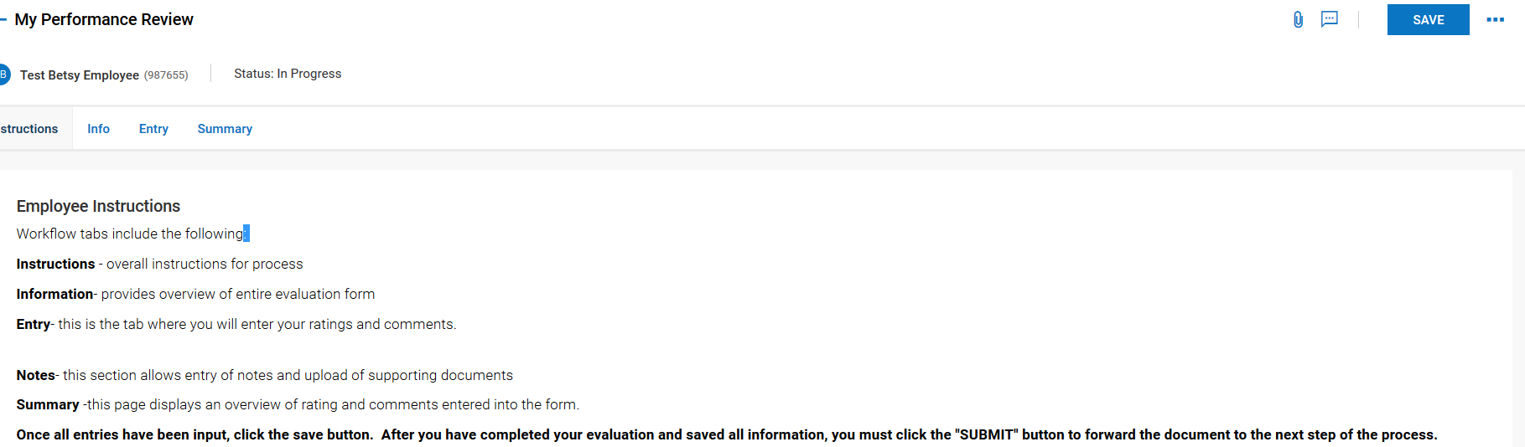
- If the employee wants a copy of the evaluation, they can click on the 3 dots to download the document and print it out or save it.
- To sign the evaluation, they click on “Sign as Employee.”
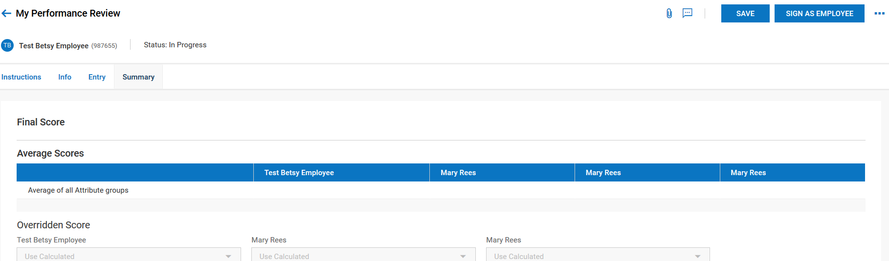

- The employee will electronically sign the evaluation by entering their UKG password and clicking on “I Agree.”

- The evaluation will go back to the supervisor to finalize in UKG.

