Performance Evaluations
Contact HR to release evaluation. Once released, Employee will receive a notification and To Do Item in UKG.

When the employee starts their self-evaluation, they will go to the Instructions screen. To start, they will click on the “Entry” tab at the top.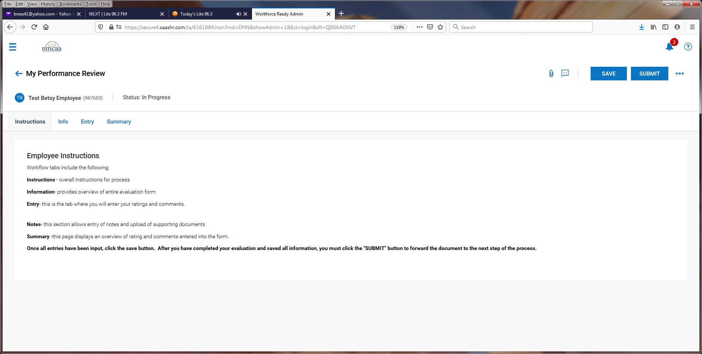

The employee will start with the Cornerstones of Culture. They will select their rating “Competent” or “Focus Area” from the drop-down box and then add any comments pertaining to the area in the “Comment” box.
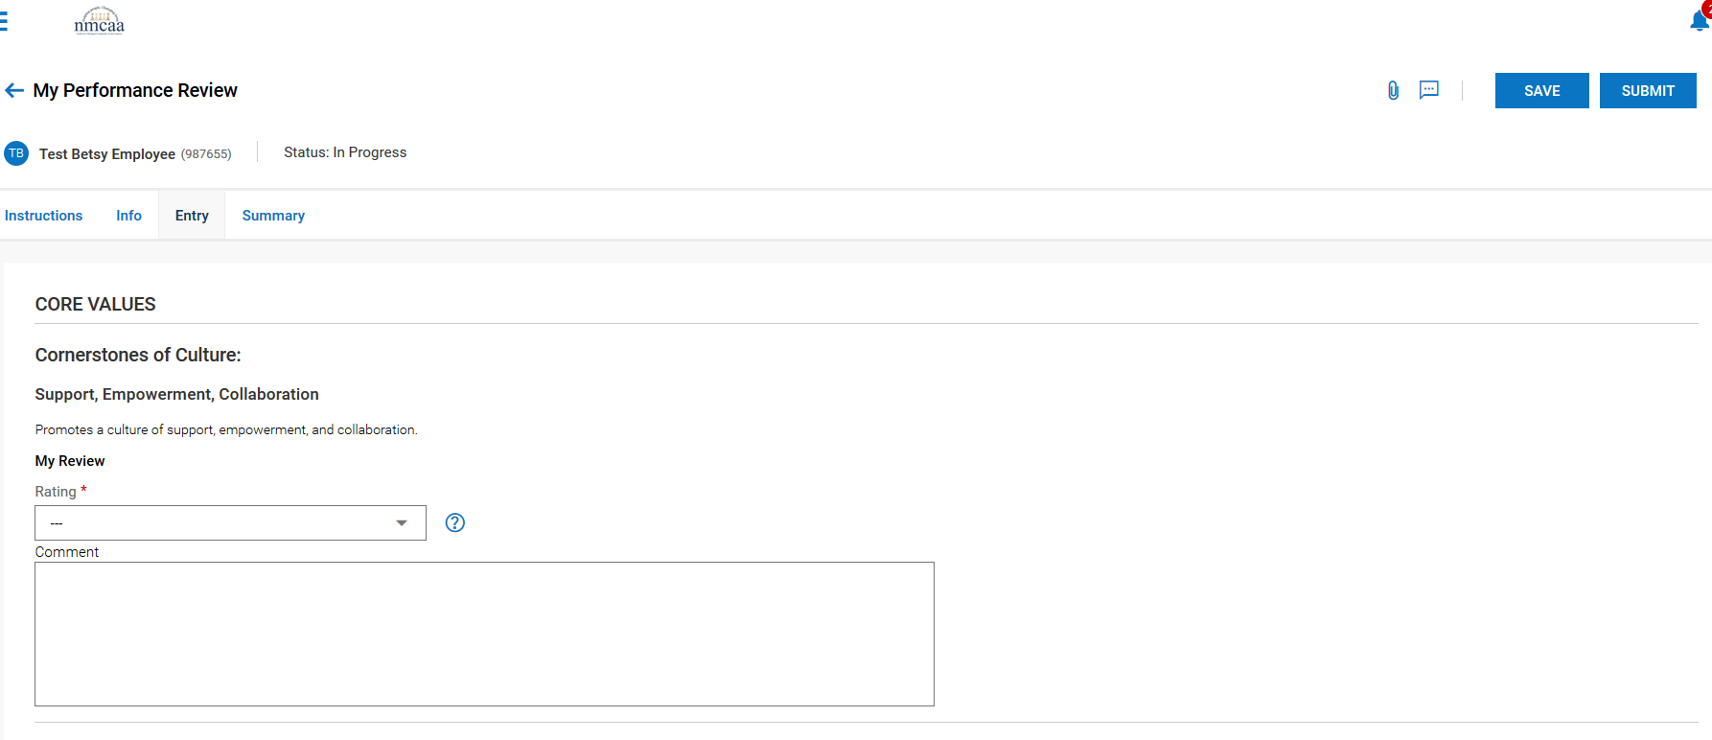

It is recommended to “SAVE” the progress after completing each section.
This process is repeated for each of the other 4 areas for the Cornerstones of Culture.

The next section is on Competencies
The employee will rate themselves as “Competent” or “Focus Area” and add comments to the “Comment” box.
It is recommended to “SAVE” the progress after completing each section.
This process is repeated for each of the other 2 areas for the Working Habits.
The last section is Job Performance. The employee will select Proficient, Competent, Developing, Needs Improvement, or Unacceptable in the rating drop down list and add comments to the “comment” box.

After completing this last section, the employee will “Save” the evaluation and then “submit” it.

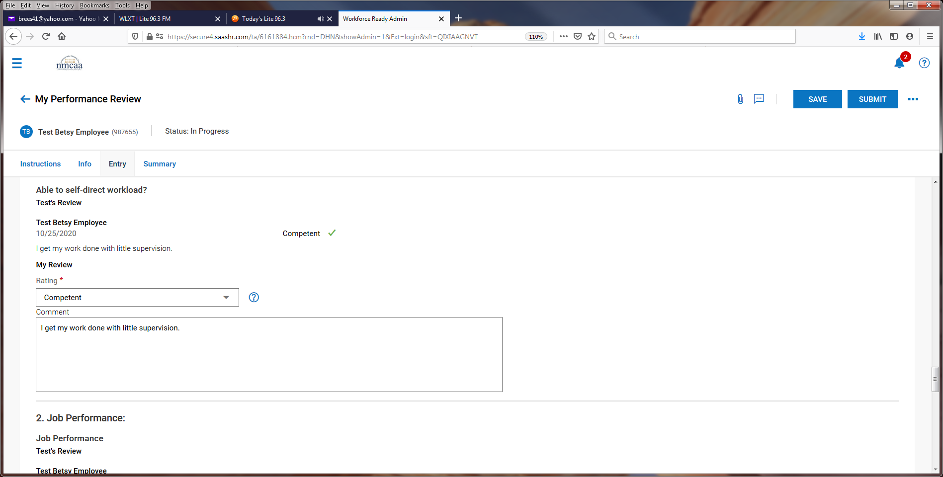

Once submitted by the employee, the supervisor will be notified my email and by a notification in UKG to complete a To Do task in UKG for the evaluation. Click on “Review” to start the evaluation.

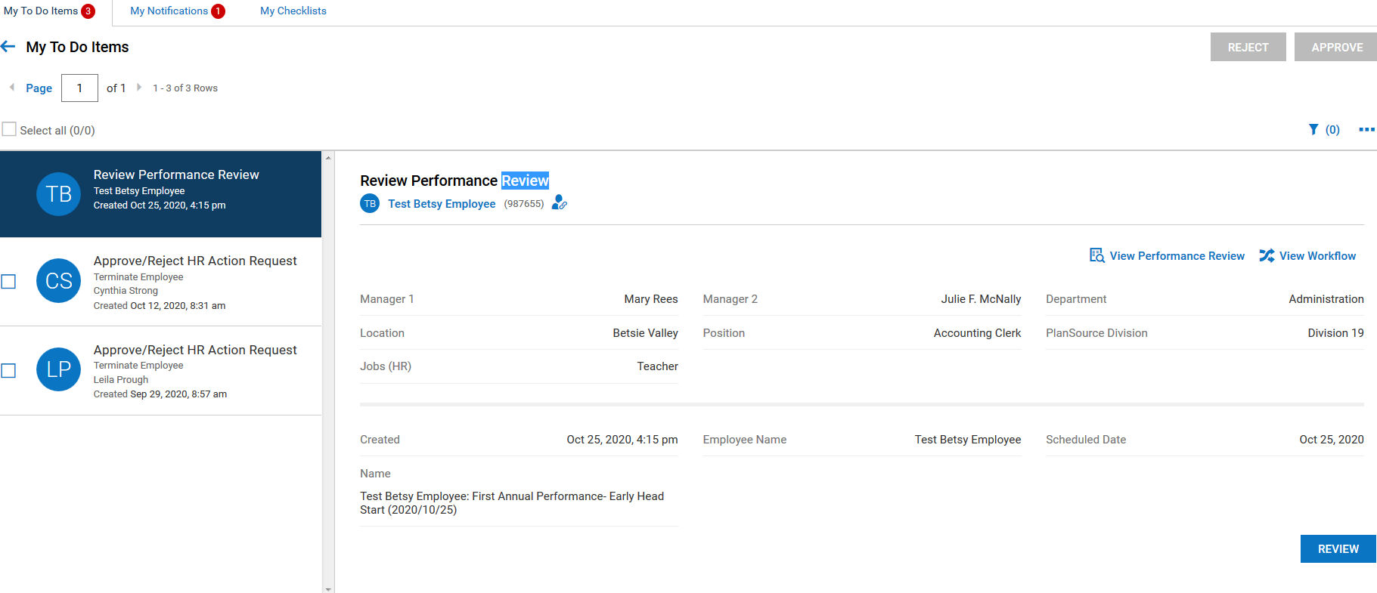

The instruction page will display and click on the “Entry” tab to review the employee ratings/comments and to complete the supervisor’s ratings/comments.
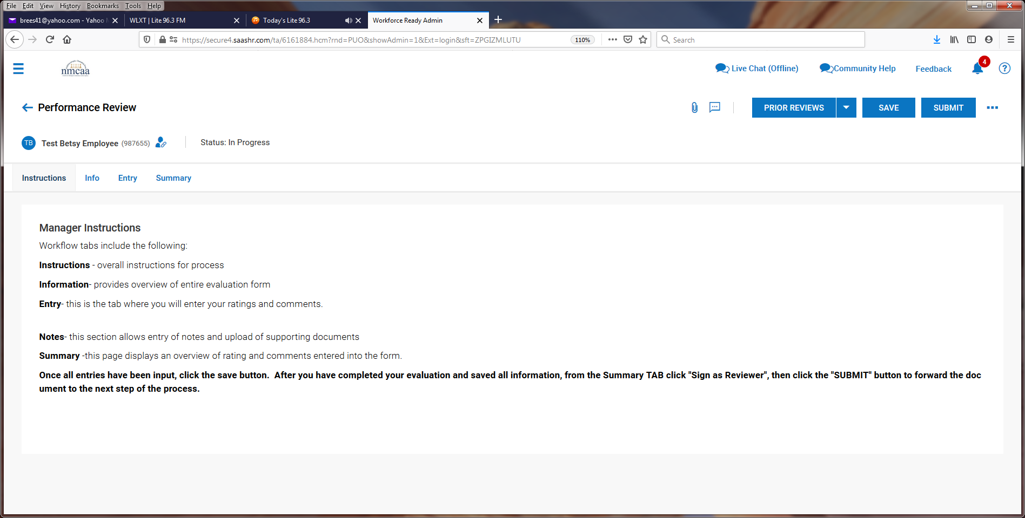

The employee’s entered information is visable.
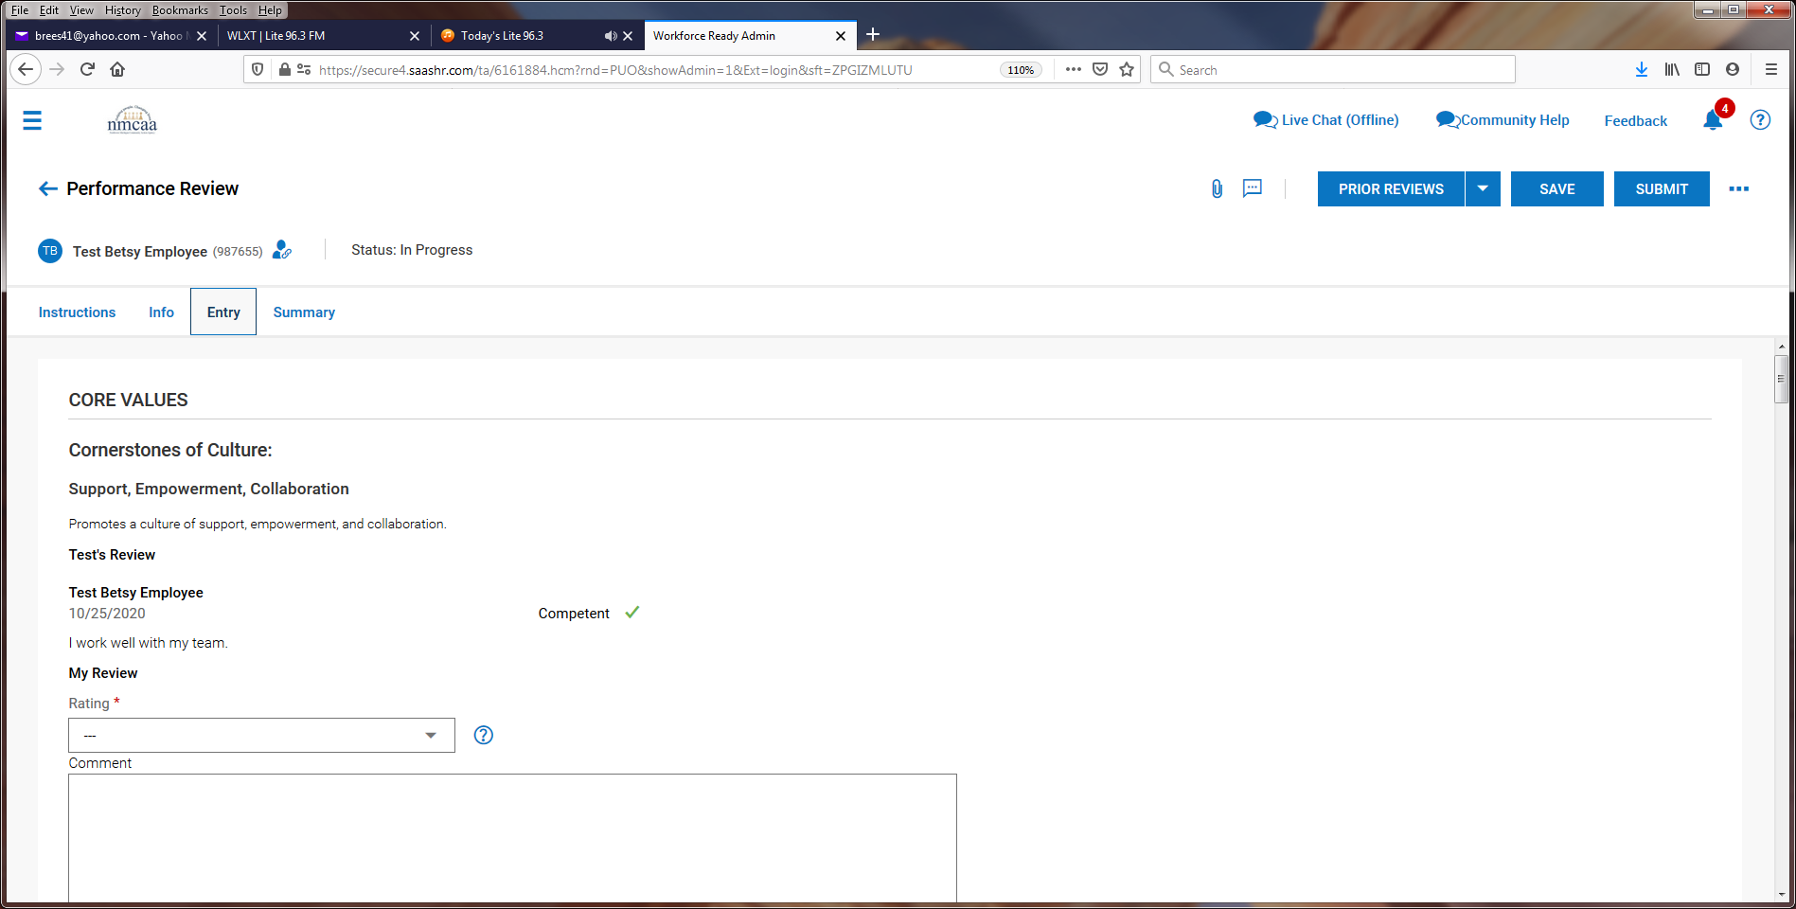
Supervisor then enters the rating (Competent or Focus Area) and comments that they have for the employee.

It is recommended to “SAVE” the progress after completing each section.
This process is repeated for each of the other 4 areas for the Cornerstones of Culture.
The Supervisor will complete the remaining areas just like the employee did for the evaluation.
Supervisor’s Recommendations – select the appropriate response from the drop down box and add comments.

Goals may be added now or after meeting with the employee. Click on “+ Add Goals” to add a goal.

The final section that can used is for General Comments but is not required.

Once entry is complete, click on “Save” and then “Submit”. The evaluation is then sent to the Supervisor’s Supervisor for review.
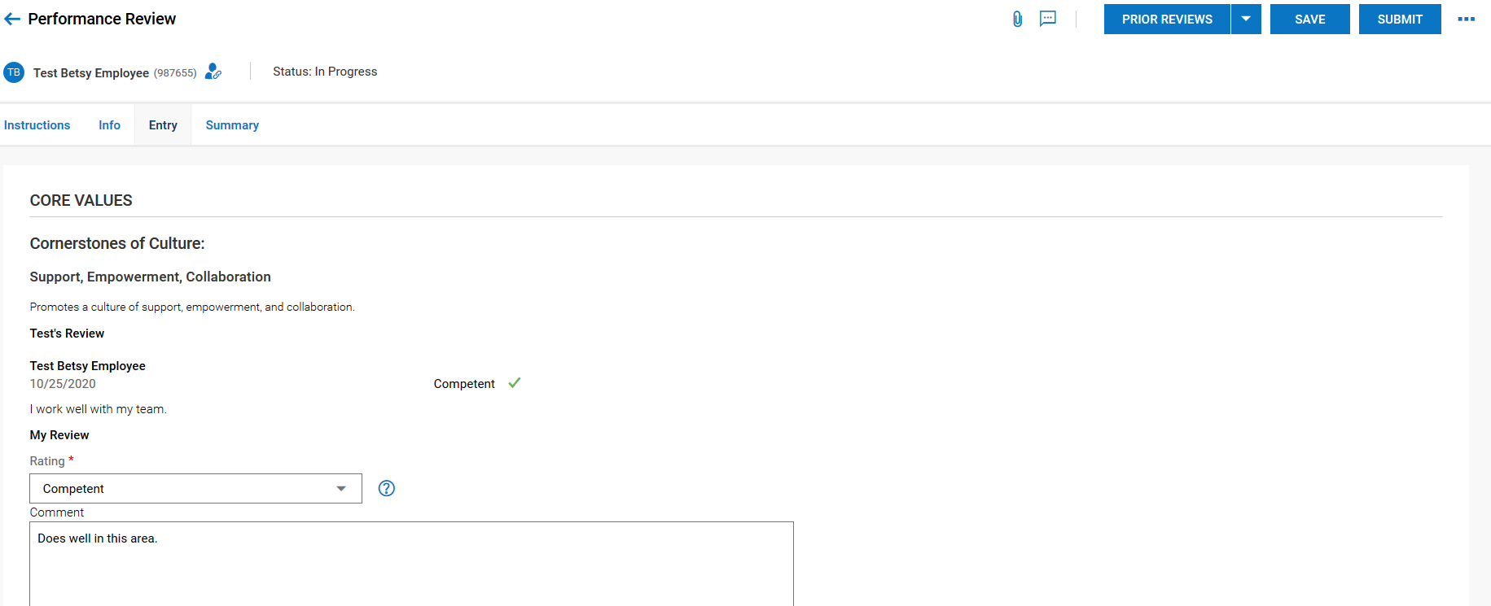

The Second Supervisor will then receive a To Do Item to review the employee’s evaluation. Click on “Review” to begin.

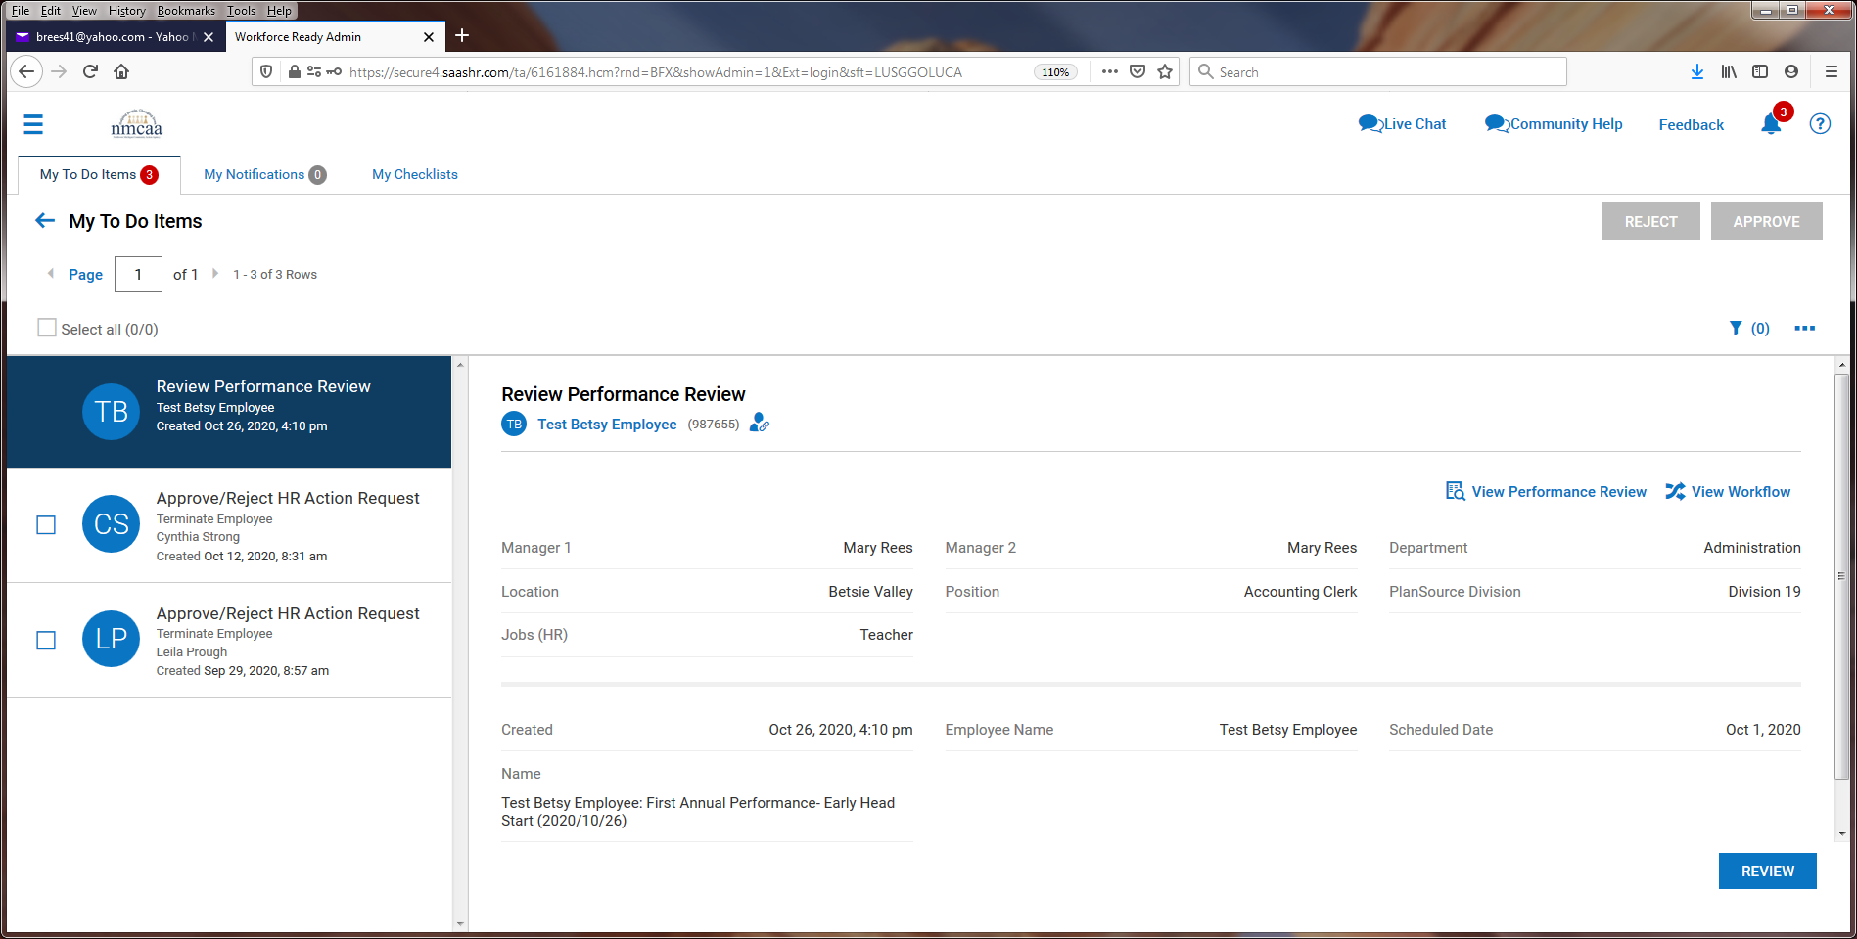

The next screen will have instructions to review and the “Entry” tab Should be clicked to begin.
The next screen shows the responses by the employee and Supervisor 1. Supervisor 2 MAY add entries it they like. After review, click on “Save” and then “Submit”.
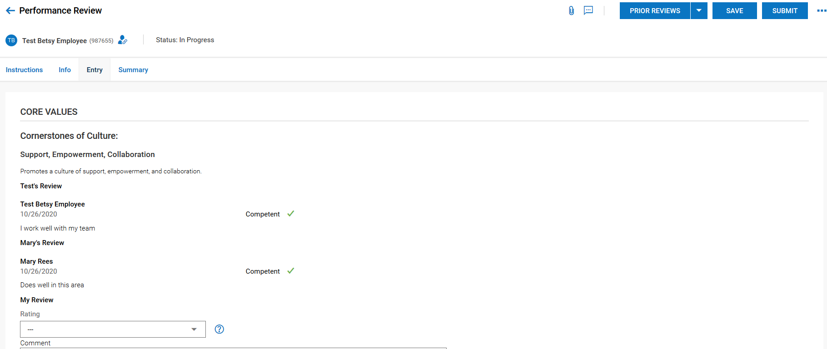
Once this is complete, the evaluation goes back to Supervisor 1 and they receive this notification with instructions:
The supervisor meets with the employee, and proceeds to the To Do Item by clicking on “Comment”.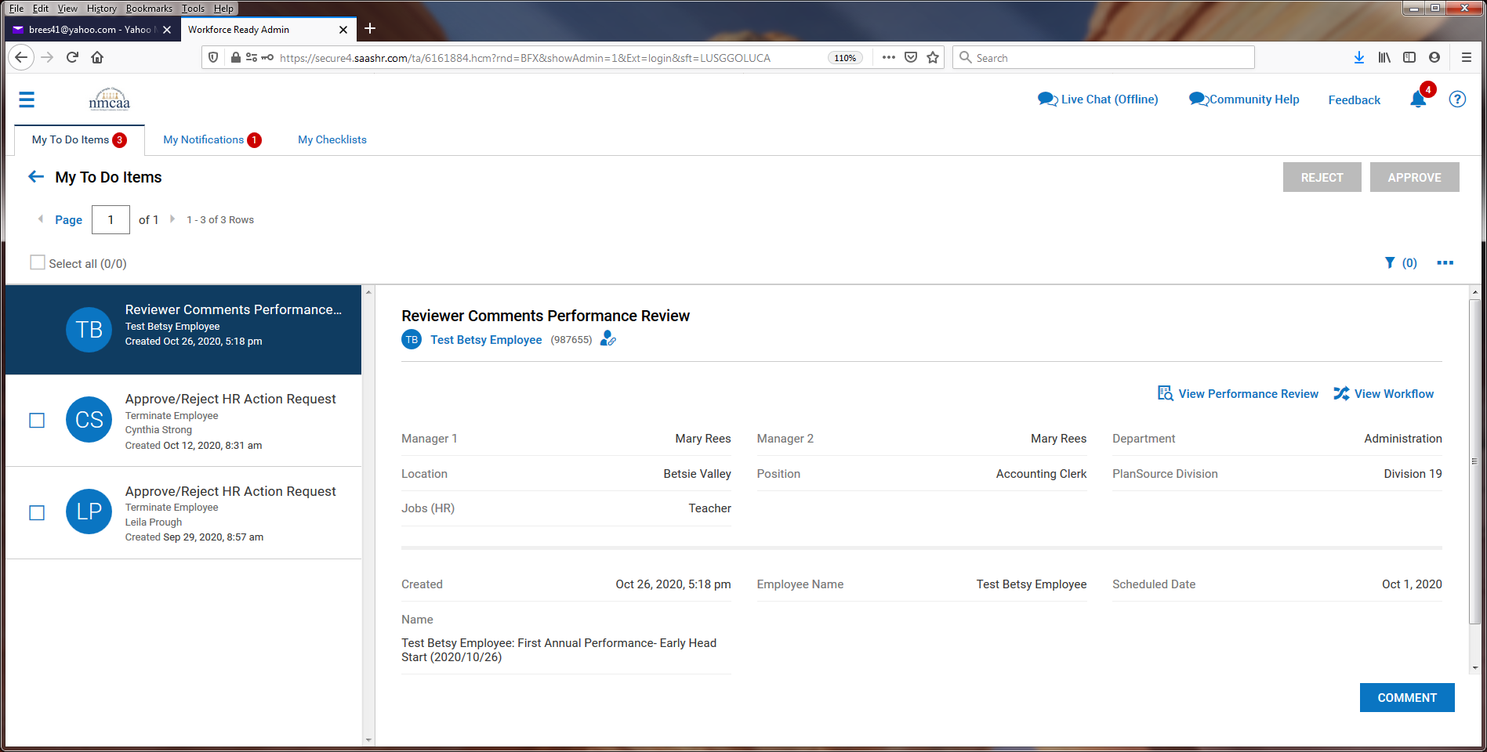
The Supervisor 2 comments can now be seen (probably will not be many, if any) and goal can added by clicking on “+ Add Goals”.

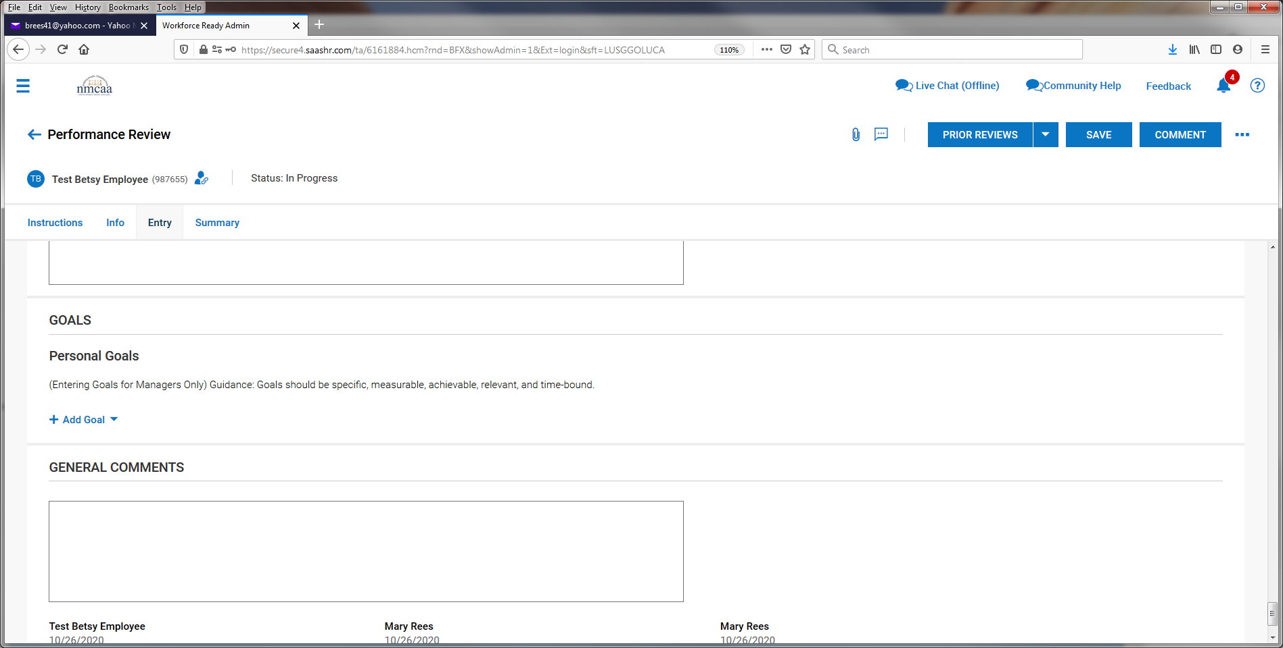

Enter in the goal information and “save”. Repeat for additional goals.

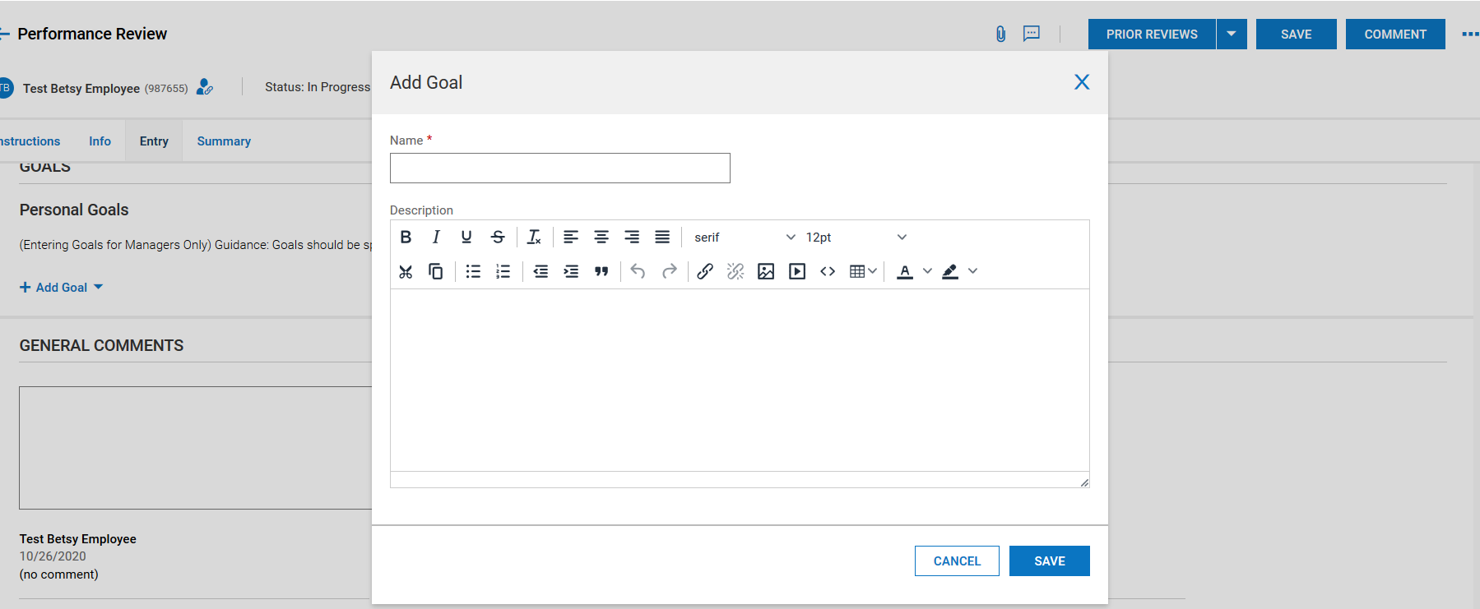

Goals will then display, and general comments can be added. When finished, click on “save” and
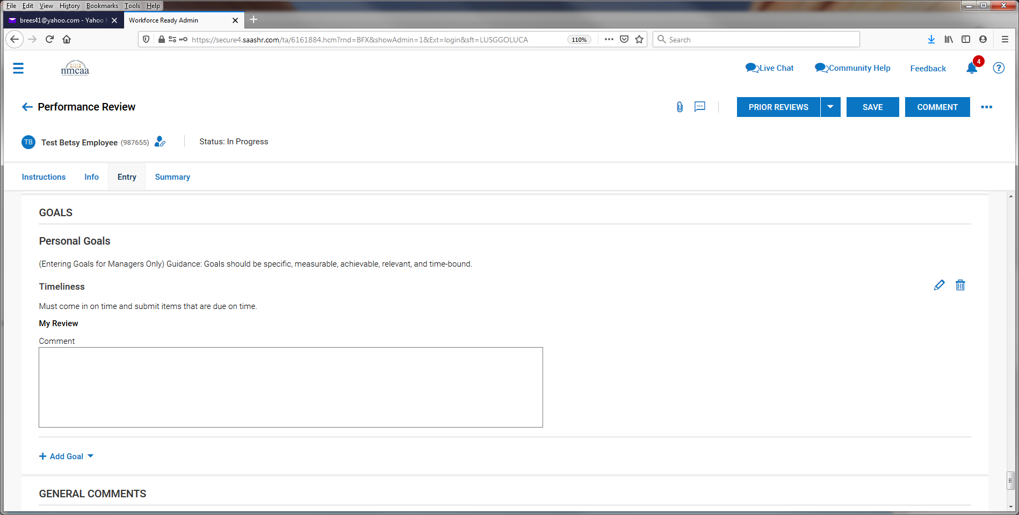

After saving, click on “Comment” and then click on “yes”
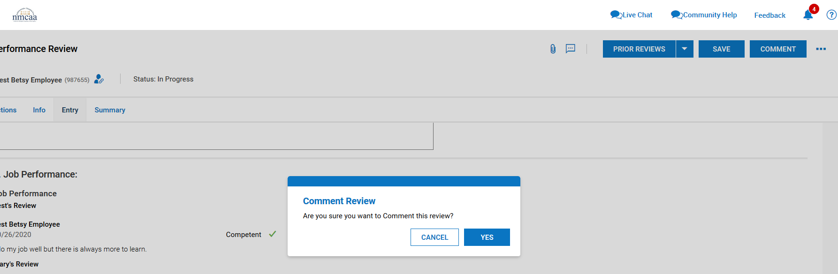

Click on the “Summary” Tab and then “Submit”
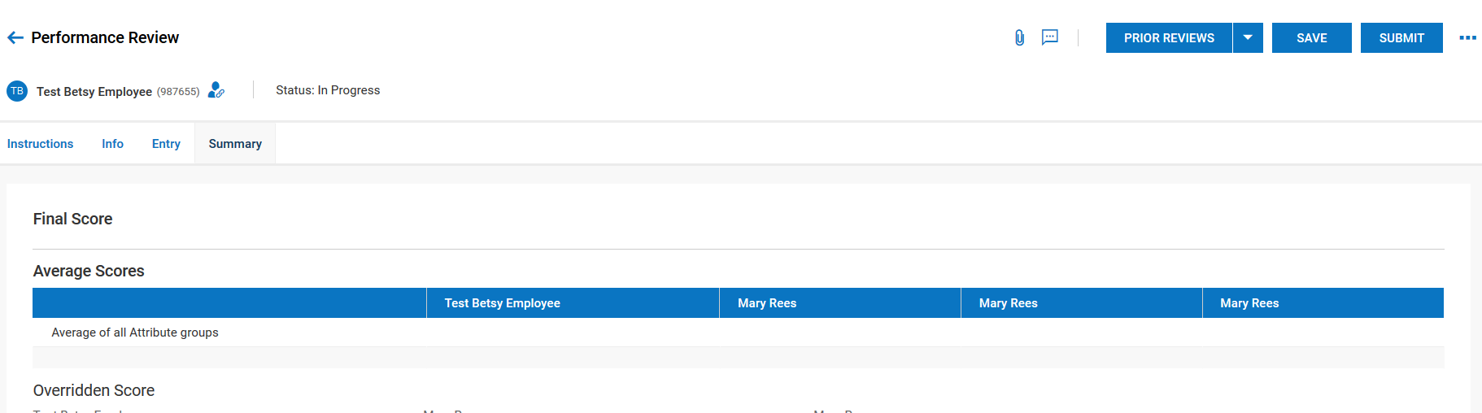

Click “yes” to submit the evaluation. Once submitted, it will send the evaluation back to the employee to sign.

The employee receives this notification and then clicks on their To Do Items

To sign the document, the employee will click on “sign”
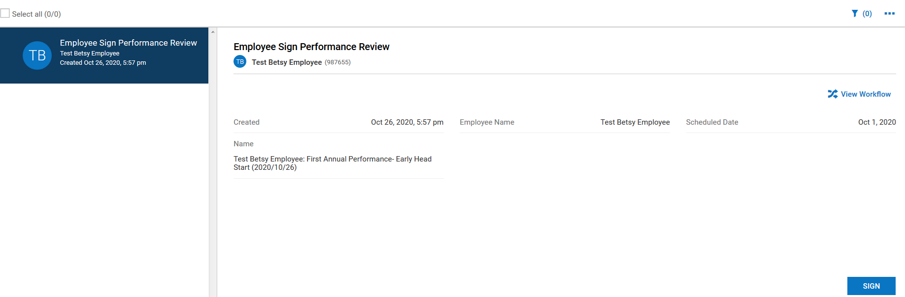

From this screen the employee will click on “Summary”

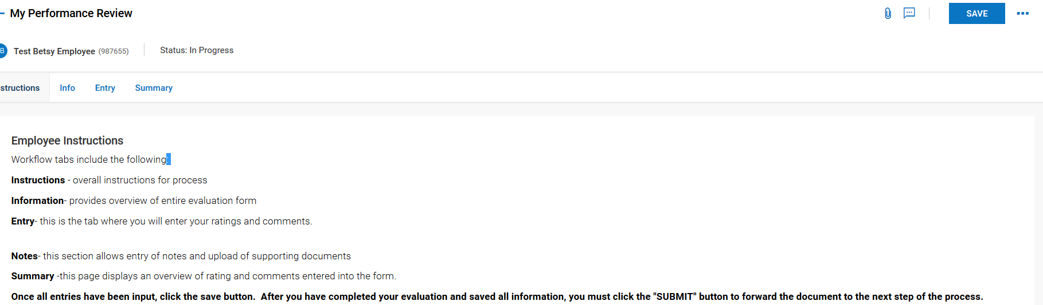
If the employee wants a copy of the evaluation, they can click on the 3 dots to download the document and print it out or save it.
To sign the evaluation, they click on “Sign as Employee”

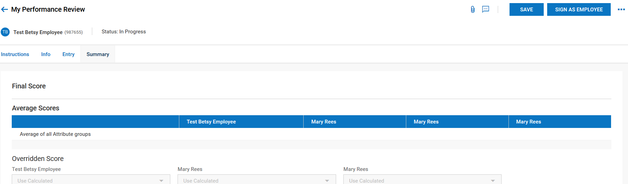
The employee will electronically sign the evaluation by entering their UKG password and clicking on “I Agree”

Supervisor 1 will receive this notification and click on “To Do Items” to proceed.

From the To Do List, the Supervisor clicks on “Finalize”

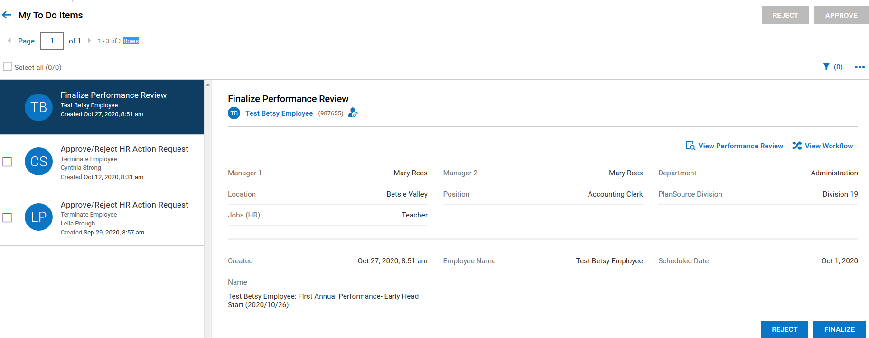

From this screen the Supervisor will click on “Summary”
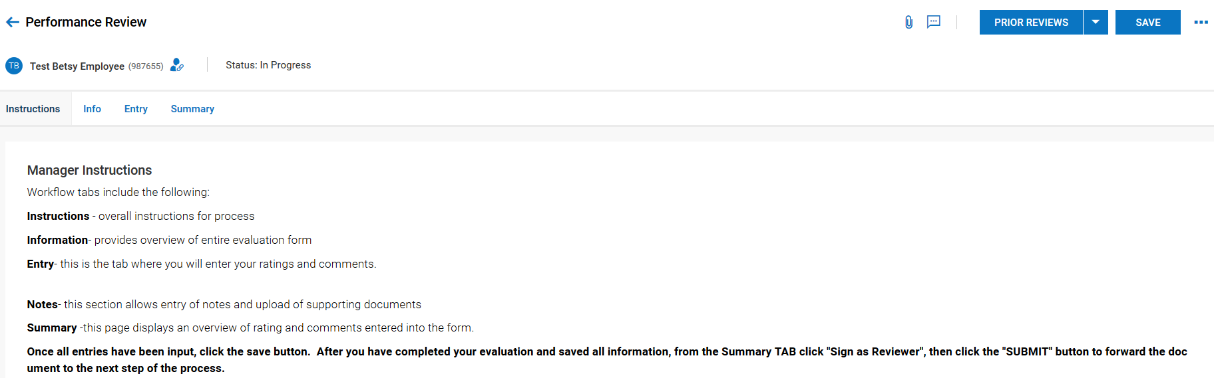
If the Supervisor wants a copy of the evaluation, they can click on the 3 dots to download the document and print it out or save it.
To sign the evaluation, they click on “Sign as Finalizer”

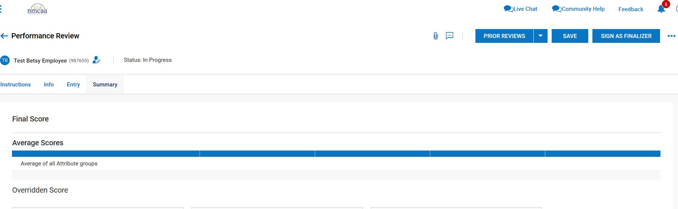

The Supervisor will electronically sign the evaluation by entering their UKG password and clicking on “I Agree”

Then click on the “3 dots” and click on “Finalize”
Click on “yes”
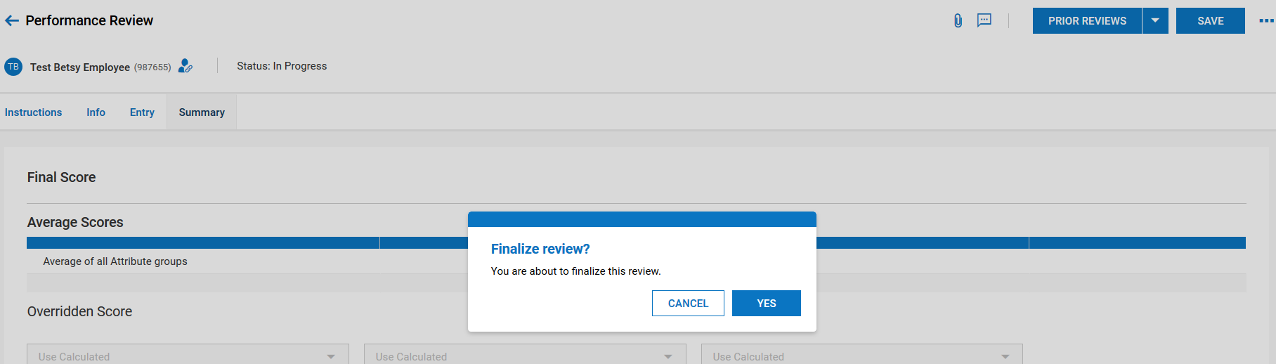

Supervisor will receive a notification that the evaluation has been finalized.

