NMCAA New Employee Onboarding Instructions

To begin the new employee onboarding process, log in to UKG; click on the bell in the upper righthand corner.

The next screen will show 3 tabs on the top left of the screen; click on the “My Checklists” tab, and then “GO TO CHECKLIST” in the lower right of the screen.

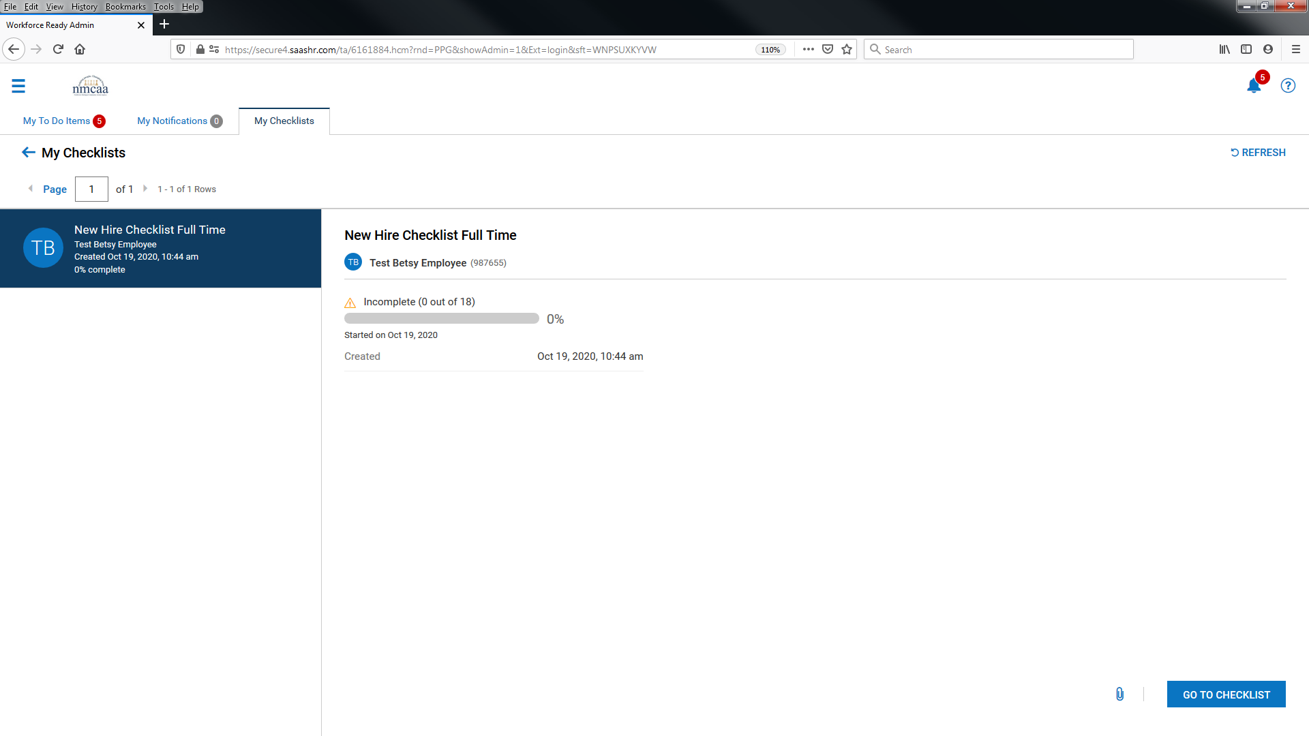

The checklist will look like this with 16 – 19 items to complete depending on the position that you are hired for. Work through each item: Follow the directions on each page, taking your time to finish the task completely. Some of the items that are a bit trickier are highlighted in this document. In most cases, as you move through the items to complete, your checklist will be checked off. If not, the instructions will advise you as to when the item will be completed.

Items with a red “*” are required to be completed. Some pages will require you to “save” the screen first and then also “submit.” Be sure to do both to complete your task, if required.

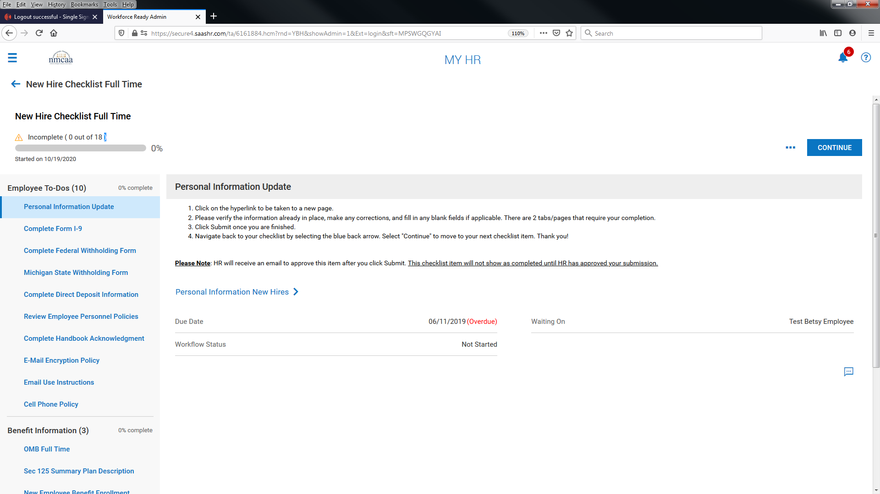
For the Personal Information Update task, you will verify your information and then be asked to add contact information. You MUST add an emergency contact, and may want to add information on dependents and beneficiaries if you are eliglble for benefits. Select the appropriate boxes across the top of the entry screen for each contact added. The contact’s SSN and DOB will also need to be added for dependents that will be added to medical, dental, and/or vision policies.

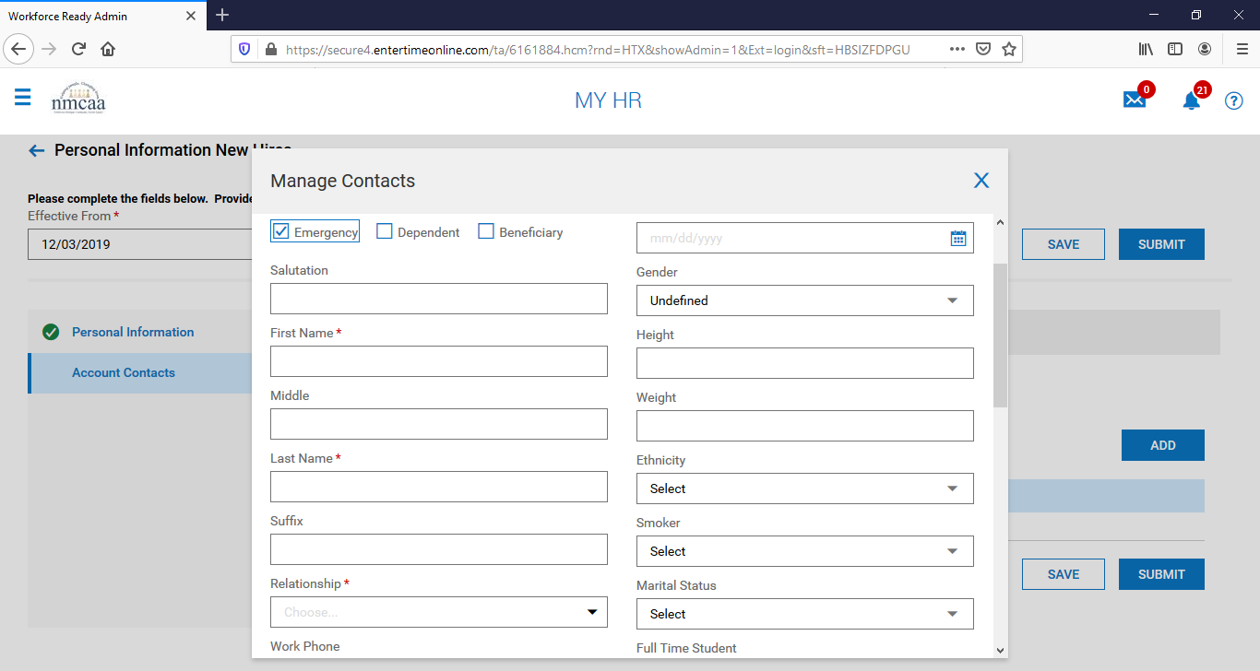
Once the information is completed, save and submit the contact. Add additional contacts as required. When entry is complete, “SAVE” and “SUBMIT” your information. Navigate back to the checklist by selecting the blue back arrow. The checklist item “Personal Information Update” will not show completed until HR has approved the submission. Select “CONTINUE” to move to the next checklist item.
Completing the I-9 Form: When selected to complete, the top of the I-9 will populate with your personal information. You should check to make sure that the information is correct and adjust as necessary. Please note: All personal information fields require an answer, so you will need to type N/A even if a field like Maiden Name or Apt Number does not apply to you. If you are unsure which fields are required, click the "Submit" button and they will be highlighted with a red exclamation point. Once the information has been completed, click “SUBMIT I9” to sign the form electronically.

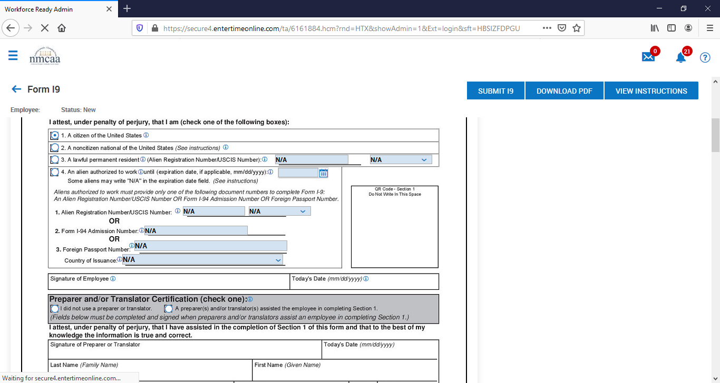

To electronically “sign” the I-9, enter the UKG password. Then select “I Agree.”

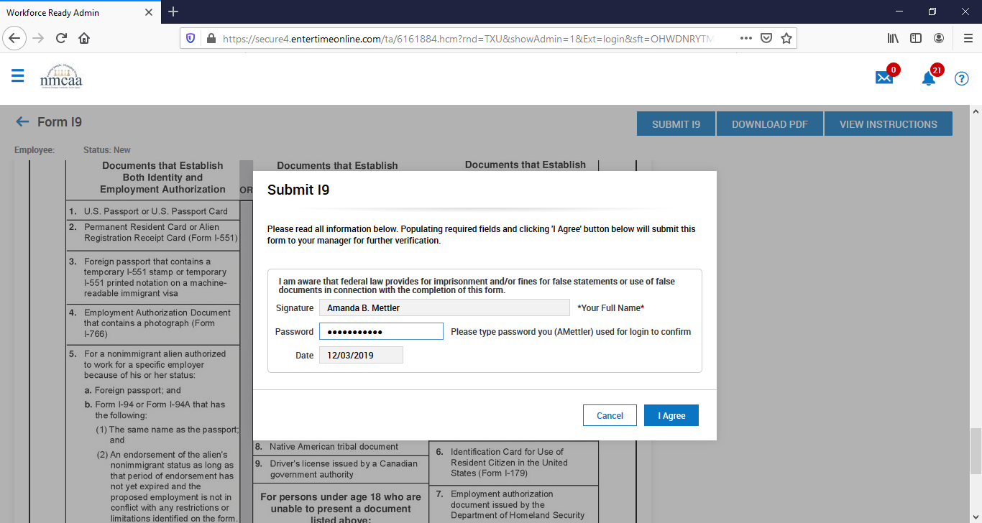

The Federal W-4 will be completed by clicking on the “Start Federal Withholding Form” hyperlink as indicated below.
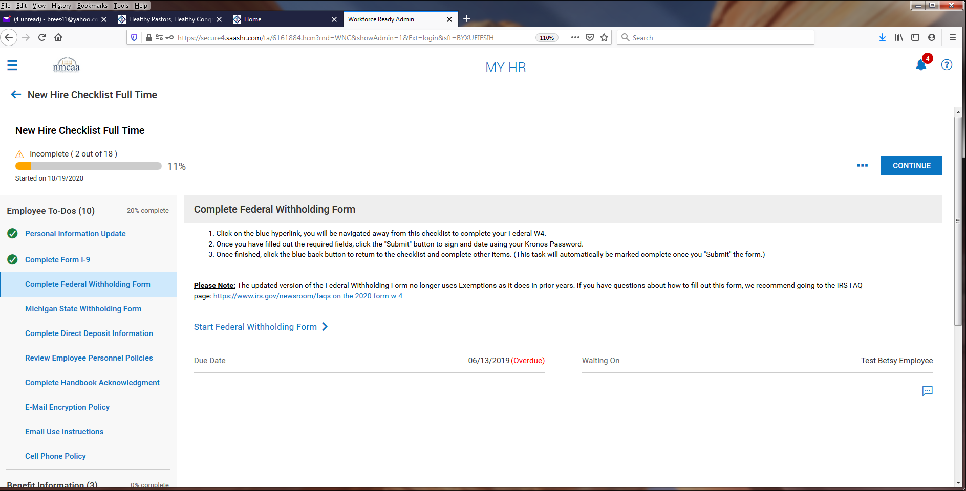

The form will populate with your personal information, name, SSN, address, marital status. You no longer indicate a number of allowances to claim on the Federal W-4. You can indicate if you would like additional dollars withheld. When finished, click on “submit withholding form” and you will be asked to sign to document electronically by entering your UKG password.

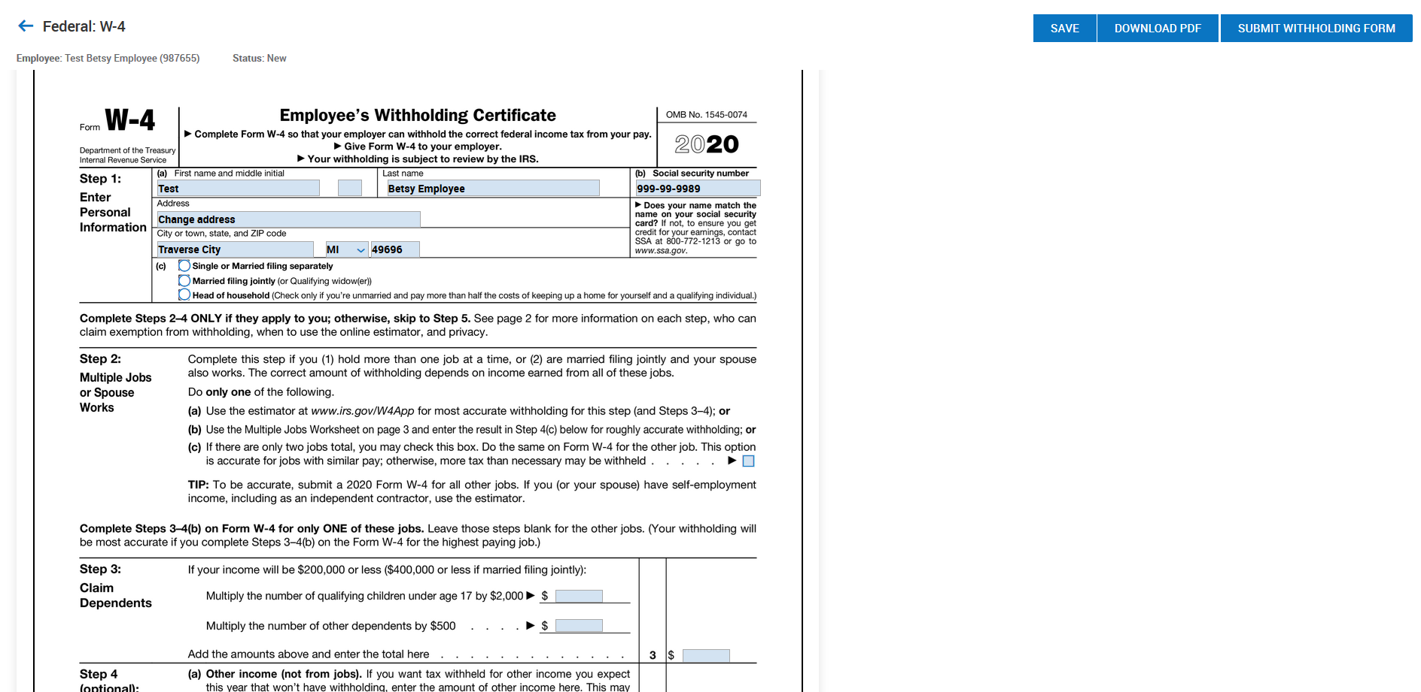

Enter your UKG password and then click “I Agree.”

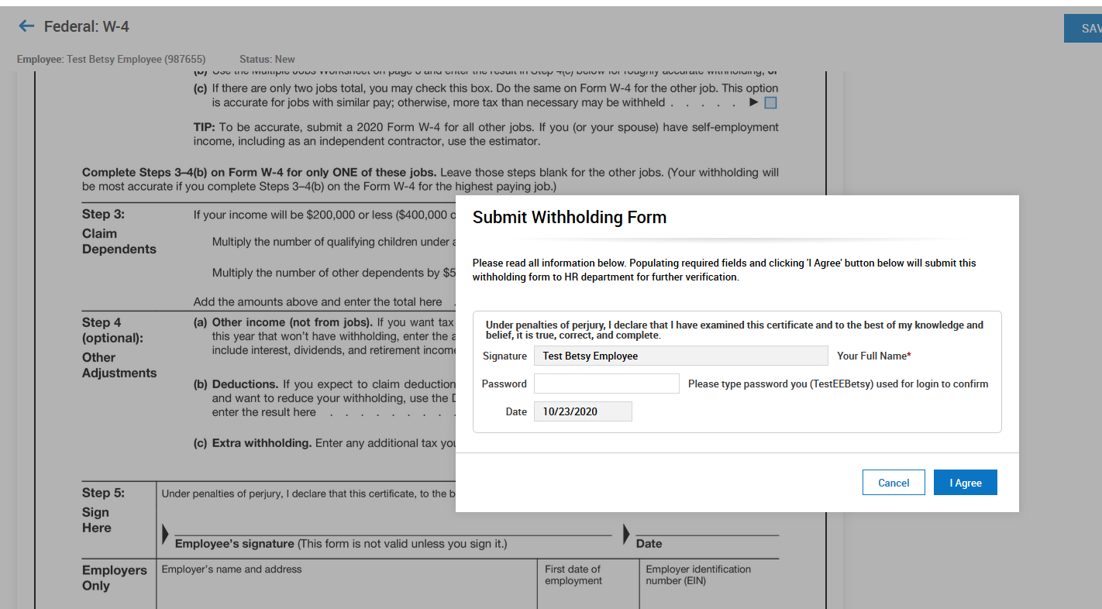

Once completed, click on the blue back arrow at the top left to move on to the Michigan Withholding Form.
Michigan State Withholding Form: To start the Michigan State Withholding Form, read the screen instructions and click on “View Your Withholding Forms.”

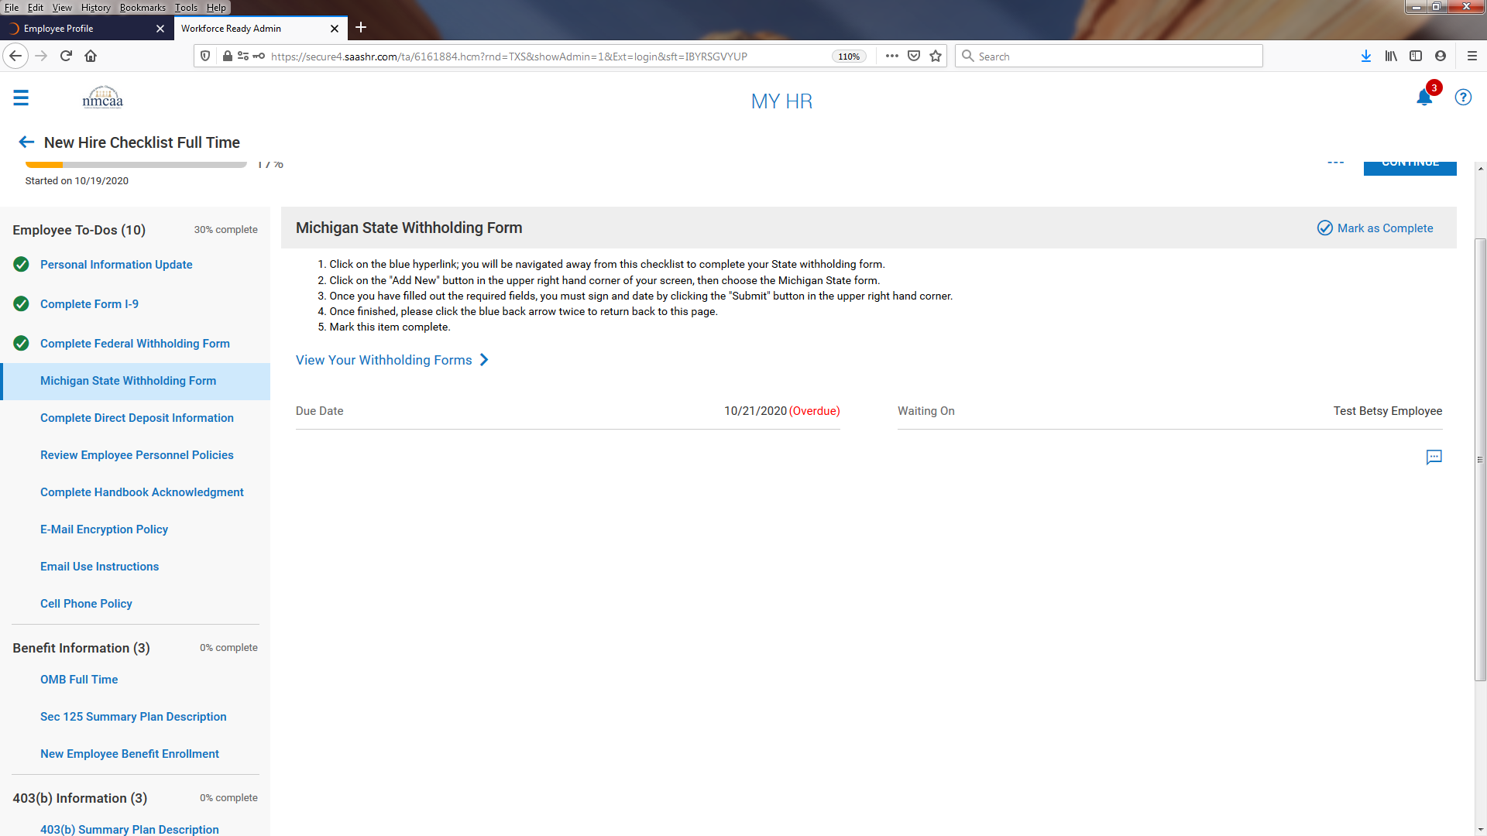

The next screen shows the already completed Federal form.
To complete the Michigan State Withholding form, click on “ADD NEW.”

Click on “+ Add’ next to Michigan.

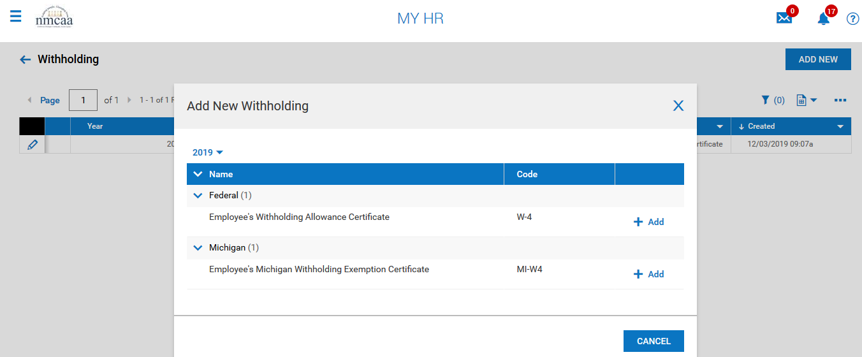

The Michigan form will be displayed and populated with your personal information. Complete the form by adding your Date of birth, Driver’s License number, completing box 5, and entering the number of personal and dependent exemptions. Click on “SAVE.”
Click on “SUBMIT WITHHOLDING FORM” to complete the form by signing it electronically.

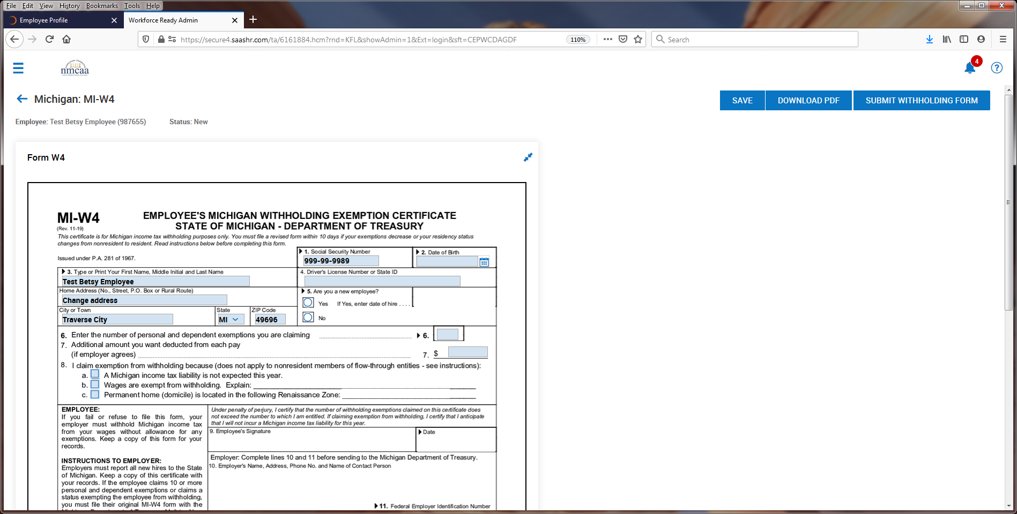

Complete the form by using your UKG password to sign the document electronically. Then click on “I Agree.”
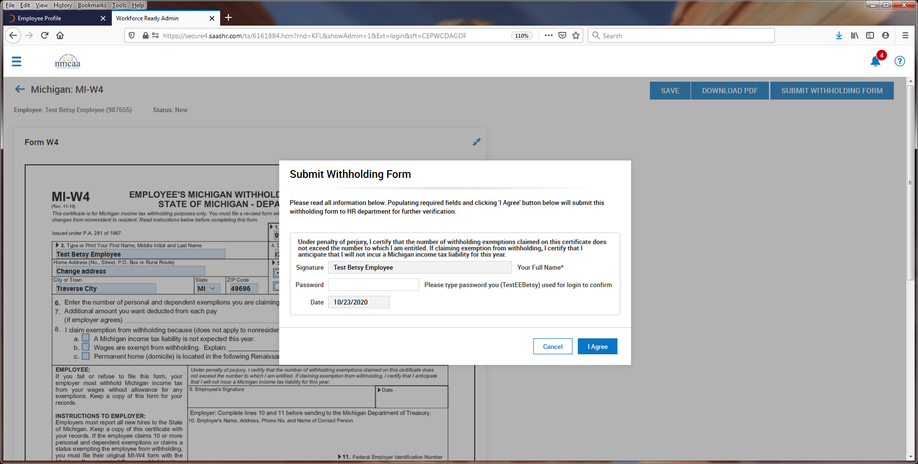

Once completed, click on the blue back arrow (twice) at the top left to move back to the checklist. Click on “Mark as Complete” on the checklist item to proceed to the next item.

Complete Direct Deposit Information: After reviewing the instructions on the screen, click on “Direct Deposit Update.”
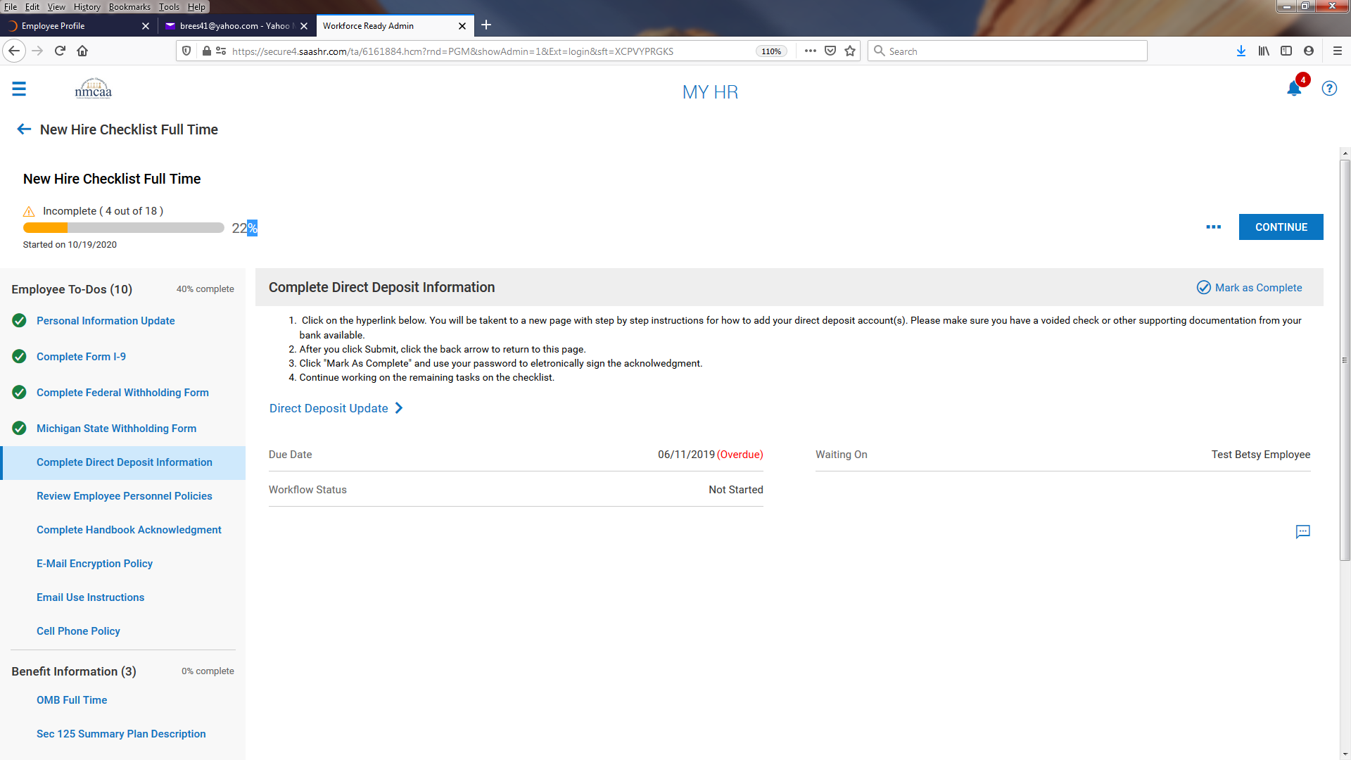

To add your direct deposit information, please review the instructions on this screen and click “+ Add.”

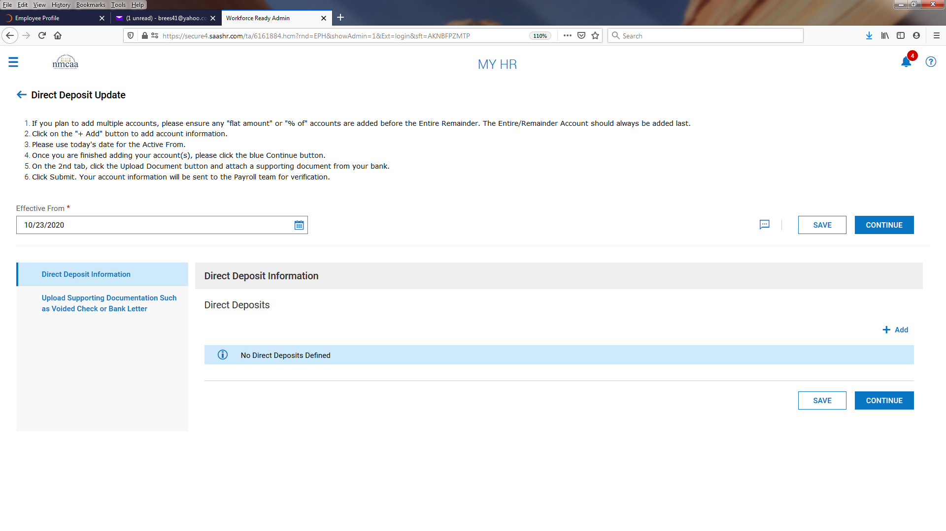
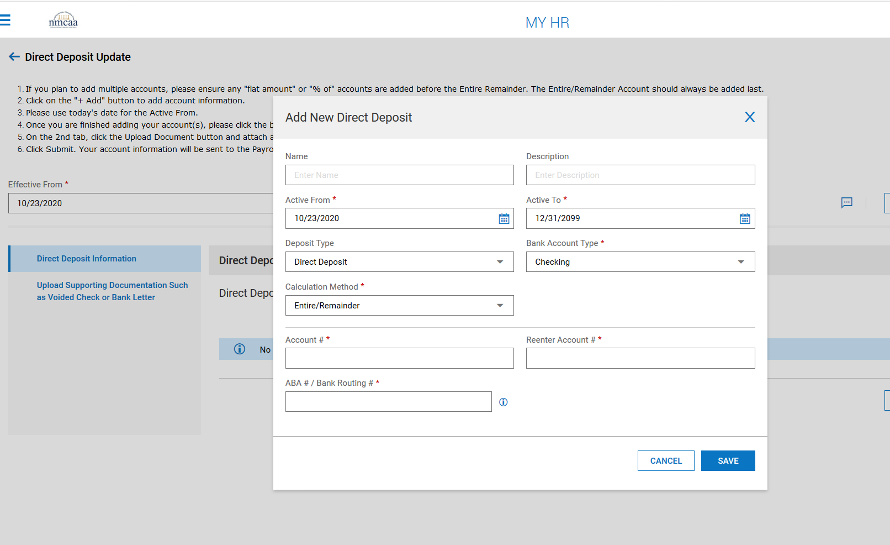

Complete the required information, then click “SAVE.” Additional accounts may be added by repeating the process.
When all accounts are entered, click “CONTINUE.”

You then move to the second section to upload your account information using a voided check or a document from your bank. Click on “Upload Document.”

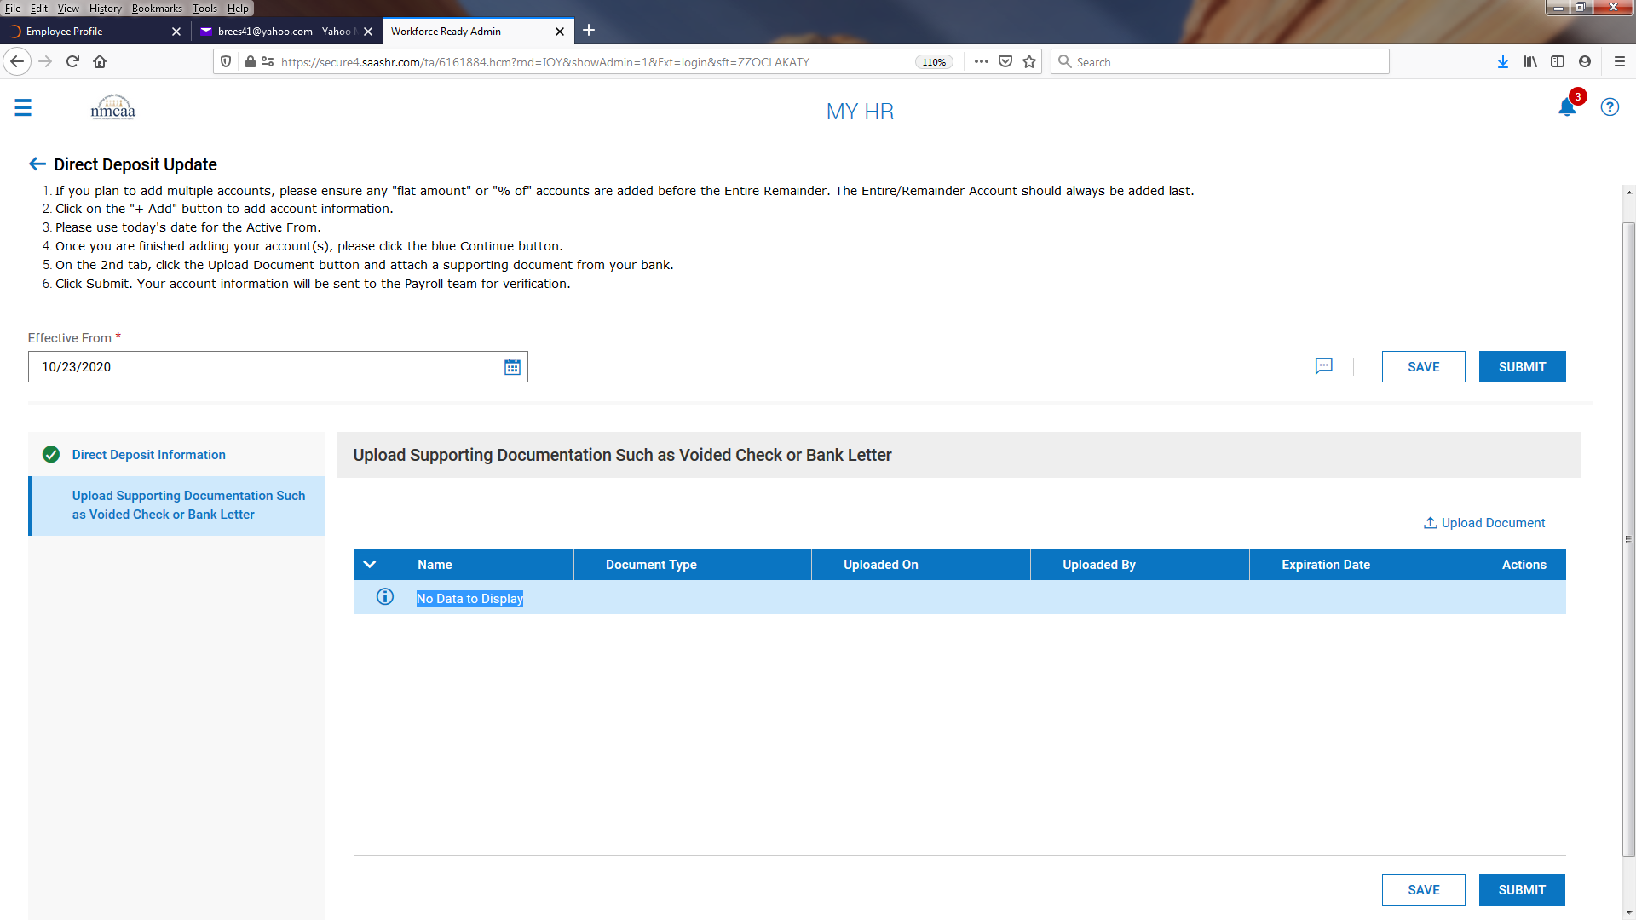

Select the document type as “Direct Deposit Void check copy” and select a document to upload.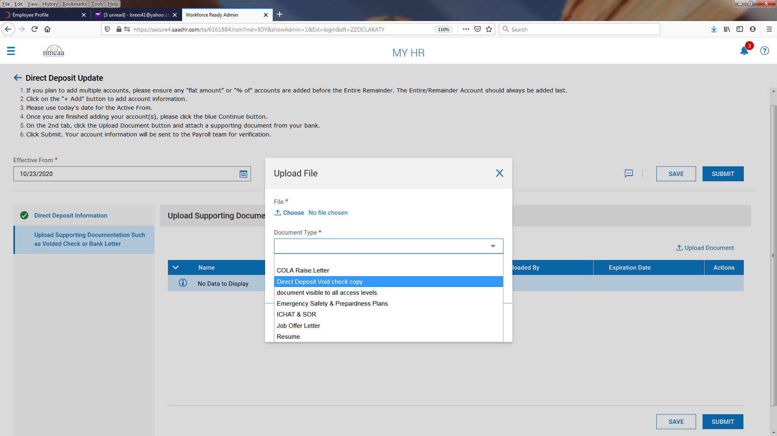

Once the document is uploaded, click on “UPLOAD.”
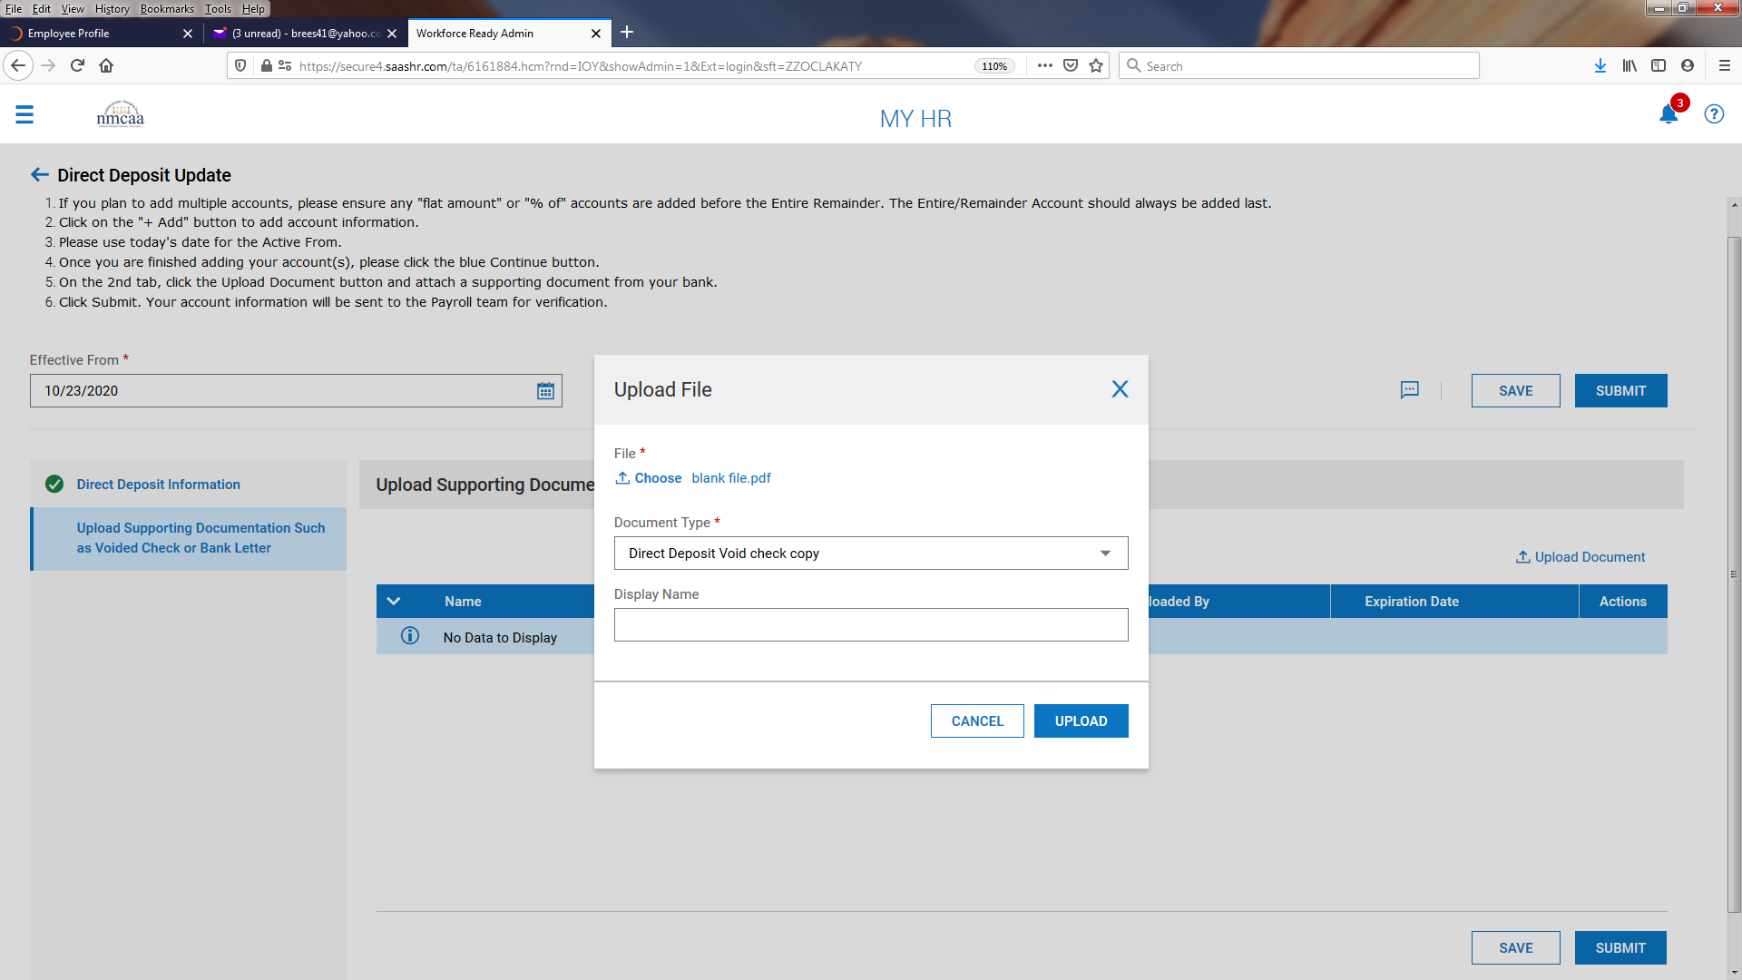

Click “SUBMIT” to complete the direct deposit update.
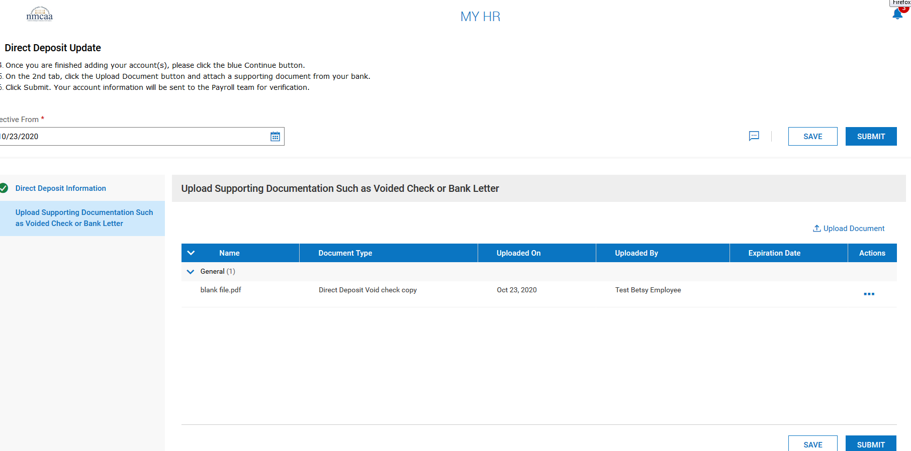

Once completed, click on the blue back arrow at the top left to move back to the checklist.

Click on on the “Direct Deposit Update” checklist item. You will be asked to Confirm Item Completion by signing electronically with your UKG password. When your password is entered, then click “I Agree” to proceed to the next item.

Review the Personnel Policies: Review the instructions on the screen and then click on when finished. This document is available in UKG by going to My Company > Documents.

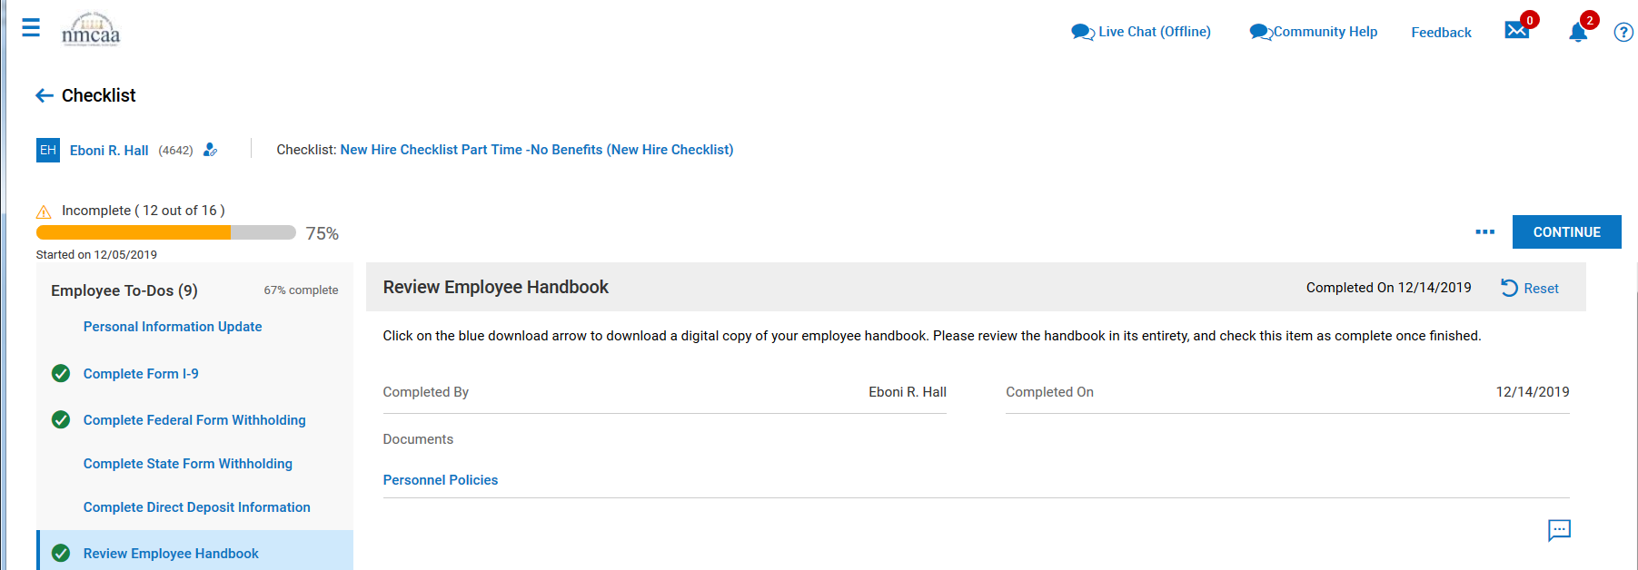

Handbook Acknowledgement Form 2020: Follow the instructions on the screen.

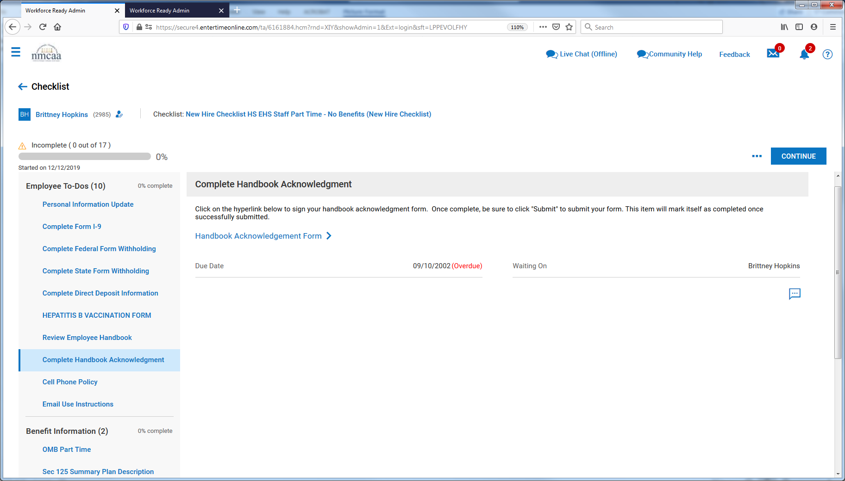

Sign the form electronically using your UKG password. Click on “SAVE,” click on “SUBMIT,” and then click on the blue back arrow at the top left to move back to the checklist.

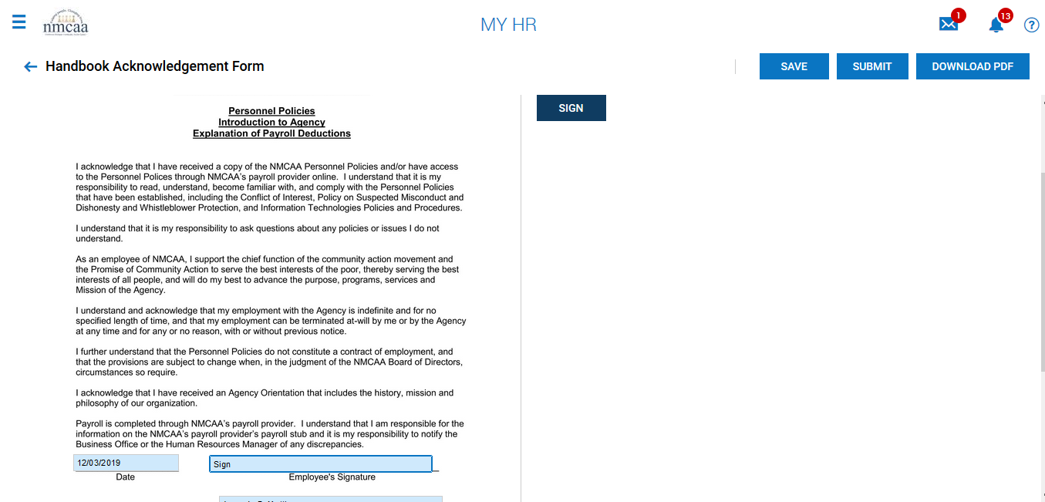

E-Mail Encryption Policy: Review the instructions on the screen and sign the form electronically using your UKG password. Click on when finished and sign electronically with your UKG password. This document is available in UKG by going to My Company > Documents.

E-Mail Use Instructions: Review the instructions on the screen and then click when finished and sign electronically with your UKG password. This document is available in UKG by going to My Company > Documents.

Cell Phone Policy: Review the instructions on the screen and click on the “Cell Phone Policy” hyperlink.

Sign the form electronically using your UKG password. Click on “I Agree.” Then click on “SAVE” and “SUBMIT”. Click on the blue back arrow at the top left to move back to the checklist.

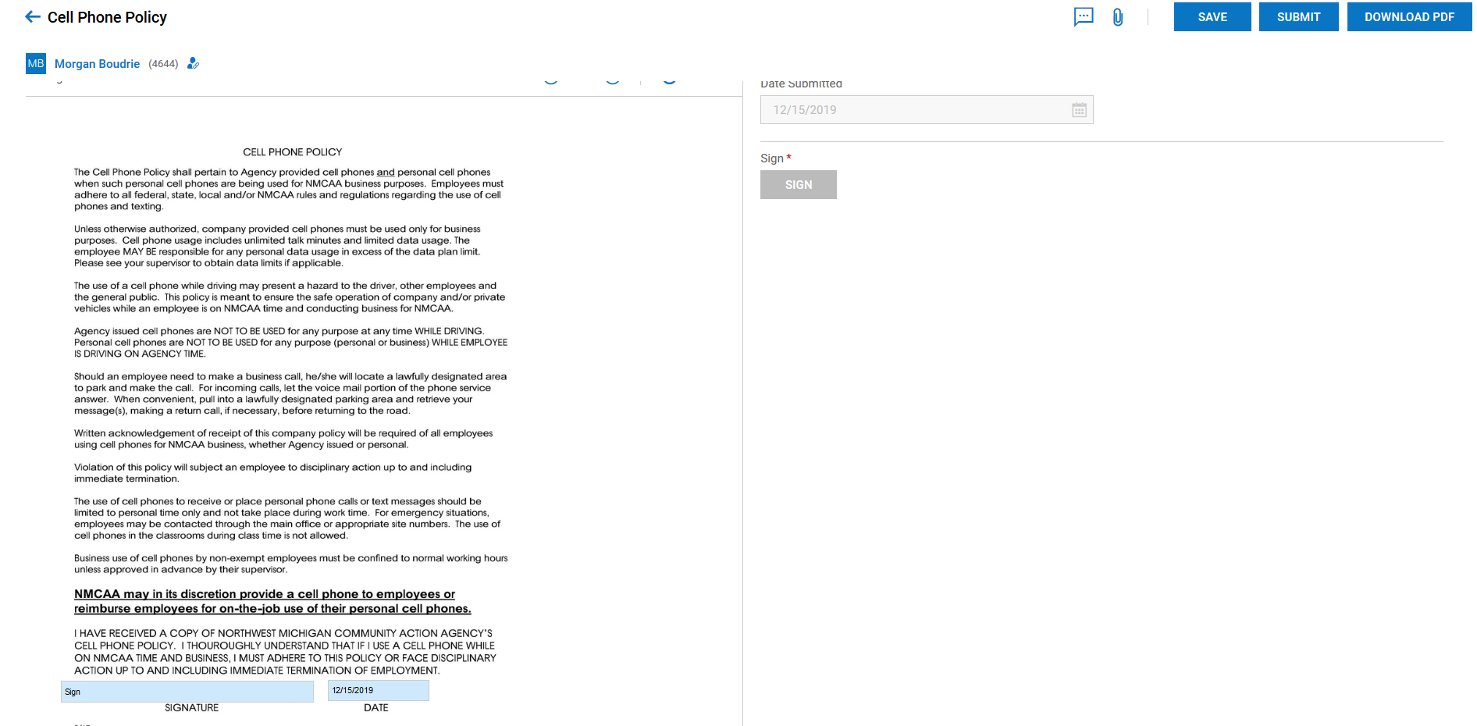

OMB Full Time: This information is provided to all employees upon hire. It advises you on how to answer questions that are asked of you if you are applying for health insurance through the marketplace. Click on the hyperlink “OMB Full Time,” review the document, and then click when finished. This document is available in UKG by going to My Company > Documents.
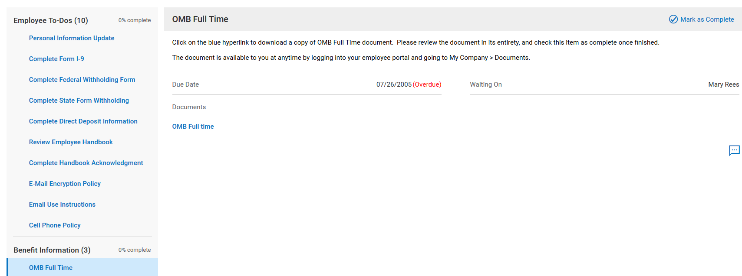
Section 125 Summary Plan Description: This information is provided to all employees upon hire giving you the benefit information in the NMCAA Section 125 Plan (FSA information). Click on the hyperlink “Sec 125 Plan Summary Plan Description,” review the document, and then click when finished.
This document is available in UKG by going to My Company > Documents.
New Employee Benefit Enrollment: Click on the hyperlink “Start Your Benefit Enrollment Process.” All eligible employees will need to complete this even if they are waiving participation in a particular benefit plan.
Review the instructions and click on the “Go To External Page” link.
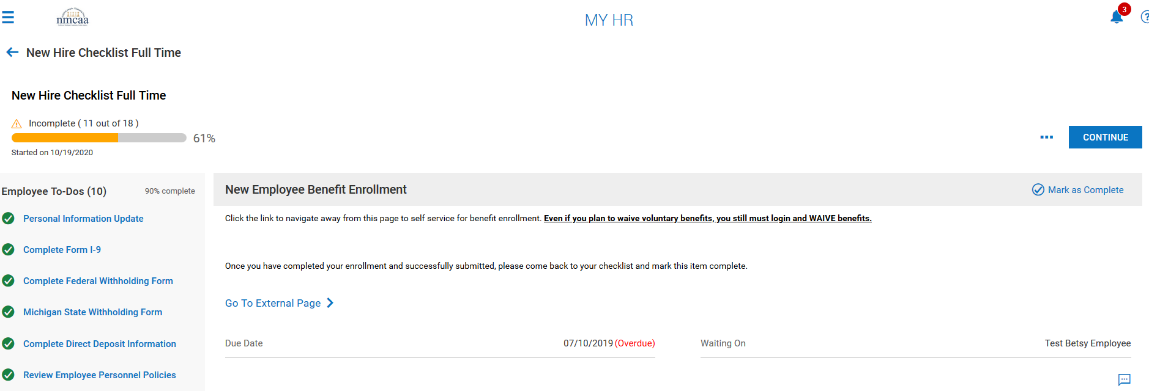
You will be routed to this page to verify your personal information.

Once you have reviewed the information, click on “Next: Review My Family” at the bottom of the page.

The next section will have you add information regarding any dependents that need benefits. Click on the “+ Add Family Member” to add the family member. Once the information is entered, click “SAVE.” Repeat as needed to add additional family members. When complete, click on “Next: Shop for Benefits.”

The next screen shows your available benefits. Click on the “Shop Plans” for medical to start reviewing the plan options.
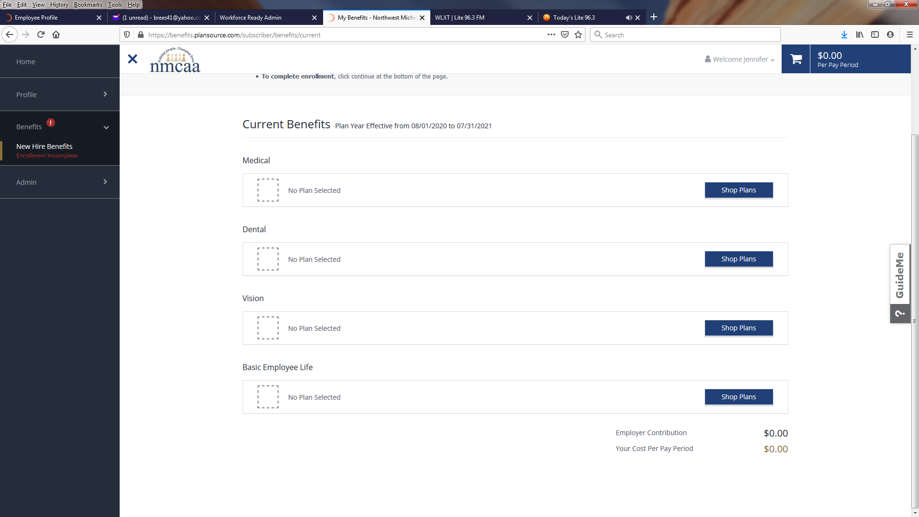

The top of the next screen allows you to review the medical plans that are available. Click the plan links to view details about the plan coverages.

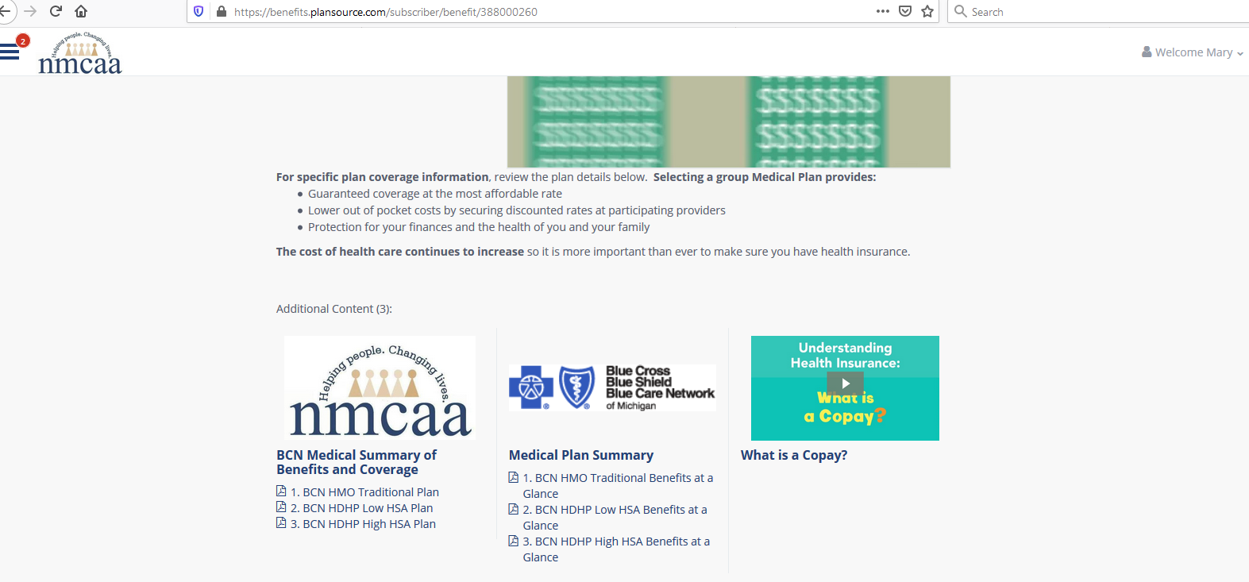

The bottom of the screen shows you who is eligible for coverage that may be included in the plan. Coverage for yourself is automatically checked off. To add other family members, click on “+ Add Family Member” and follow the step to add the family member. Once the family member(s) are added, you may check off the ones that you want to include in the plan.
Next, click on “View Plan” for the plan that you want to purchase.
You must click on “Decline Medical Benefits” if you have other coverage and do not want to participate in the NMCAA medical plans.

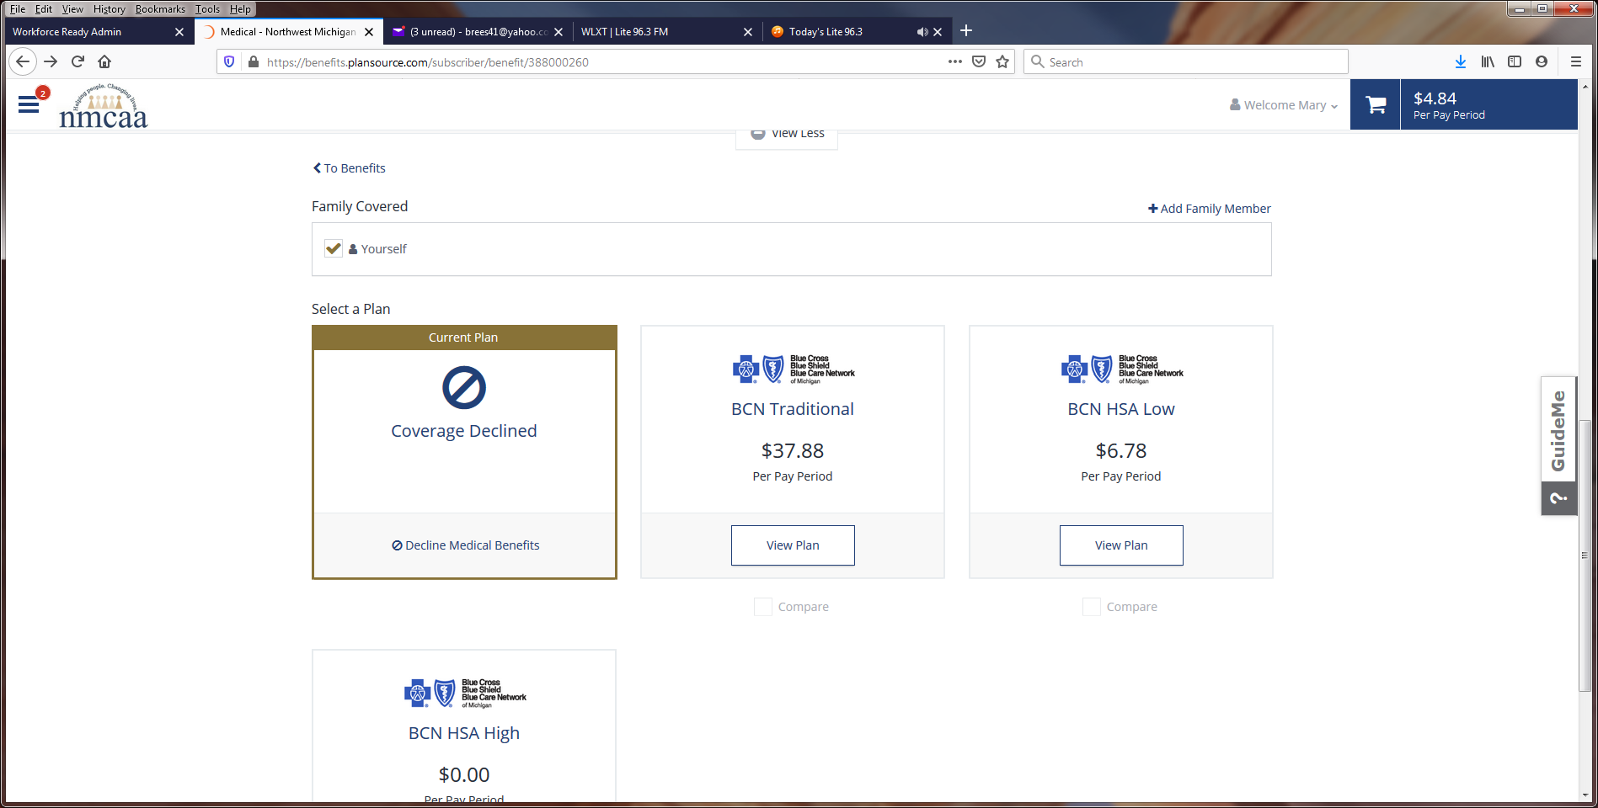

The next screen shows the costs for the selected plan based on how many people you may want to cover. If this is the plan that you want to click on “Update Cart.”
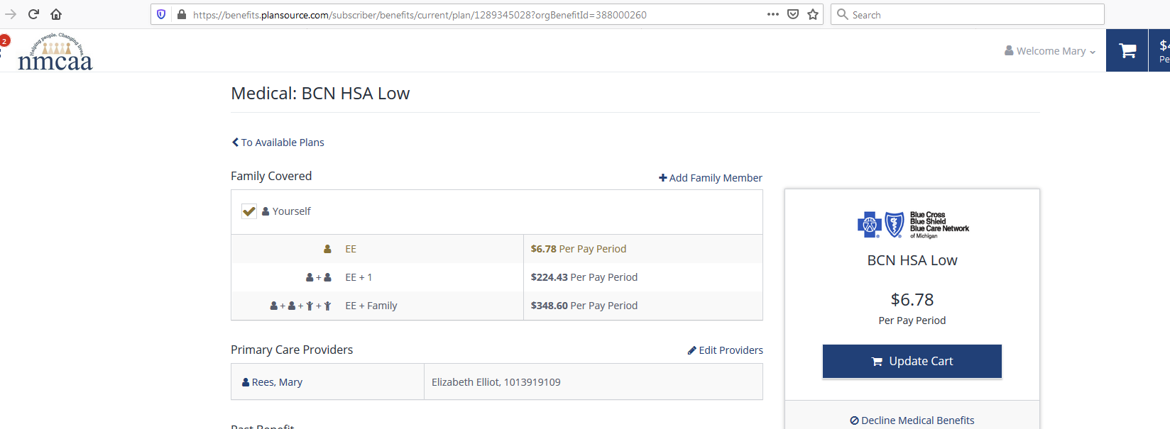

Next you will be asked to enter in the information for the Primary Care Physician(s) for each person to be covered. You can go to bcbsm.com to look up this information. First click on the blue box on the left “Find a Doctor.” Click on the blue link “Search without logging in” under “not yet a member?”. Choose a location by entering in a zip code. Click on “doctors by name.” Enter the last name of the doctor. The doctor should come up or a list to select from. Another screen comes up with the doctor’s name and information about them. Click on the doctor’s name and the additional information is posted. The Provider ID number is in the lower left area of the page. This is the number you will need to enter with your doctor’s name.

Once you have the information for each family member enter it on this screen. When complete, click on “continue”.

If you have selected the low or high HSA medical plan, you will next see this screen about HSA accounts. Review the information. Click on the blue hyperlinks for more information or to get the Chemical Bank form which can be taken to Chemical Bank (now TCF Bank) to open your account.
Also note that the shopping cart now contains the costs for your benefits, and this will adjust as you select additional plans.

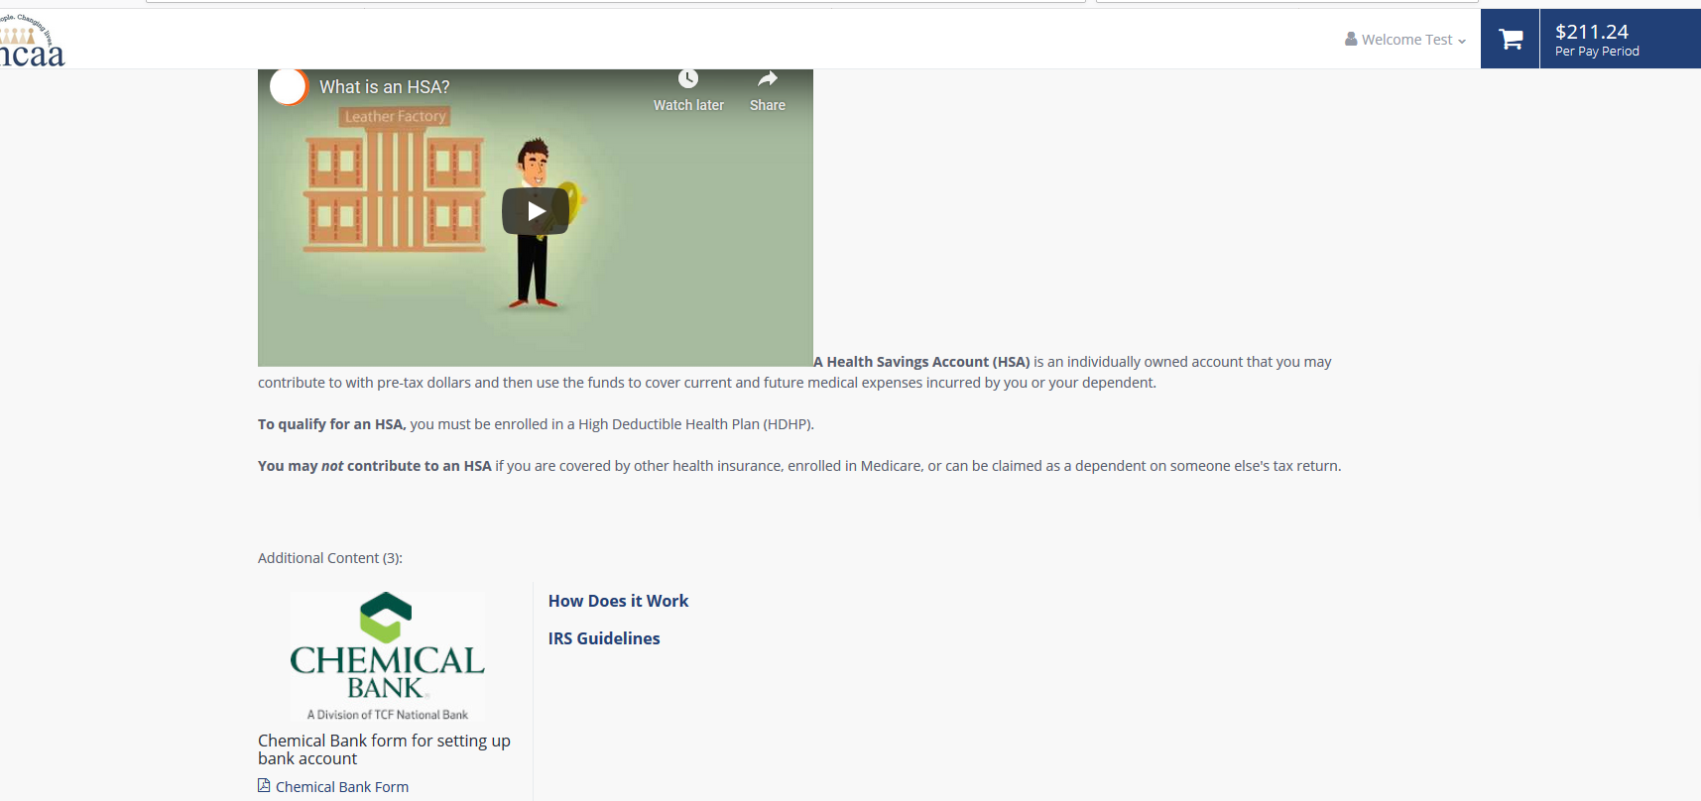

On the bottom of the screen, you may add contributions that you want to add to your HSA bank account. Any money designated to go to your account will be taken on a pretax basis. Review the instructions, enter the annual amount to contribute and update cart or Decline Health Savings Account Benefits.
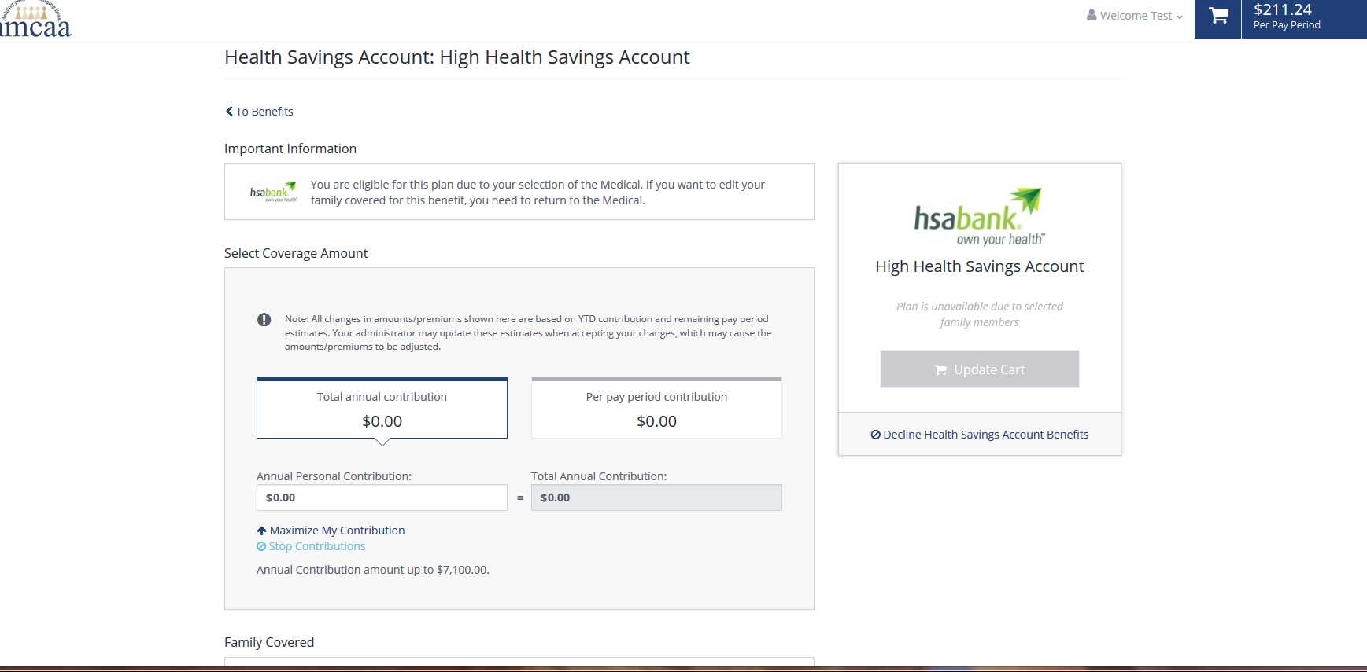
Continue the same process for dental and vision coverage options.
For fulltime employees, there is a life insurance policy that you should sign up for. This plan is at no cost to the employee. You will be asked to add a beneficiary (or multiple ones) to your policy.

Once this benefit selection is complete, return to the UKG checklist and mark the “New Employee Benefit Enrollment” task as complete by clicking on

403(b) Information
403(b) Summary Plan Description: Click “403(b) Summary Plan Description” to review the document. Once the review is complete, close the document and click on to move on to the next item. This document is available in UKG by going to My Company > Documents.

403(b) TIAA Investment Options: Click “403(b) TIAA Investment Options” to review the document. Once the review is complete, close the document and click on to move on to the next item. This document is available in UKG by going to My Company > Documents.

Agreement for Retirement Plan 403(b): All employees must either waive participation or sign up to participate in the NMCAA 403(b). By waiving it at the time of hire does not mean that you cannot change to participation in the future. There is no waiting period to participate and ALL employees (substitutes and seasonal employees included) are eligible to participate. To start, click on the hyperlink “Agreement for Retirement Plan 403(b).”
Instructions for setting up your 403(b) account through TIAA are also included here. If you are going to participate in the 403(b), you MUST set up an account with TIAA so you will need these instructions. Click on “403(b) Instructions” to review.
These documents are available in UKG by going to My Company > Documents.
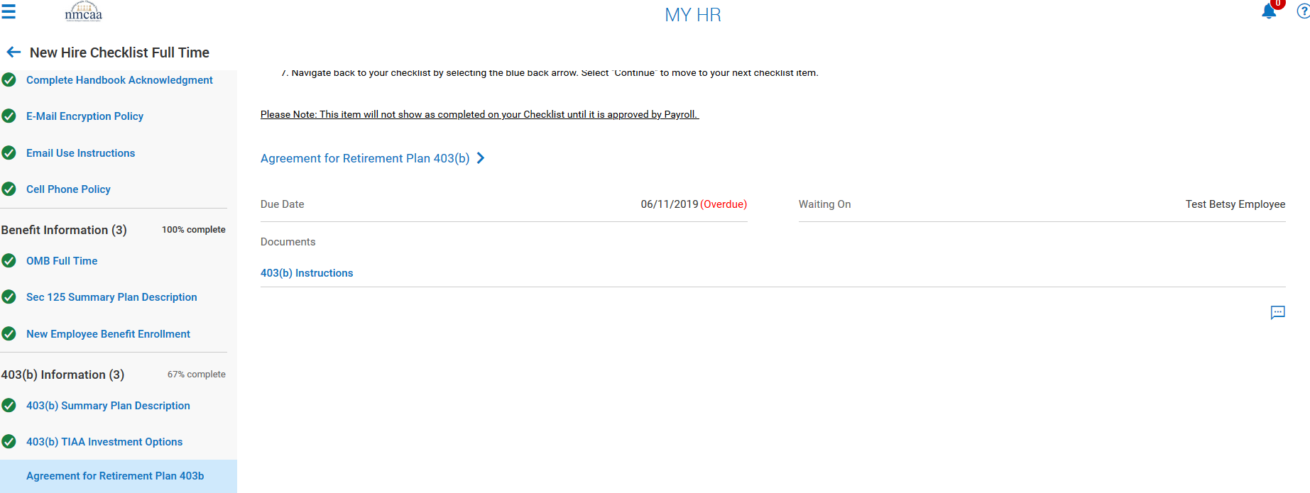
To complete this form, review the instructions on the page and complete the appropriate boxes to the right. DO NOT try to fill in the light blue boxes on the form itself. If you are waiving participation, click the box next to “Choose Not to Participate.” Click on “SIGN” when the boxes are completed. Click on “Save & Sign”. Electronically sign the document using your UKG password and click “I Agree.” Click on “SAVE” and then “SUBMIT.” Use the blue back arrow at the top of the screen to return to the checklist. This item will NOT be marked complete on the checklist until approved by payroll. Click continue to move on to the next checklist item.
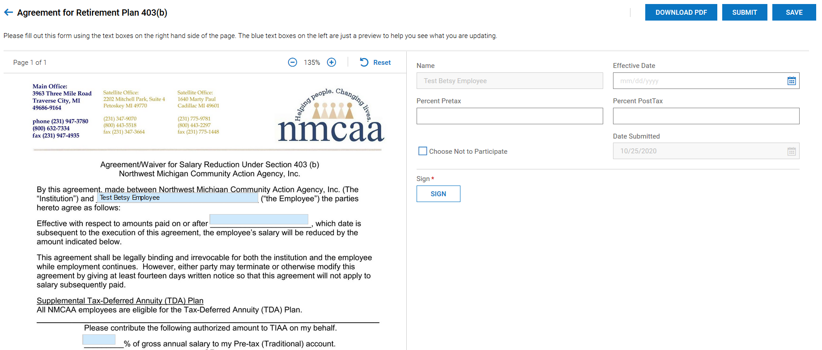
NMCAA Orientation
NMCAA Introduction Video: This is a short video about the services offered through NMCAA. Click on “Go to External Page.” Once the viewing is complete, click on to move to the next item.

NMCAA Orientation includes a history of NMCAA and Community Action, general Board information, and department services information. Click on the hyperlink “NMCAA Orientation,” review the document, and check this item as complete on the checklist by clicking on . This document is available in UKG by going to My Company > Documents.

This completes your onboarding checklist. Thank you, and if you should have questions please contact Julie McNally at jmcnally@nmcaa.net or Betsy Rees at brees@nmcaa.net. Thank you and welcome aboard!

5/2022 P:\Agency\Human Resources\Supervisors Manual\Tab 1 – Hiring\New Employee Onboarding Instructions

