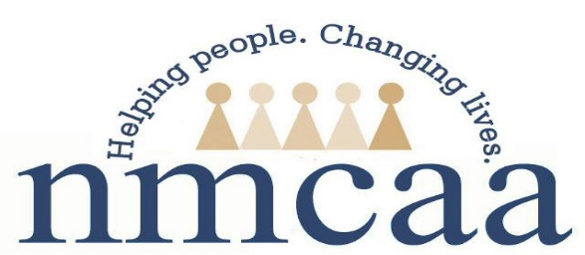
Northwest Michigan Community Action Agency, Inc.
Serving the counties of Antrim, Benzie, Charlevoix, Emmet, Grand Traverse, Kalkaska, Leelanau, Missaukee, Roscommon, and Wexford.

Mission Statement

Helping people by linking services,
resources, and opportunities.

Vision Statement

NMCAA leads in strengthening our communities by empowering people to overcome barriers, build connections and improve their quality of life.

Program Philosophy

The Northwest Michigan Community Action Agency
Head Start philosophy is:

We believe that children need strong families in order to develop into mature adults who are productive members of society. Our goal is to nurture families. We will seek whatever support is available and advocate for what is needed to enable the children in each family to be successful in school and beyond.

People will forget what you said, people
will forget what you did, but people
will never forget how you made them feel.
- Maya Angelu

