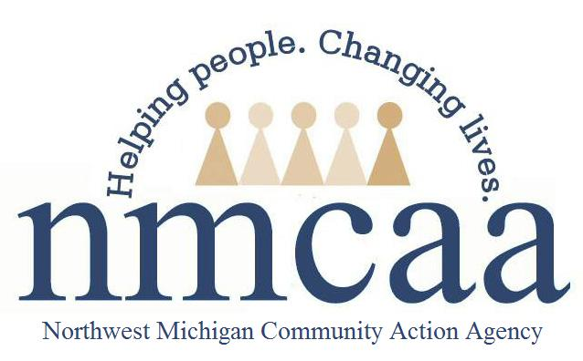
Fulltime Employee Benefits August 1, 2021 – July 31, 2022
MEDICAL, DENTAL, and VISION coverage goes into effect the first of the month after hire. Open Enrollment is in June each year and the plan year is from August 1 – July 31 for medical. Dental and vision are the calendar year.

Medical – 3 plans are available through Priority Health.
- Traditional Plan with a $2000/$4000 deductible
- HSA Low Plan with a $1400/$2800 deductible
- HSA High Plan with a $3000/$6000 deductible
HSA Accounts are set up by the employee through bank of their choice. NMCAA provides employees with $5,268 towards a single coverage medical plan and $7,165 towards a 2 party or family plan for the year. Any additional costs are paid by the employee through payroll deductions.
If an employee has insurance through another source, they can complete a waiver and submit a copy of their current insurance card to receive “optional earnings” instead of insurance through NMCAA. The amount of this benefit is $3,883 per year.

Dental – 2 plans are available through Equitable (AXA)
- Low Plan with basic yearly cleanings (2) covered at 100%. 60% coverage for basic extractions and filings after a $50 deductible is met per person. Total benefit per year $750/person.
- High Plan with basic yearly cleanings (2) covered at 100%. 80% coverage for basic extractions and filings after a $50 deductible is met per person. After 12 months of coverage, 50% coverage for crowns, root canals, bridges and other major procedures. Limited orthodontia for children. Must begin while covered and $1,000 lifetime maximum. Total benefit per year $1000/person.
Employee paid premiums.

Vision – 1 plan through VSP.
Plan includes yearly exam with $10 copay. $130 frame allowance every 24 months. Or $130 contact allowance. Lenses may be replaced annually. Costs for lenses varies based on criteria selected.
Employee paid premiums.

Life Insurance Policy – Companion Life
A $20,000 life insurance policy is provided to each fulltime employee at no cost. At age 65, this coverage is reduced to $13,000 and at age 70, $10,000. The policy goes into effect 90 days after hire.
Employer paid premiums

Optional Insurance Coverage – Colonial Life
Critical Illness, Short Term Disability, Accident, and other optional insurances are available. Open enrollment for these is in October of each year. Coverage is form November to October.
Employee paid premiums.

403 (b) – NMCAA’s Tax Differed Annuity Program through TIAA
This is available to all employees by contributing a percentage of your earnings into a tax deferred program for retirement. No waiting period for participation. Currently, NMCAA does not contribute a match for this program. Employees may set up a pre-tax (traditional) account or a Post-tax (ROTH IRA) account.

PTO – Employee’s accrue sick/personal time and vacation time each payroll starting at the time of hire.
Employees have 80 hours of sick/personal time that are accrued each year and 80 hours of vacation time. Vacation time must be used by the end of September (the end of our fiscal year). Sick/personal time can accrue up to 240 hours. After 5 years of employment, employees earn an additional vacation day each year up to year 10 and will then have 120 vacation hours.

Holidays – NMCAA observes the following holidays:
New Year’s Eve, New Year’s Day, Martin Luther King Day, Presidents Day, Good Friday (1/2 day), Memorial Day, July 4th, Labor Day, Thanksgiving, Day after Thanksgiving, Christmas Eve, and Christmas.

