Employee Performance Review Procedure

Policy: All staff, including substitutes, will participate in the employee performance review process to adhere to NMCAA’s Personnel Policies, Head Start Program Performance Standards, Great Start Readiness Program Implementation Manual, Licensing Rules for Child Care Centers, and Great Start to Quality requirements.

Procedure: All staff will complete a self-evaluation in UKG. Additionally, employees serving in supervisory roles, including those acting as classroom program directors, will complete performance reviews on staff they oversee. Performance reviews shall occur according to the timelines set forth in NMCAA’s Personnel Policies.

Training Period
- The training period is a time of continuing review and instruction for an employee.
- All new Child and Family Development employees will serve a minimum training period of one year.
  - If an employee begins mid-year, the training period will continue into the next program year.
- When an employee transfers to a new site and/or position, the employee is placed on a training period for at least one program year.
- All employees will complete at least one evaluation 90 to120 days from their date of hire or from their date of transfer/position change. An additional evaluation will be completed at the end of the one-year training period.

Employee Evaluation
- Direct supervisors shall evaluate employee performance, either orally or in writing, on an ongoing basis. This will highlight employees’ strengths and contributions, foster areas of development, and promote transparency and employee engagement.
- Additionally, all employees will be formally evaluated, including completion of a self-review, at least once per year utilizing the agency’s evaluation form located in UKG.
- Employees and their supervisors shall complete the following within the evaluation form:
  - Cornerstones of Culture items: Select Competent or Focus Area and add relevant comments.
  - Working Habits items: Select Competent or Focus Area and add relevant comments.
  - Job Performance: Select Proficient, Competent, Developing, Needs Improvement, or Unacceptable and add relevant comments.
  - Employment Status items: Select Continue Training, Continued Employment, Place Back on Training, or Training Period Complete and add relevant comments.
  - Goals: These shall be mutually determined between employees and their supervisors. Goals listed should be appropriate and attainable and should be a focus for the employee in the following program year.
- Employees and supervisors should refer to the following when completing the evaluation form: Job descriptions, professional development plans, mutual goals for the coming year, work-training-success plans, disciplinary documentation, employee compliance plans, and any other identified and documented goals.
  - If a situation or behavior is important enough to be on the review, it should be addressed at the time of the situation. The review should not include any surprises for an employee.
- Supervisors should schedule time to present the final review to their employees after the process has been completed and approved in UKG.

Completing the Evaluation Process in UKG:
- When an employee is due for an evaluation, supervisors will notify the Human Resources Director that an employee’s evaluation needs released and indicate whether this is a 90 to 120-day review or an annual review. The supervisor should plan accordingly to ensure that enough time is allotted from the time the employee’s self-review is released until the review process must be finalized in UKG. If additional time is needed, the supervisor should contact the Human Resources Director for additional guidance and support.
The Employee
- The employee will receive a notification in their “To-Do” items that their self-evaluation is ready to be completed. Instructions for accessing and completing the self-evaluation are located within the “To-Do” notification. Additional guidance for completing the self-evaluation may be accessed on the Human Resources Weebly site:
https://www.nmcaahr.com/tab-4-evaluations-work-support-plan--disciplinary-documentation.html
- The employee must complete all sections of the evaluation form, including the addition of comments, prior to submitting the self-evaluation. It is recommended that the employee saves their progress after the completion of each individual section in the evaluation form. When all sections have been completed and saved, the employee must submit their self-evaluation.
The Supervisor
- After an employee submits their self-evaluation, their supervisor will receive an email and a notification in their “To-Do” items that there is an evaluation awaiting their review. Instructions for accessing and completing the evaluation are located within the “To-Do” notification. Additional guidance for completing the evaluation may be accessed on Weebly.
- As the supervisor begins their piece of the evaluation process, the employee’s ratings and comments will be visible. The supervisor should review the employee’s completed pieces. If there are pieces that are incomplete (i.e. missing comments), the supervisor may choose to “reject” the evaluation, adding a comment as to why the evaluation is being rejected. The evaluation will go back to the employee to complete. When the supervisor receives an acceptable submittal, they should enter their ratings and comments for each section as well. It is recommended that the supervisor saves their progress after the completion of each individual section in the evaluation form. When all sections have been completed and saved, the supervisor must submit the evaluation. The evaluation will move to the 2nd-level supervisor for approval.
- The 2nd-level supervisor will receive an email and a notification in their “To-Do” items that there is an evaluation awaiting their review. All the employee and supervisor’s ratings and comments will be visible. The evaluation may be rejected if changes or edits are needed; the evaluation will then go back to the supervisor for modifications. Upon the receipt of an acceptable submittal, the 2nd-level supervisor may offer additional entries if they’d like. Following the 2nd-level supervisor’s review, they will hit save and submit. This will send the evaluation back to the supervisor with a notification that the evaluation is ready for discussion with the employee.
Finalizing the Evaluation
- After the 2nd-level supervisor’s approval, the supervisor will receive an email and a notification in their “To-Do” items that there is an “evaluation ready to discuss.” The supervisor should refer to the instructions within the “To-Do” notification, as well as the instructions on Weebly, for additional guidance.
- The supervisor should download a PDF version of the evaluation to share with the employee during their scheduled review.
- Following the presentation of the review, the supervisor must enter the employee’s goals into UKG. After the goals and any relevant comments are added, the supervisor will save and submit the evaluation. This will send the evaluation back to the employee for their signature.
- The employee will receive a “performance review ready to sign” notification. The employee should refer to the instructions in their “To-Do” notification, as well as those on Weebly, for needed guidance. The employee will electronically sign the evaluation by entering their UKG password; NO “in person” signature is required.
- Upon the employee’s electronic signature, the supervisor will receive notification that the employee has submitted and signed their evaluation. The supervisor will refer then refer to their “To-Do” items in order to finalize the performance review. Additional guidance and instructions for completing this step are located on Weebly.
- Human Resources will receive a notification after an employee’s evaluation is finalized in UKG. HR personnel will print a copy of the evaluation to place in the employee’s Central Office personnel file.
  - Additionally, employees must print a copy of their finalized evaluation to be placed in their employee center file on-site.

Additional Options for Completing the Evaluation:
- Employees and/or supervisors may choose to write their evaluation pieces in a review template located outside of UKG. The template is available on Weebly: Supervisors’ Manual – Tab 4: Evaluations, Work/Support Plan & Disciplinary Documentation – Employee Performance Review Template.
  - The template may be saved to a desired location on your computer.
  - Once completed, the document may be shared with your supervisor for feedback and approval.
  - The content of the review will then need to be copied into the evaluation form in UKG.
  - The employee and supervisor(s) will still need to complete the submittal and approval processes in UKG as noted above. Completion of the review template alone does not finalize the performance review process.
Bus Driver Review Checklist
- The Bus Driver Review Checklist must be completed three times for new drivers and twice for returning drivers throughout the school year. The checklist is available on Weebly: Supervisors’ Manual – Tab 4: Evaluations, Work/Support Plan & Disciplinary Documentation – Child & Family Development – Bus Driver Review Checklist.
  - The lead teacher will ride the bus to complete the Bus Driver Review Checklist and shall review any findings with the bus driver after the checklist is completed.
  - Upon completion and review of each of the checklists throughout the year, the original checklist must be sent to the Director of Operations. A copy must be placed in the driver’s staff file on-site. Additional copies must be distributed to the Human Resources Director and the Site Supervisor.

Performance Reviews at a Glance
Performance reviews are beneficial for employees, their supervisors, and the agency. Some benefits of completing performance reviews include the following:
- Clear expectations are defined and set.
- Provides an opportunity to facilitate goal setting.
- Promotes open communication.
- Provides opportunity for necessary feedback.
- Offers legal protection for the involved parties.
Completing the performance review process can be challenging. To avoid pitfalls, consider the following:
- Be prepared: Have all the necessary documentation and prior feedback available to assist with the present review.
- Stay objective: Refrain from comparisons and subjective language. Utilize real examples to support your findings.
- Conflict mediators: Create an environment where those involved feel valued and listened to. Be sure to be a neutral listener, taking into consideration all sides before offering feedback.
- Role expectations: Ensure that all involved understand their roles in the performance review process. Refer to job descriptions and to higher level supervisors for support and guidance.
- Time management: An employee’s performance review deserves attention and thought. To ensure adequate time is set aside to complete the process, be sure to block off the necessary time needed on your calendar.
- Be consistent: Make sure that the comments and feedback that are provided correlate with the job performance ratings. Again, objectivity is key; use real examples to support the various ratings.
- Respect the process: Performance reviews are important! All involved need to commit to giving the process the attention and focus that it deserves.

Reference: Licensing Rule 400.8113 (3)(c), NMCAA Personnel Policies, NMCAA Human Resources Director & Operations Director

04/2021 P:/Agency/Human Resources/Supervisors Manual/Tab 4 – Evaluations, Work-Support Plan, Disciplinary Documentation/CFD
Performance Evaluations – Instructions for Employees
- After an evaluation is released by HR, the employee will receive a notification and To Do Item in UKG.
- When the employee starts their self-evaluation, they will go to the Instructions screen. To start, they will click on the “Entry” tab at the top.
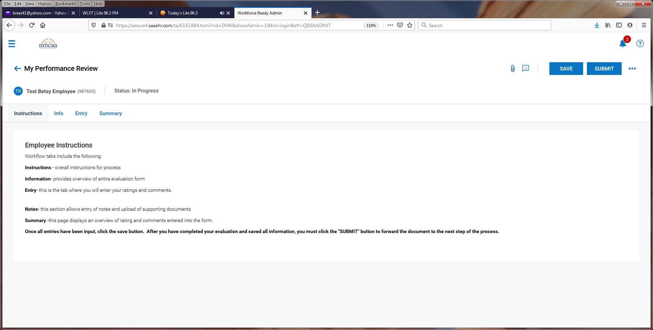
- The employee will start with the Cornerstones of Culture. They will select their rating “Competent” or “Focus Area” from the drop-down box and then add any comments pertaining to the area in the “Comment” box.
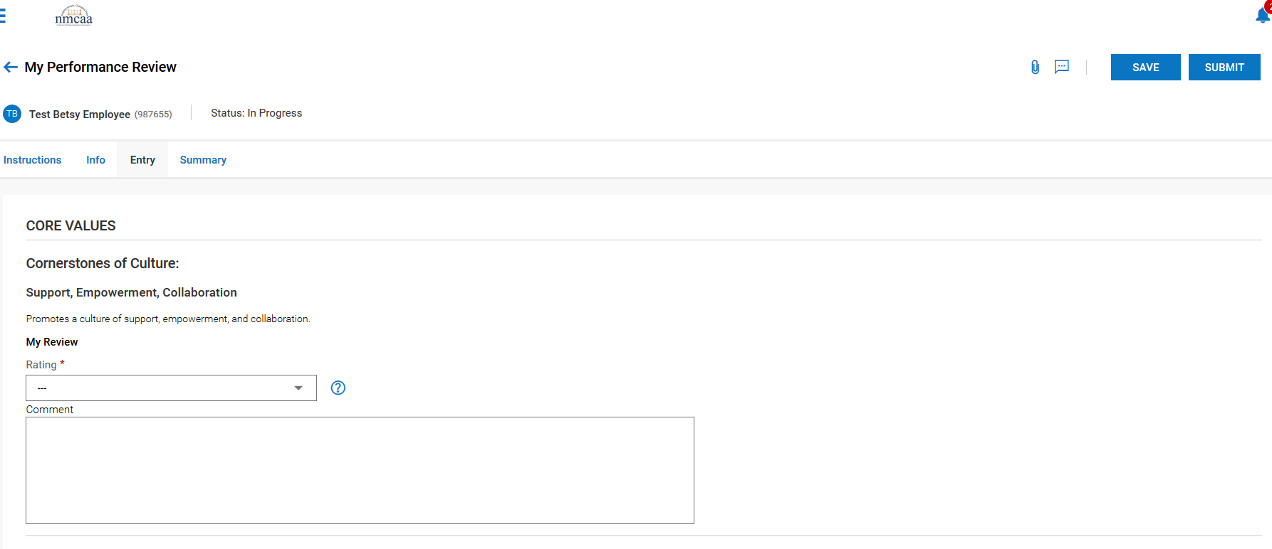

*** It is recommended to “SAVE” the progress after completing each section.
This process is repeated for each of the other four areas for the Cornerstones of Culture.

- The next section is on Competencies. The employee will rate themselves “Competent” or “Focus Area” and add comments to the “Comment” box.
*** It is recommended to “SAVE” the progress after completing each section.
This process is repeated for each of the other two areas for the Working Habits.
- The last section is Job Performance. The employee will select Proficient, Competent, Developing, Needs Improvement, or Unacceptable in the rating drop down list and add comments to the “comment” box.

- After completing this last section, the employee will “SAVE” the evaluation and then “SUBMIT” it.
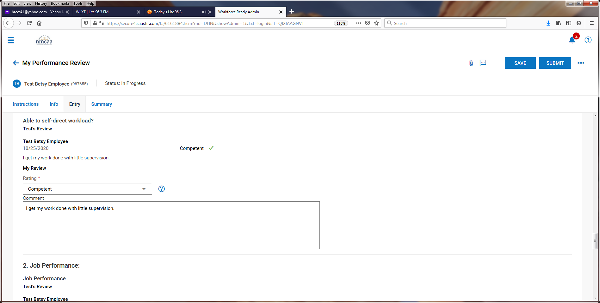
- Once submitted by the employee, the supervisor will be notified by email and by a notification in UKG to complete a To Do task in UKG for the evaluation. They will then proceed with their part of the review process. Once approved, they will present the review to the employee.
- Following the presentation of the review, the supervisor will enter employee goals, and then will save and submit the review. Once submitted, it will send the evaluation back to the employee to sign.
- The employee receives this notification and then clicks on their To Do Items:

- To sign the document, the employee will click on “SIGN.”
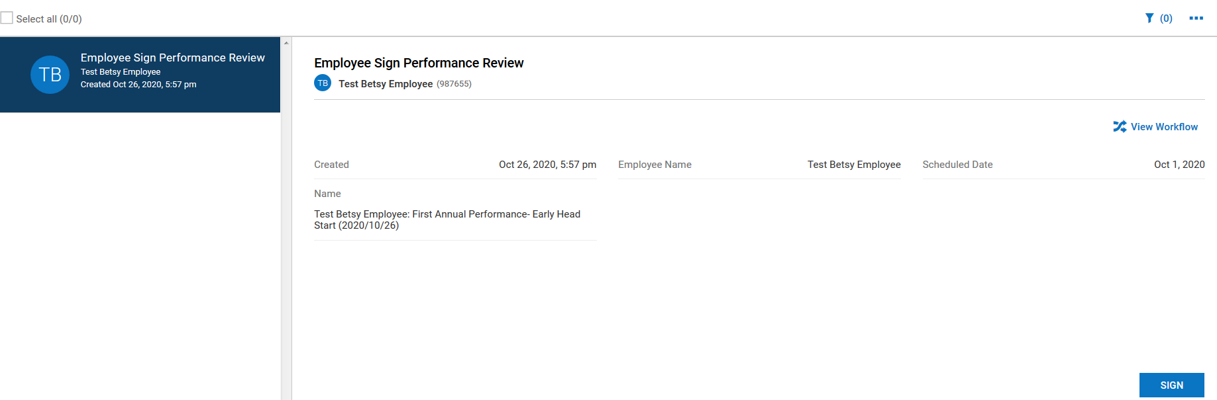
- From this screen the employee will click on “Summary.”
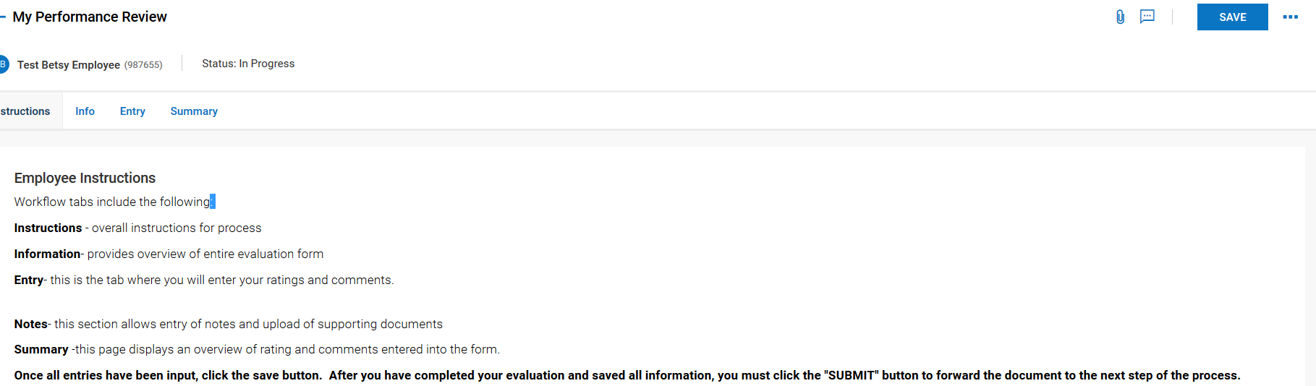
- If the employee wants a copy of the evaluation, they can click on the 3 dots to download the document and print it out or save it.
- To sign the evaluation, they click on “SIGN AS EMPLOYEE.”
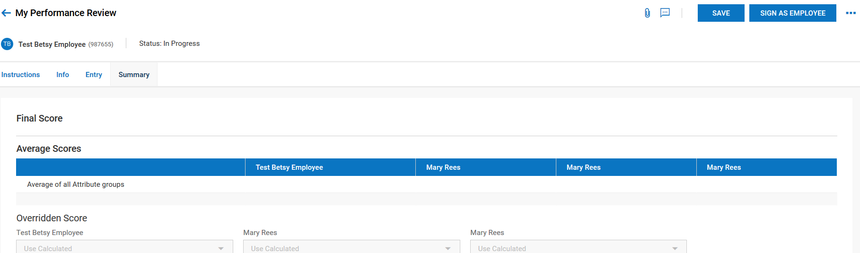

- The employee will electronically sign the evaluation by entering their UKG password and clicking on “I AGREE.”
- The evaluation will go back to the supervisor to finalize in UKG.

Performance Evaluations – Instructions for Supervisors
- Contact the HR Director to release an evaluation; indicate whether it’s a 90 to 120-day or annual review. Once released, the employee will receive a notification and To Do Item in UKG and will move forward with their piece of the process.
- Once submitted by the employee, the supervisor will be notified by email and by a notification in UKG to complete a To Do task for the evaluation. Click on “REVIEW” to start the evaluation.
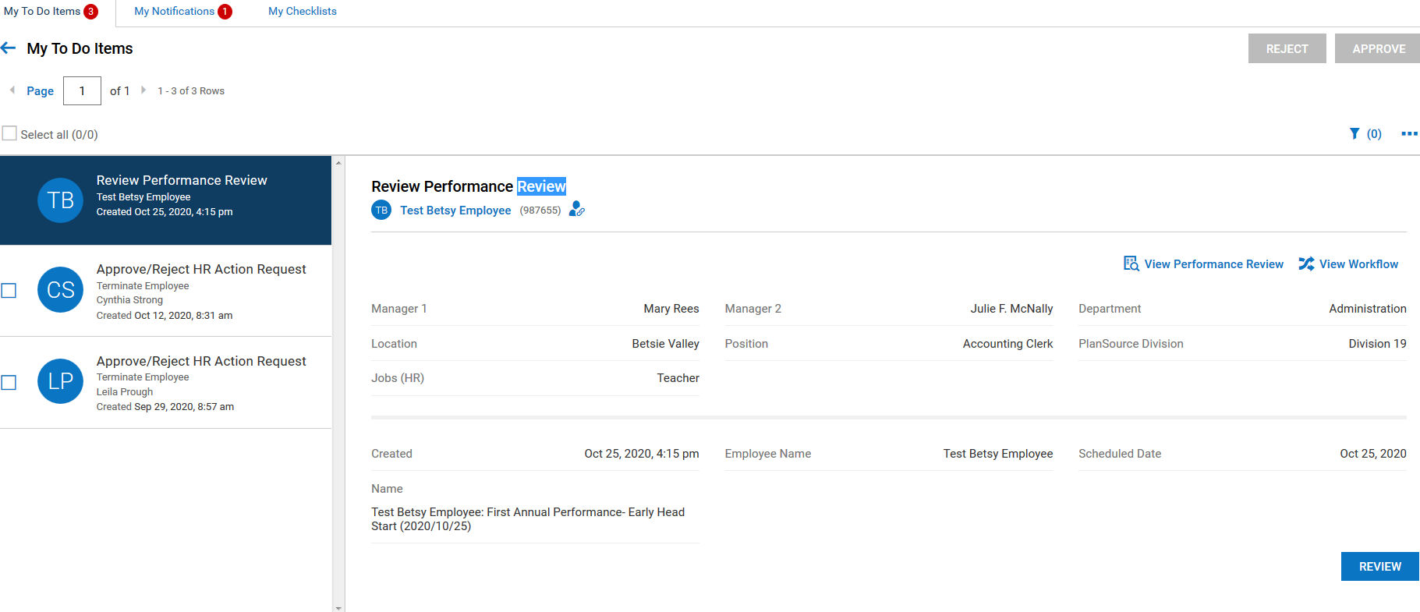

- The instruction page will display; click on the “Entry” tab to review the employee ratings/comments and to complete the supervisor’s ratings/comments.
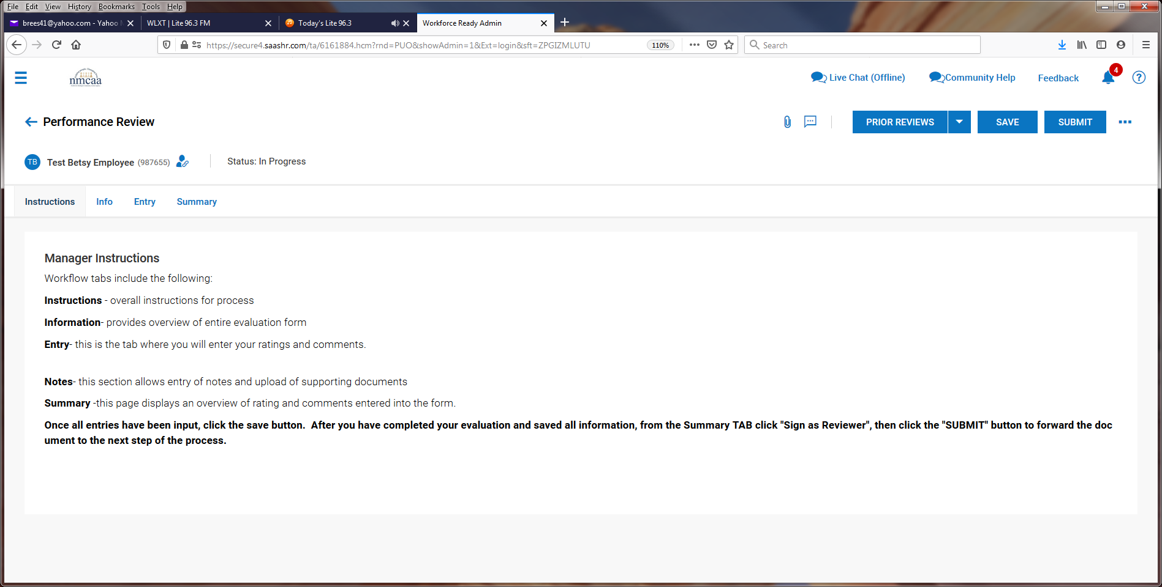
- The employee’s entered information is visable.
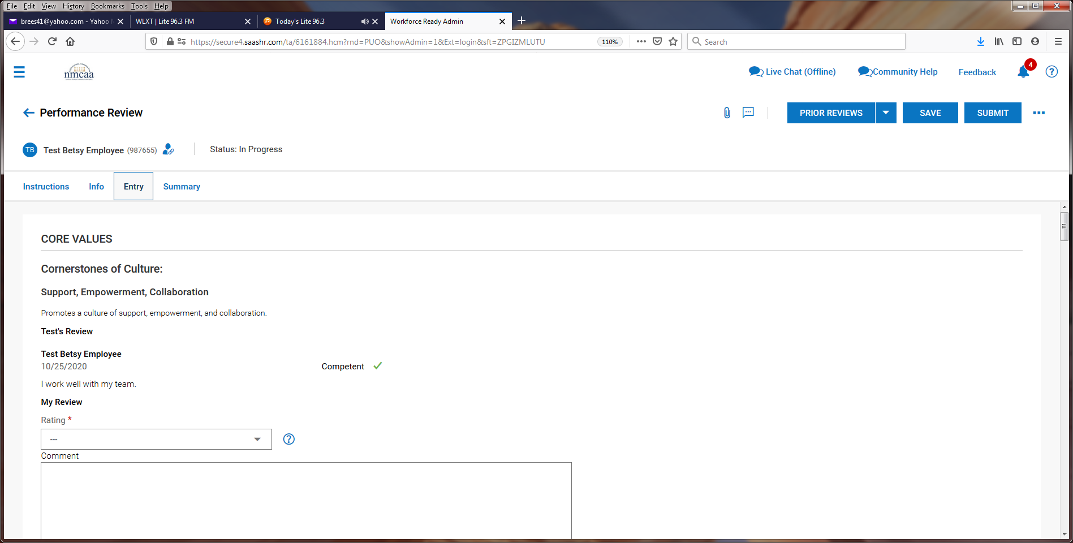
*** After reviewing the employee’s information, the supervisor may choose to proceed with their entries or “reject” the evaluation, which sends the evaluation back to the employee. This may need to occur if the employee missed a rating, did not complete the “comments” section, etc.
- The supervisor then enters their rating (Competent or Focus Area) and comments that they have for the employee.
*** It is recommended to “SAVE” progress after completing each section.
- This process is repeated for each of the other four areas for the Cornerstones of Culture.

- The Supervisor will complete the remaining areas just like the employee did for the evaluation.
- Supervisor’s Recommendations: Select the appropriate response from the drop-down box and add comments.

- Goals may be added now or after meeting with the employee. Click on “+ Add Goal” to add a goal.
- The final section can be used for General Comments but is not required.

- Once entry is complete, click on “SAVE” and then “SUBMIT.” The evaluation is then sent to the Supervisor’s Supervisor for review.
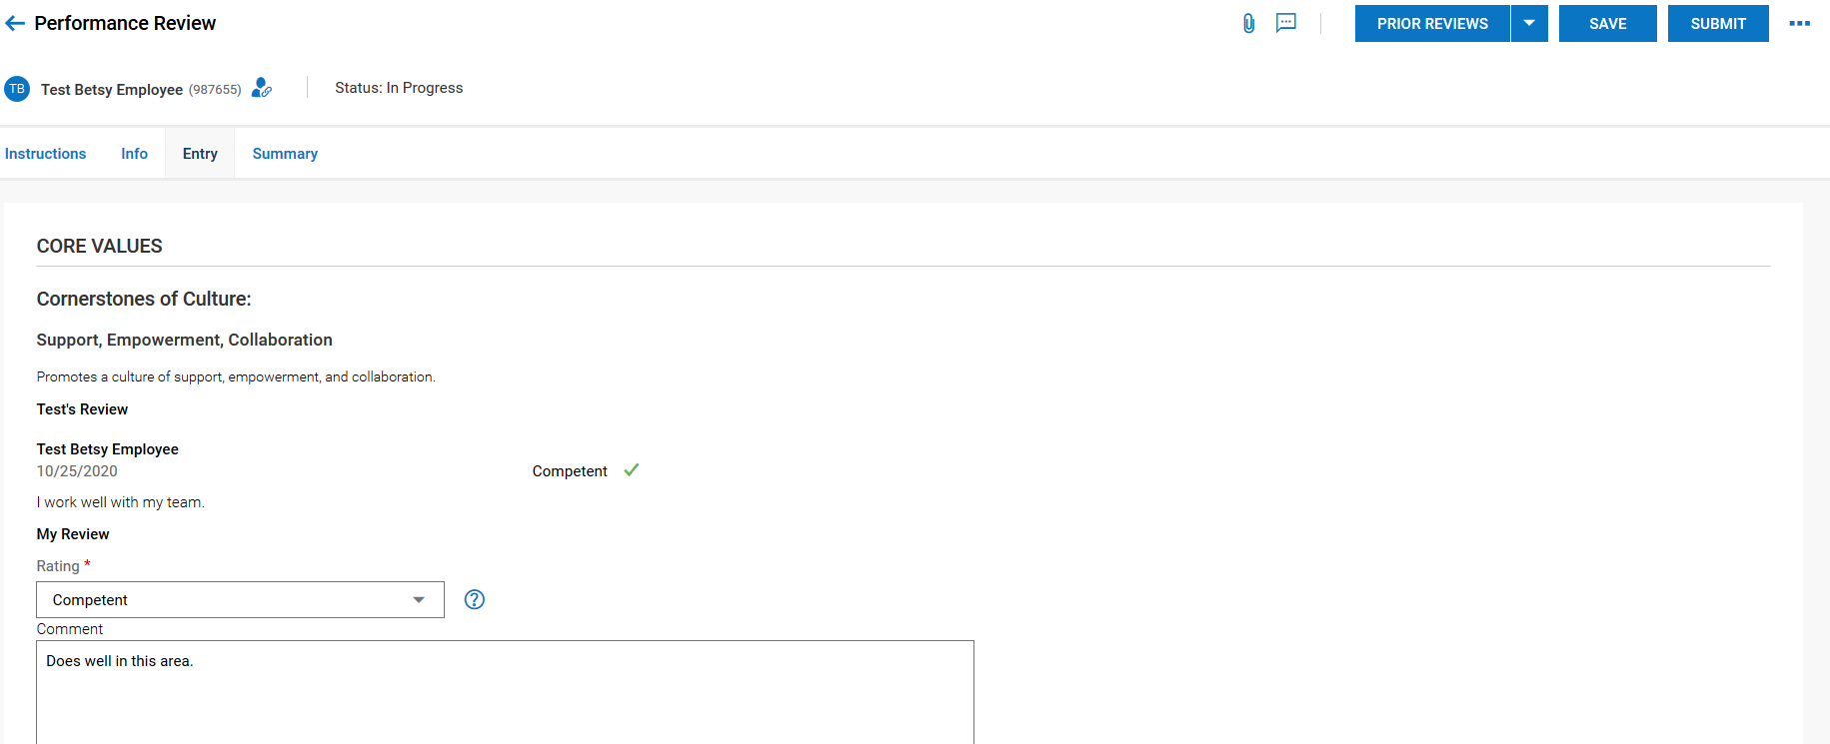
- Supervisor 2 will then receive a To Do Item to review the employee’s evaluation. Click on “REVIEW” to begin.
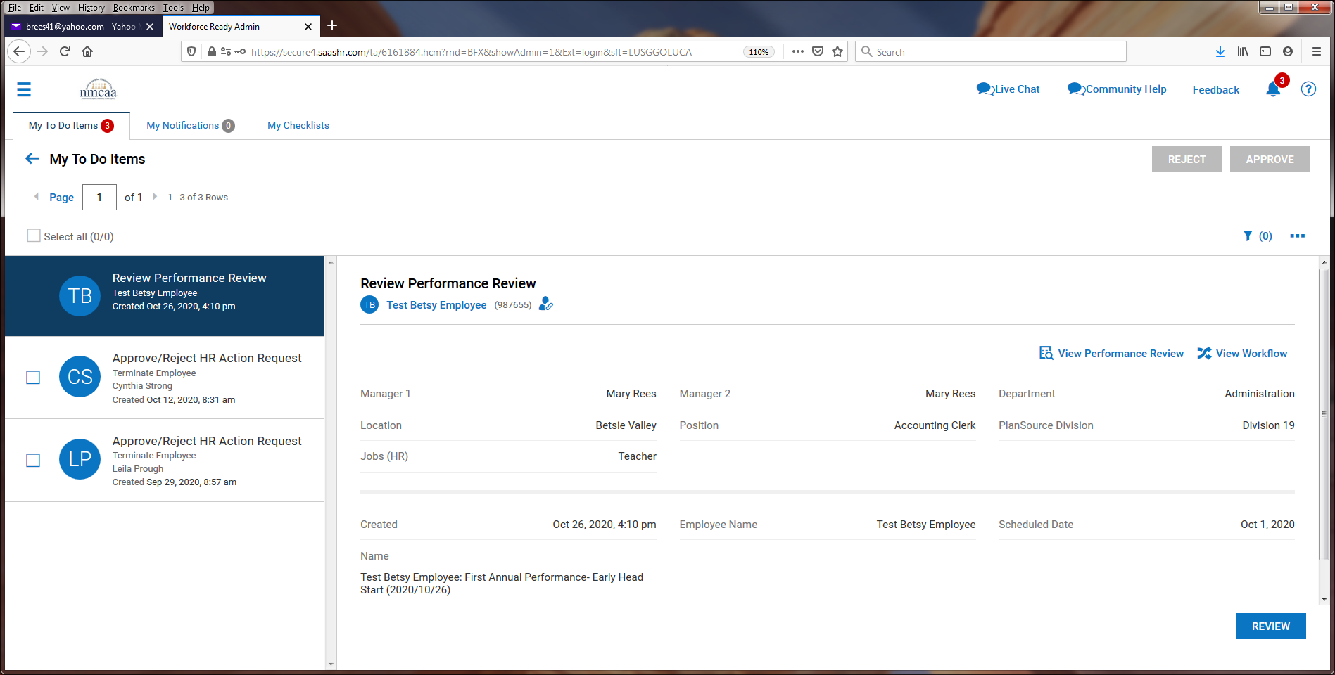

- The next screen will have instructions to review and the “Entry” tab should be clicked to begin.
- The next screen shows the responses by the employee and Supervisor 1. Supervisor 2 MAY add entries if they like. After review, click on “SAVE” and then “SUBMIT.” ** Supervisor 2 may choose to “reject” the evaluation after review, which will send the evaluation back to Supervisor 1 for any needed changes.
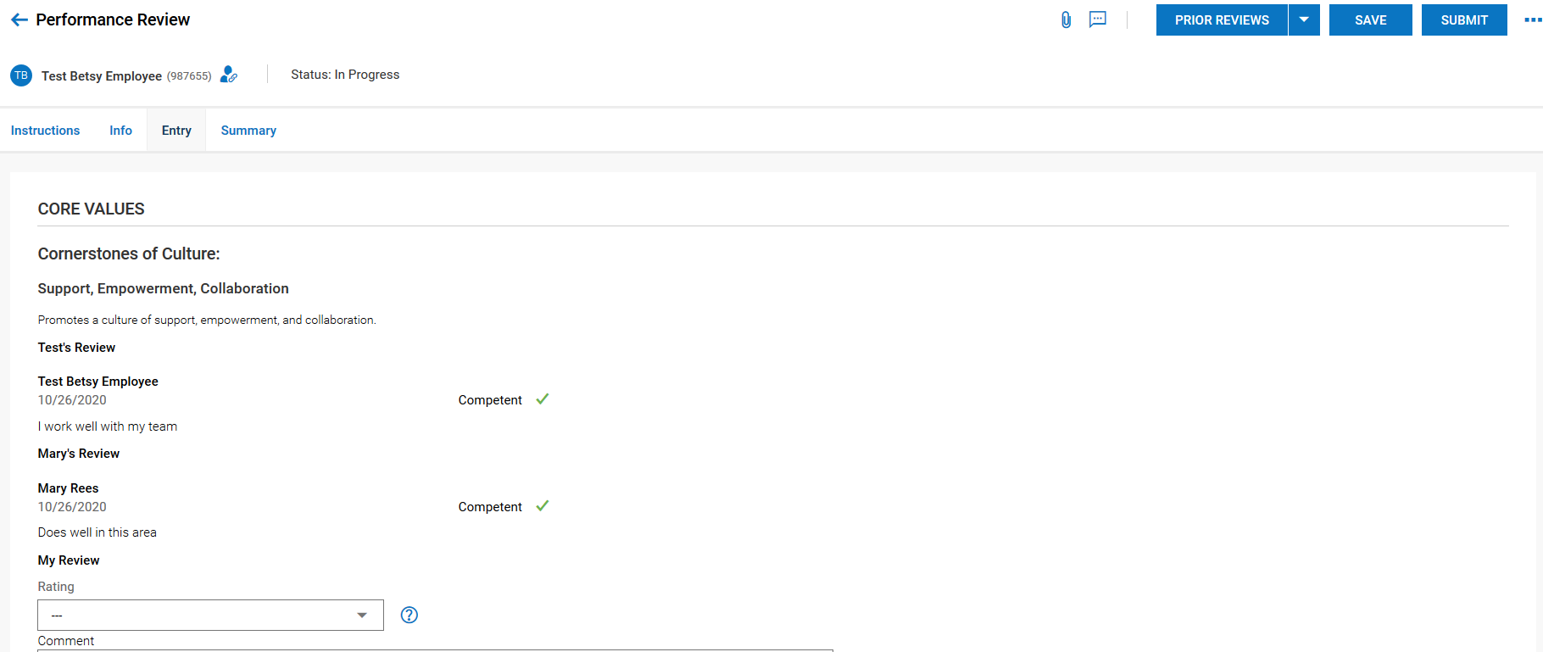
- Once this is complete, the evaluation goes back to Supervisor 1 and they receive this notification with instructions:
- The supervisor meets with the employee to present the review. Following (or during) the presentation, the supervisor proceeds to the To Do Item by clicking on “COMMENT.”
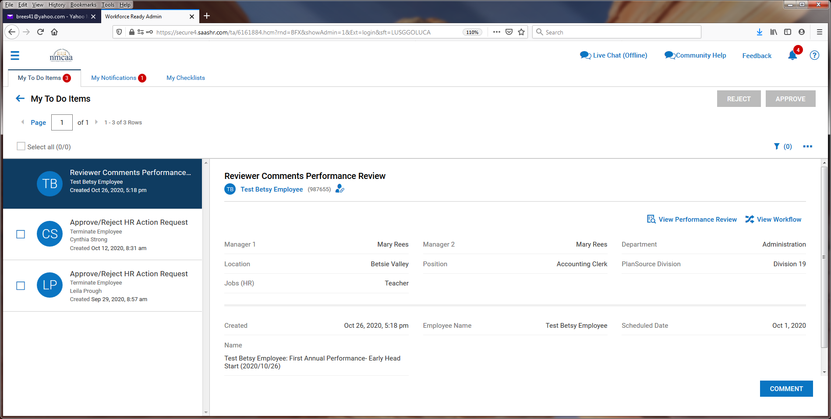

- Supervisor 2’s comments can now be seen (probably will not be many, if any) and goals can added by clicking on “+ Add Goal.”
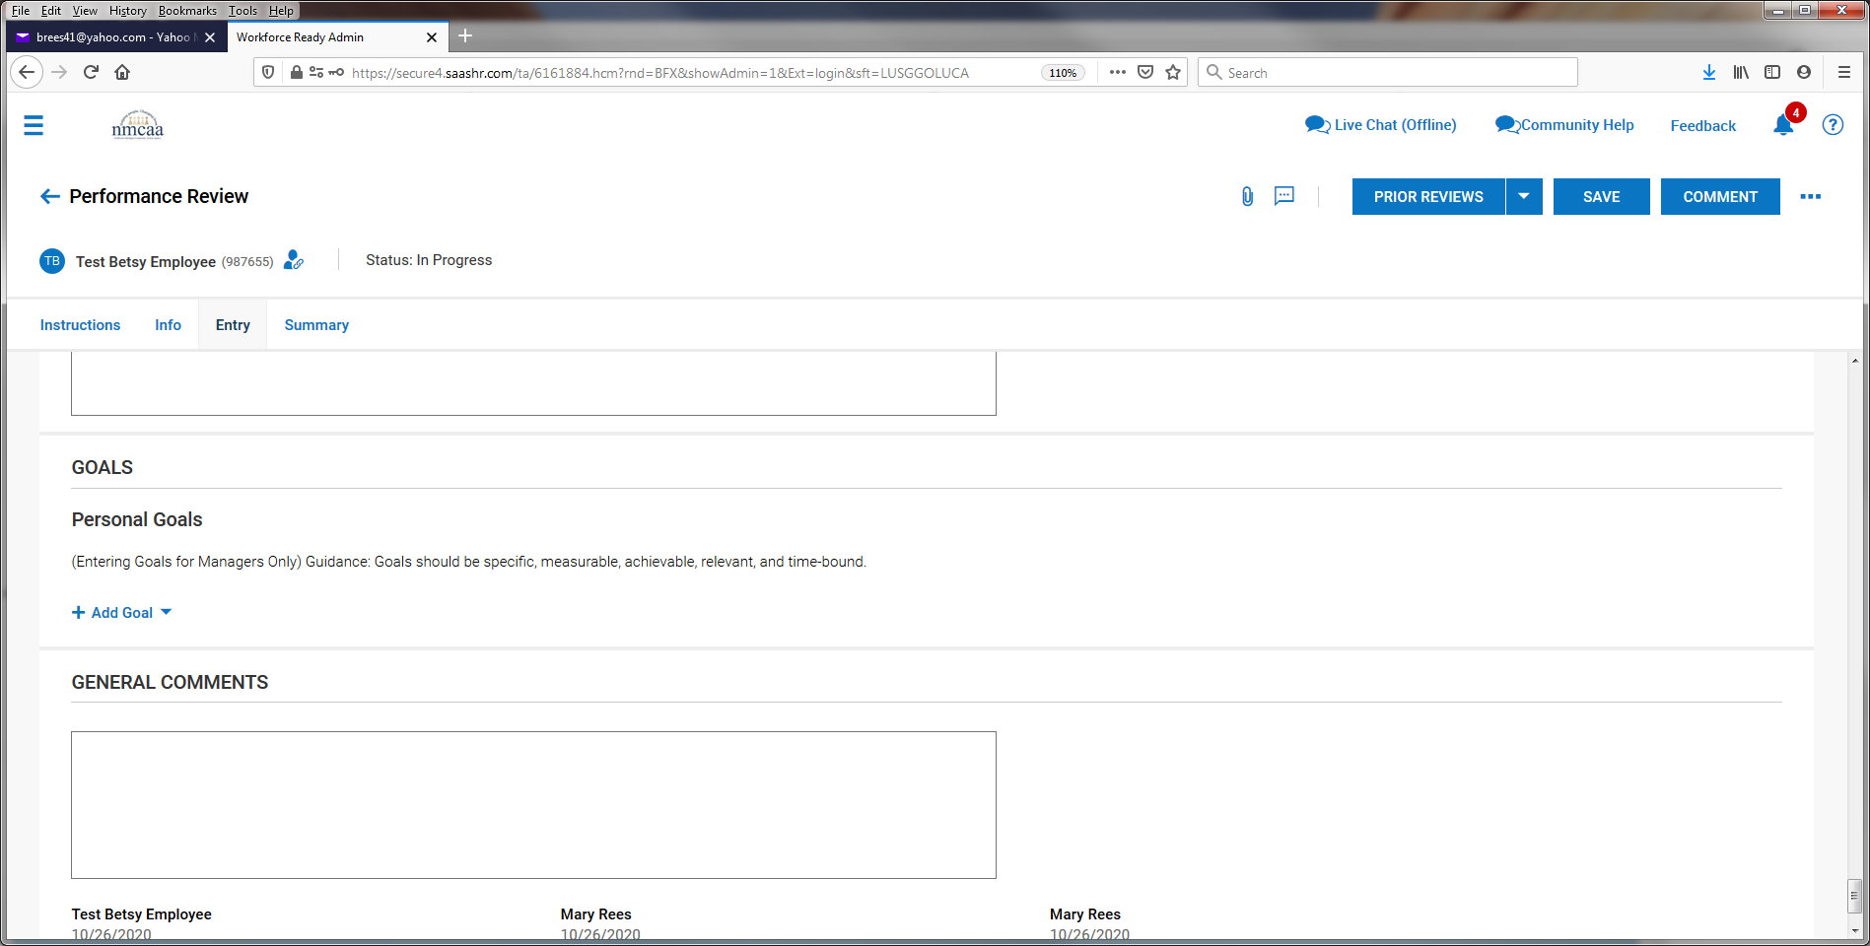

- Enter in the goal information and “SAVE.” Repeat for additional goals.
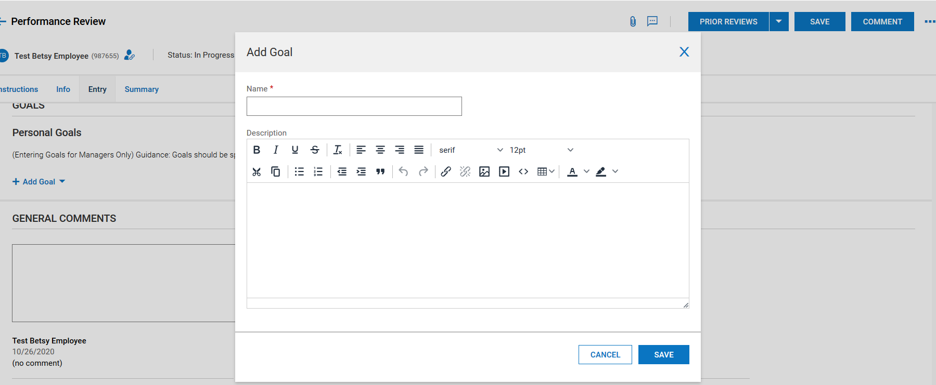
- Goals will then display, and general comments can be added. When finished, click on “SAVE.”
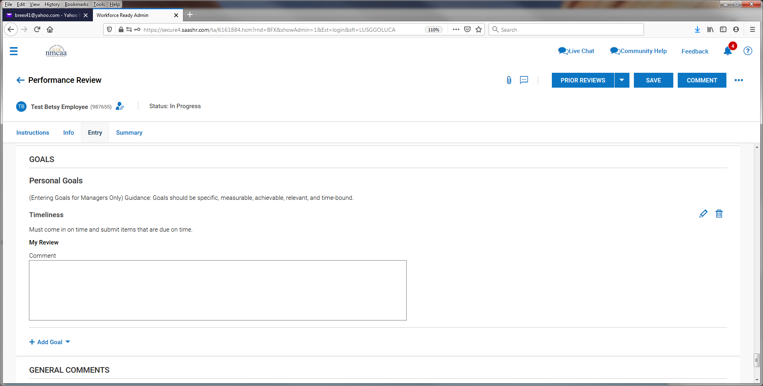

- After saving, click on “COMMENT” and then click on “YES.”
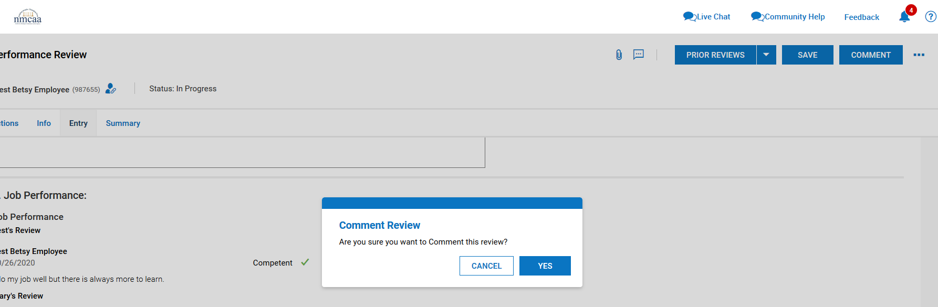
- Click on the “SUMMARY” tab and then “SUBMIT.”
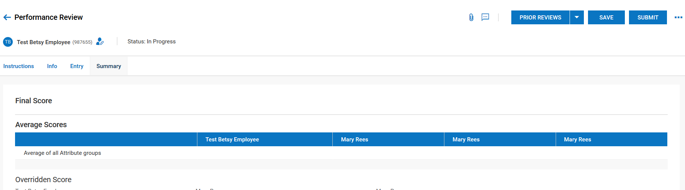
- Click “YES” to submit the evaluation. Once submitted, it will send the evaluation back to the employee to sign.

- After the employee has electronically signed their evaluation, Supervisor 1 will receive this notification and click on “To Do Items” to proceed:
- From the To Do List, the Supervisor clicks on “FINALIZE.”
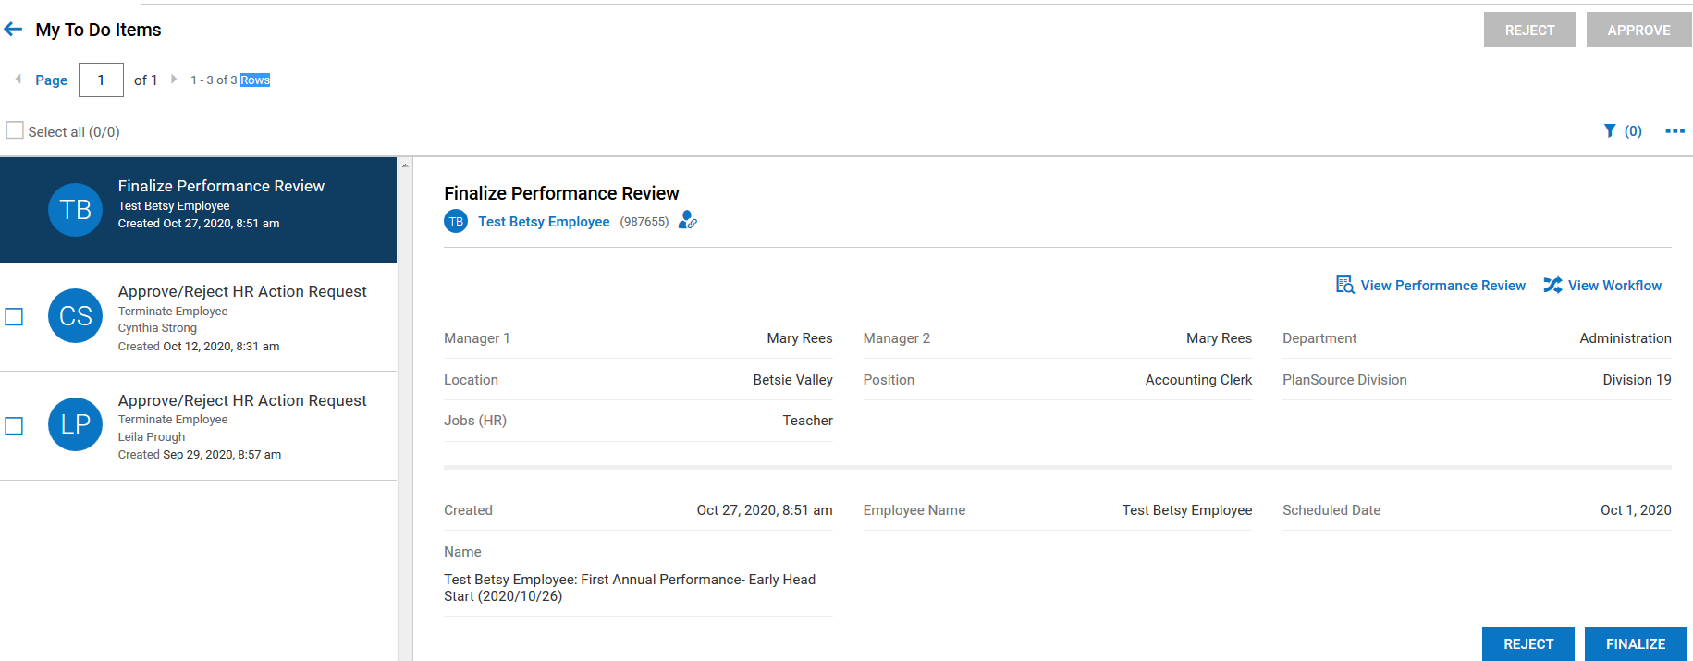
- From this screen the Supervisor will click on “Summary.”
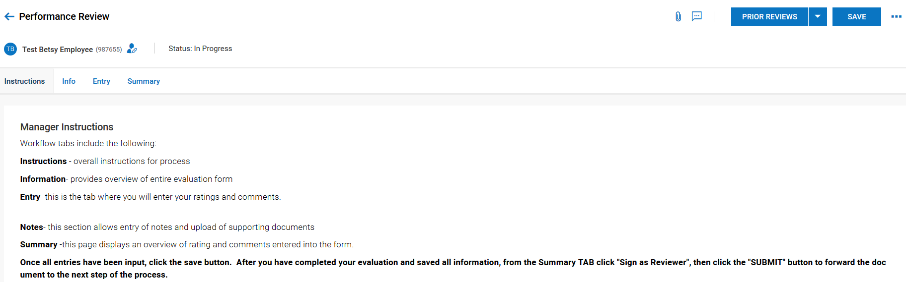

- If the Supervisor wants a copy of the evaluation, they can click on the 3 dots to download the document and print it out or save it.
- To sign the evaluation, they click on “SIGN AS FINALIZER.”
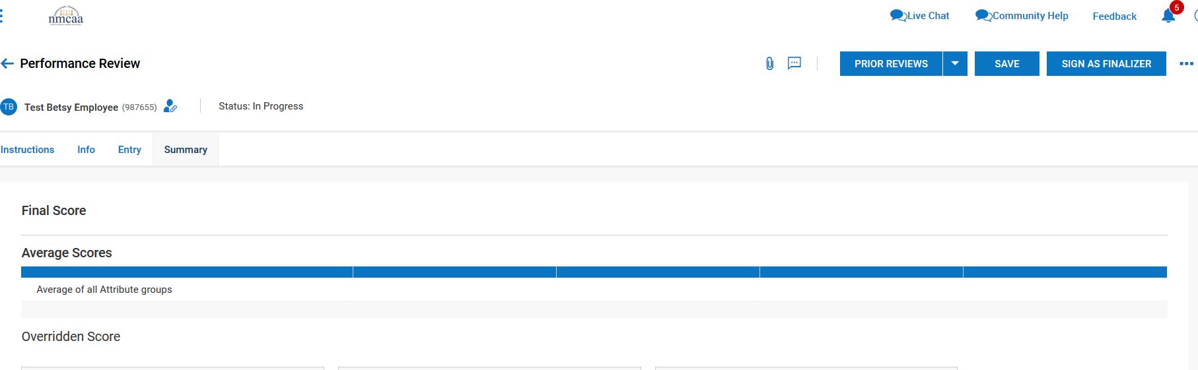
- The Supervisor will electronically sign the evaluation by entering their UKG password and clicking on “I AGREE.”

- Then click on the 3 dots and click on “Finalize.”
- Click on “YES.”
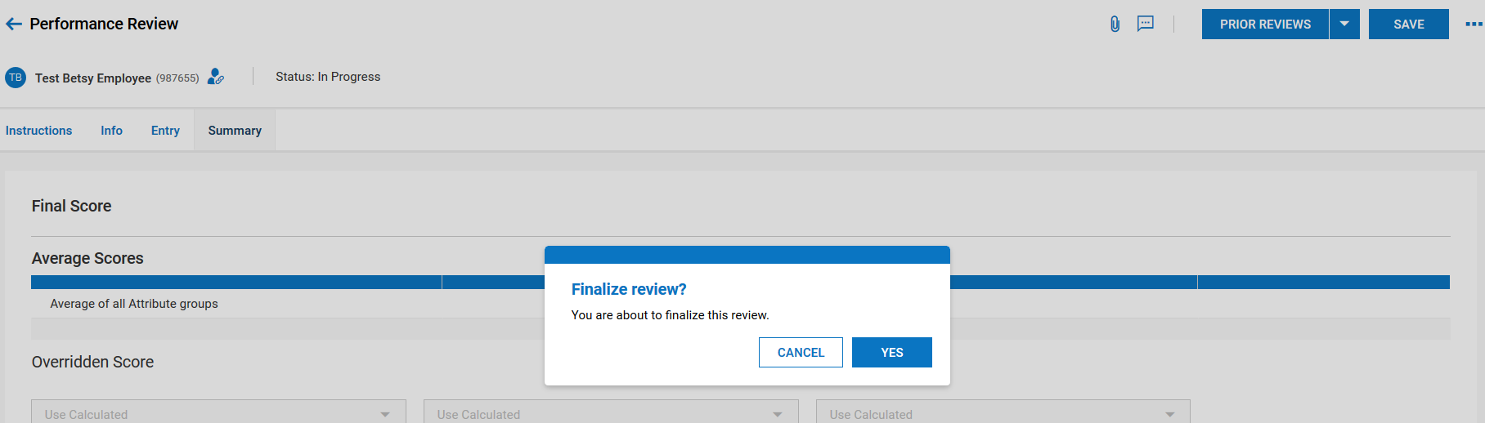
- Supervisor will receive a notification that the evaluation has been finalized.

Employee Performance Review Template

Review Type: ☐ Annual Review ☐ Training Review
Performance Review for: Enter Employee’s Name Date: Date of Review
Reviewed by: Enter Reviewer’s Name
Cornerstones of Culture | Competent | Focus Area
- Promotes a culture of support, empowerment, and collaboration. | ☐ | ☐
Enter comments here.
- Respect, appreciate, and celebrate each other’s differences. | ☐ | ☐
Enter comments here.
- Promote ongoing agency goals and commit to team success. | ☐ | ☐
Enter comments here.
Share ideas, be open to suggestions, and maintain a positive attitude. | ☐ | ☐
Enter comments here.
- Be professional, honest, and sincere to help create a trusting work environment. | ☐ | ☐
Enter comments here.

Working Habits | Competent | Focus Area
- Punctual when maintaining work hours? | ☐ | ☐
Enter comments here.
- Assignments completed in a timely manner? | ☐ | ☐
Enter comments here.
- Able to self-direct workload? | ☐ | ☐
Enter comments here.
Job Performance:
Select one:
☐ Proficient: Results are very good. Significant contributions to objectives of department.
☐ Competent: Results are good. Performance is consistence with expectations. No areas of concern.
☐ Developing: Results show progression towards job performance expectations. More experience needed.
☐ Needs Improvement: Several areas of performance require additional training.
☐ Unacceptable: Performance does not meet expectations.
Enter comments here.

Personal Goal Guidance: Goals should be specific, measurable, achievable, relevant, and time bound.
GOAL:
Enter goal here.
GOAL:
Enter goal here.
GOAL:
Enter goal here.
GOAL:
Enter goal here.

Staff Signature: Enter signature. | Date: Pick a date.
Supervisor Signature: Enter signature. | Date: Pick a date.
Director/Manager Signature: Enter signature. | Date: Pick a date.

Distribution: Copy/Paste into UKG Performance Review
04/2021 P:/Agency/Human Resources/Supervisors Manual/Tab 4 – Evaluations, Work-Support Plan, Disciplinary Documentation
BUS DRIVER REVIEW CHECKLIST

Bus Driver Name: ________________________________________________________________

Center: _______________________________________ Date: __________________________

Review the following job responsibilities and check any items to be focused on to facilitate individual professional growth and enhance program quality. Attach to NMCAA Evaluation for drivers in their training period (three times during a school year/every 90 days). For experienced drivers, the checklist will be completed two times a year, with the second checklist accompanying the NMCAA Annual Performance Review.
Item(s) Reviewed | Focus for Growth | Specific Job Responsibilities
 |  | Ability to meet school bus driver certification requirements.
 |  | Ability to obtain a Commercial Driver License with an S endorsement.
 |  | Have no more than 6 active points on license.
 |  | Ability to meet Department of Education Physical examination requirements.
 |  | Ability to meet Department of Education competency levels of driving skills. Including the completion and maintenance of Michigan Department of Education Bus Driver Certification.
 |  | Meet Federal Department of Transportation drug/alcohol requirements.
 |  | Complete other training as required. (Including CPR and First Aid).
Job Responsibilities
Flexible hours may be required to accomplish the duties/responsibilities described below:
 |  | Performance Abilities:
 |  | Experience and comfort in operating a vehicle while transporting children.
 |  | Familiarity with the geographic service areas.
 |  | Knowledge of local, state and federal rules, regulations, ordinances and laws regarding school bus operation.
 |  | Alert and able to exercise good judgment concerning emergencies, disabled vehicles and abnormal driving conditions.
 |  | Uphold NMCAA, Motor Vehicle and Head Start vehicle and passenger rules and regulations.

Item(s) Reviewed | Focus for Growth | Job Responsibilities  Flexible hours may be required to accomplish the duties/responsibilities described below:
 |  | Recordkeeping:
 |  | Assist in planning and scheduling of bus routes and maintaining a daily schedule.
 |  | Responsible for the daily and regularly scheduled vehicle maintenance as recommended by the manufacturer or agency policy and procedures.
 |  | Maintain accurate records of vehicle operations. Submit the Daily Inspection Form to the Director of Operations on a weekly basis.
 |  | Inform the teacher of any child absences and reasons why (if known).
 |  | Conduct a minimum of 3 emergency evacuation drills and submit documentation to the Director of Operations.
 |  | Report vehicle and/or student accidents/injuries to the Director of Operations and his/her designee, and complete the appropriate form(s).
Job Responsibilities
Flexible hours may be required to accomplish the duties/responsibilities described below:
 |  | Drive safely and defensively at all times.
 |  | Daily communication with the center teacher staff regarding bus activities and concerns.
 |  | Attend parent meetings when requested by the Director of Operations or his/her designee.
 |  | Maintain acceptable communications with the Director of Operations, Center staff, parents and the public.
 |  | Exhibit a positive image as a representative of the NMCAA Head Start program.
 |  | Ensure that all passengers are secured in seat belts or restraint systems as necessary.
 |  | Ensure the no children are left unattended on the bus at any time. Must conduct a complete walk through on the bus at the end of each run.
 |  | Arrange for a sub bus attendant if necessary.
 |  | Act as a Liaison between parents and the center, and promote positive involvement in the program.
 |  | Be available for scheduled field trips and center meetings.
 |  | Adhere to the NMCAA Guidance Policy and implement positive behavior management techniques.
 |  | Adhere to NMCAA Confidentiality Policy at all times.
 |  | Adhere to the scheduled work hours as required.
 |  | Meet as requested with supervisor for evaluation of job performance.
 |  | Perform other duties as assigned.

YES | NO | THE FOLLOWING MUST BE COMPLETED WHILE  OBSERVING THE DRIVER DURING A RUN
 |  | All objects on board are secured (First Aid Kit, fuses, clipboard, children’s backpacks, toys, etc.)
All required emergency equipment is on board and secured:

First Aid Kit: Contains only the following items: (2) 4” bandage compress, (2) 2” bandage compress, (2) 1” bandage compress, (1) 40” triangle bandage with 2 safety pins, (1) roll gauze, (1) 3” elastic bandage.

 |  | Fire Extinguisher: minimum 2A-10
 |  | Fuses / Flares: 3
 |  | Triangles: 3
 |  | Seat Belt Cutter
 |  | Complies with all applicable driving laws:
 |  | Correct use of “red lights”.
 |  | Stops at all railroad crossings.
 |  | Other:

Teacher Signature: _______________________________________________ Date:___________

Bus Drive Signature: ______________________________________________ Date:___________

Director of Operations Signature: ____________________________________ Date:___________

Comments:

Distribution: Original: Director of Operations Copies: Driver’s classroom file, Site Supervisor, and HR Director
03/2021 P:/Agency/Human Resources/Supervisors Manual/Tab 4 – Evaluations, Work-Support Plan, Disciplinary Documentation/CFD

