EMPLOYEE HIRING PAPERWORK IN KRONOS
- Submit the Employment Papers Request form which is located at P:Agency/formsforagency/employmentpaperserquest to Human Resources. One change to how this was done before Kronos is to obtain the new employee’s SSN (All areas except Child Development)
- Human Resources will “hire” the new employee in Kronos, advise IT to set up email, and notify the Business Office of the new Hire. DMT will also be notified for Head Start/Early Head Start.
- An Email will be sent to the new hire and their supervisor with information on how to login to Kronos. Their Offer Letter of Employment is also attached to this email. The letter should be signed and returned to Human Resources as soon as possible. Scan to email is acceptable.

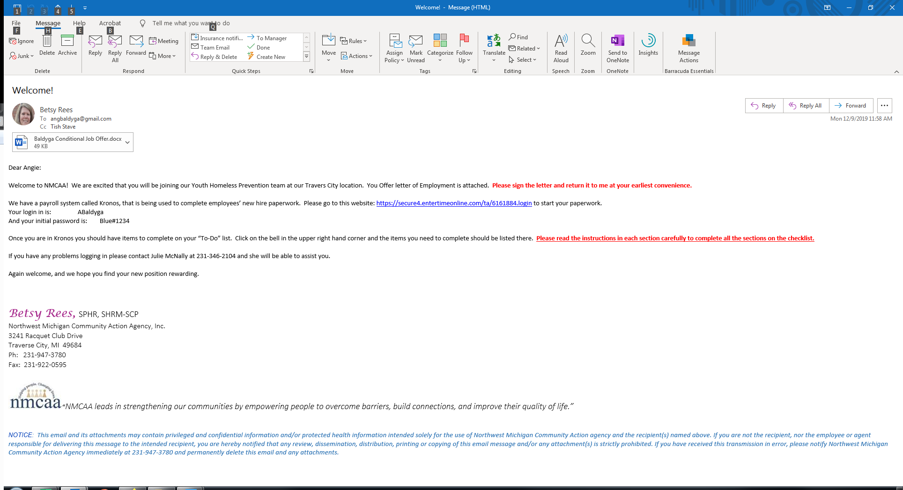

Once the new employee has logged in to Kronos, they will be able to continue to their To-Do list by selecting the bell in the upper right-hand corner.
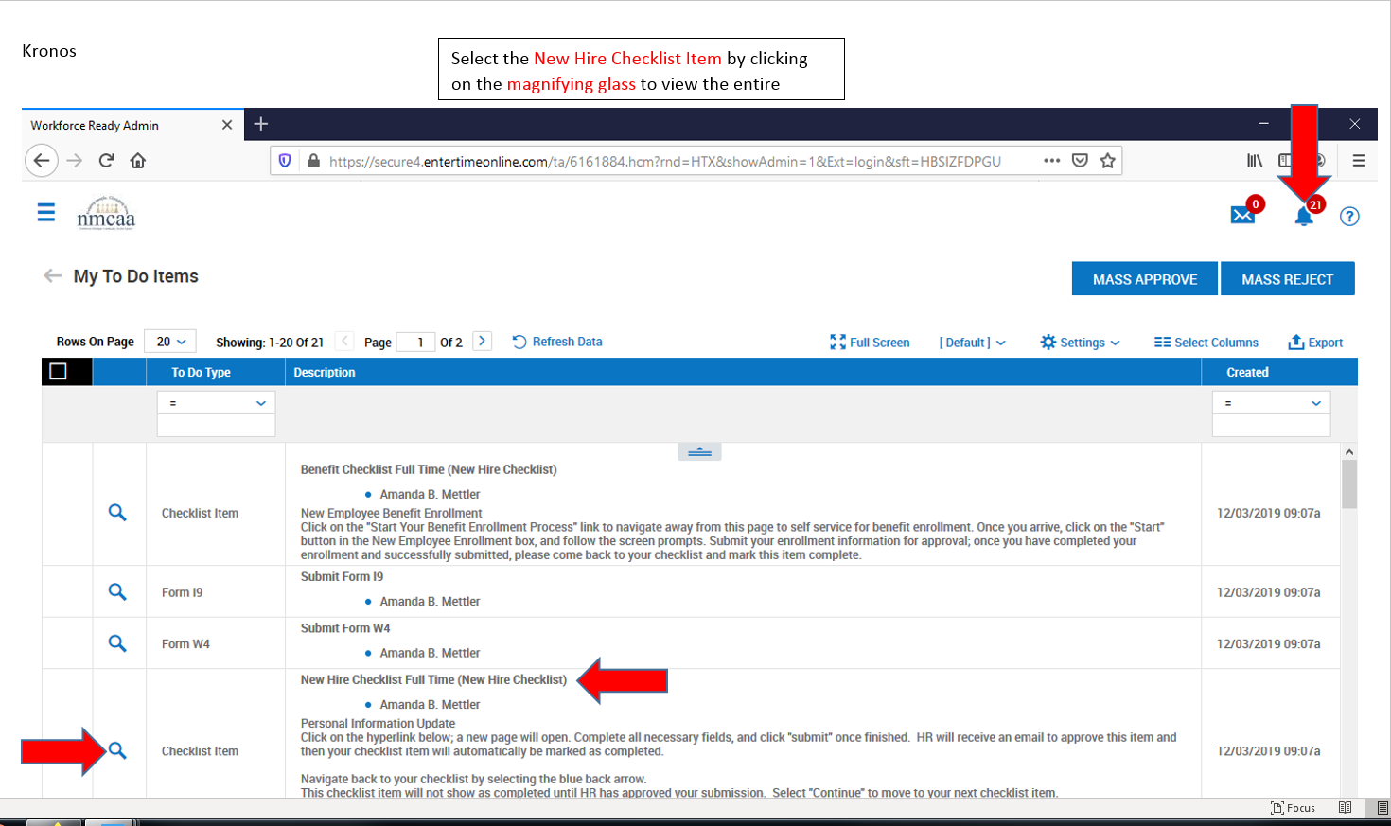

The Employees’s Checklist will contain between 16 and 19 items to complete depending if they are fulltime or part time or Child development or bus drivers or all other departments.
ALL employees will have: FT or PT Employees eligible for Benefits:
Personal Information Update New Employee Benefit Enrollment
I-9
Federal Withholding
State Withholding
Direct Deposit FT or PT Employees for Child Development:
Review of Personnel Policies Hebatitis B Vaccination
Personnel Policies acknowledgement
Cell Phone Policiy Sign off
Email Use Instructions Sign off
OMB document for FT or PT (ACA required) Bus Drivers:
Section 125 Plan description Vehicle Operator Certification
403(b) Agreement for Salary Reduction
403(b) Instructions
403(b) Summary Plan Description403(b) TIAA Investment OptionsNMCAA Orientation
Personal information Updates – The new hire will first select the “Personal Information” and make any needed changes. Save and submit
Then the “Account Contacts” is selected to add the new hire’s emergency contact information, Dependents, and/or Beneficiaries. It is VERY beneficial to add these contacts at this time especially for full time employees who will have beneficiaries for their Life Insurance and dependents for medical, dental, or vision insurance. Click on the “Add” button and add the contact information. See next page.

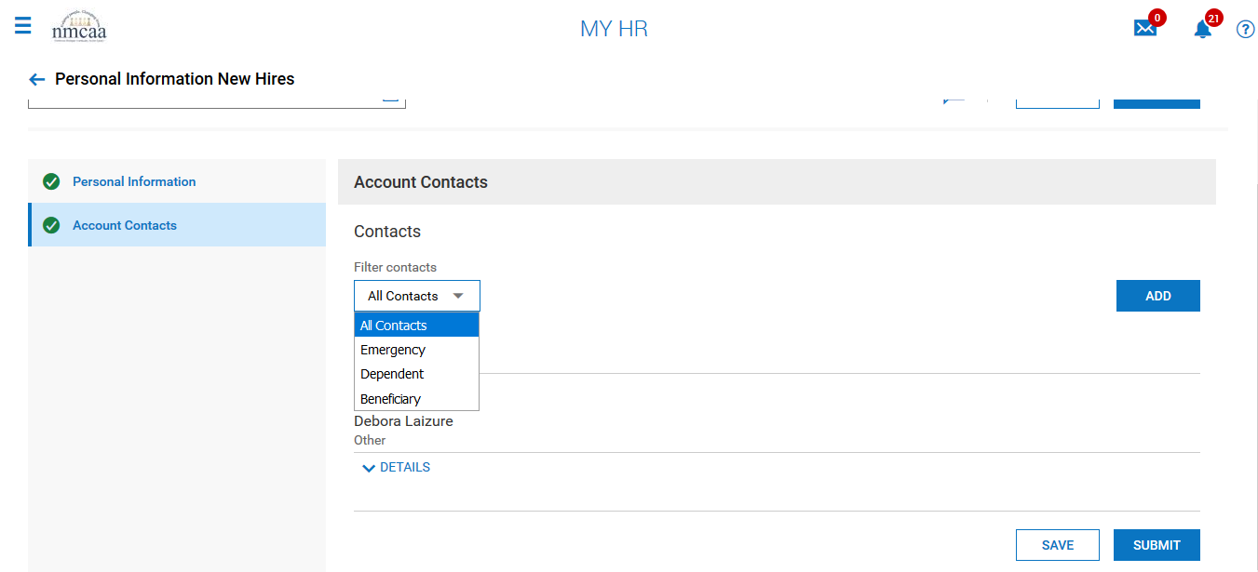

Select the appropriate boxes across the top of the entry screen for each contact added. The contact’s SSN and DOV will also need to be added for dependents that will be added to medical, dental, and/or vision policies.

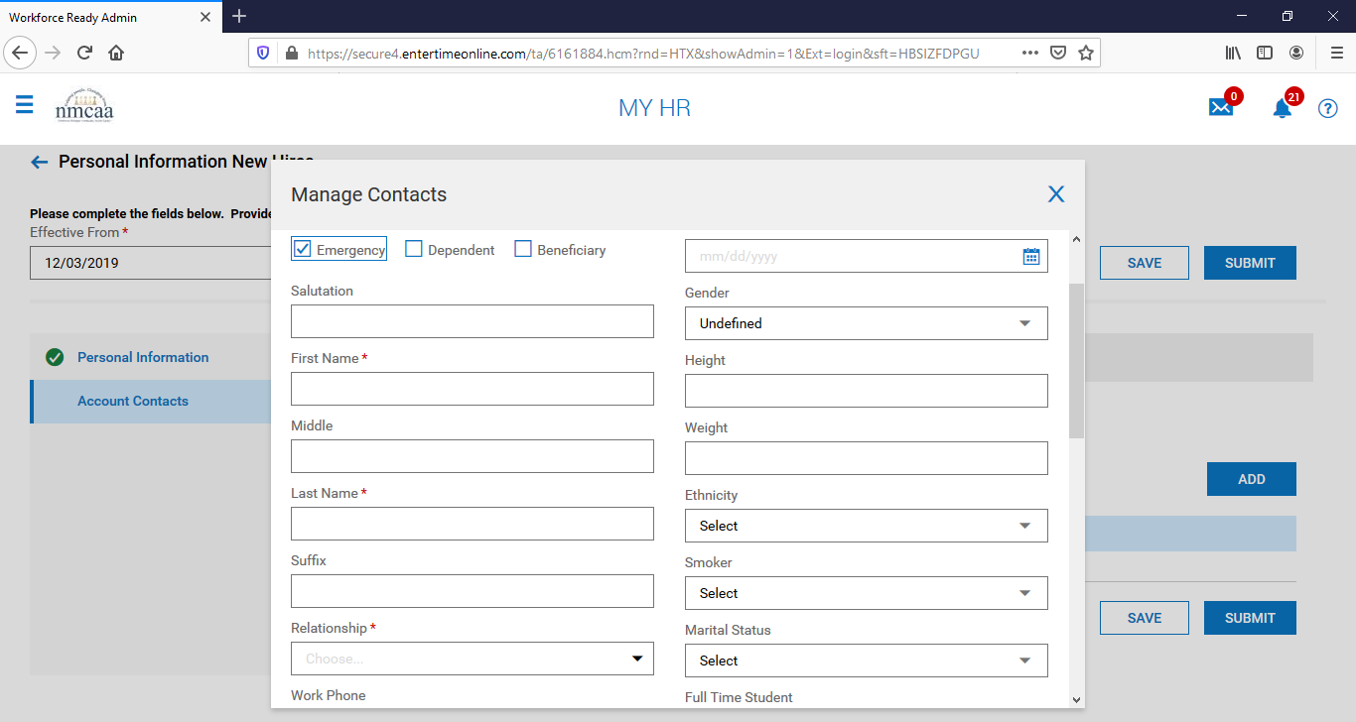

Once the information is completed, save and submit the contact. Added additional contacts as required. Navigate back to the checklist by selecting the blue back arrow. The checklist item “Personal Information Update” will not show completed until HR has approved the submission. Select “continue” to move to the next checklist item.

Complete Form I-9 – When selected to complete, the top of the I-9 will populate with the employee’s information. They should check to make sure that the information is correct and adjust as necessary. They will select either 1,2,3, or 4 by clicking on the blue circle and filling out any other required information. I most cases, number 1 is selected and that is all that needs to be completed by the employee. Once their selection has been made, they click “submit I9”.

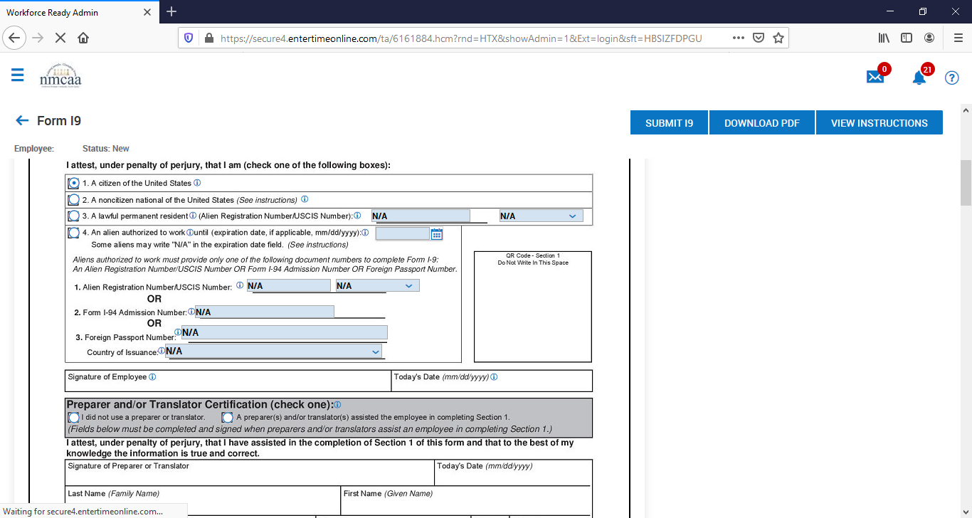

The employee will then electronically “sign” the I-9 by entering in their Kronos password. Then select “I Agree”.

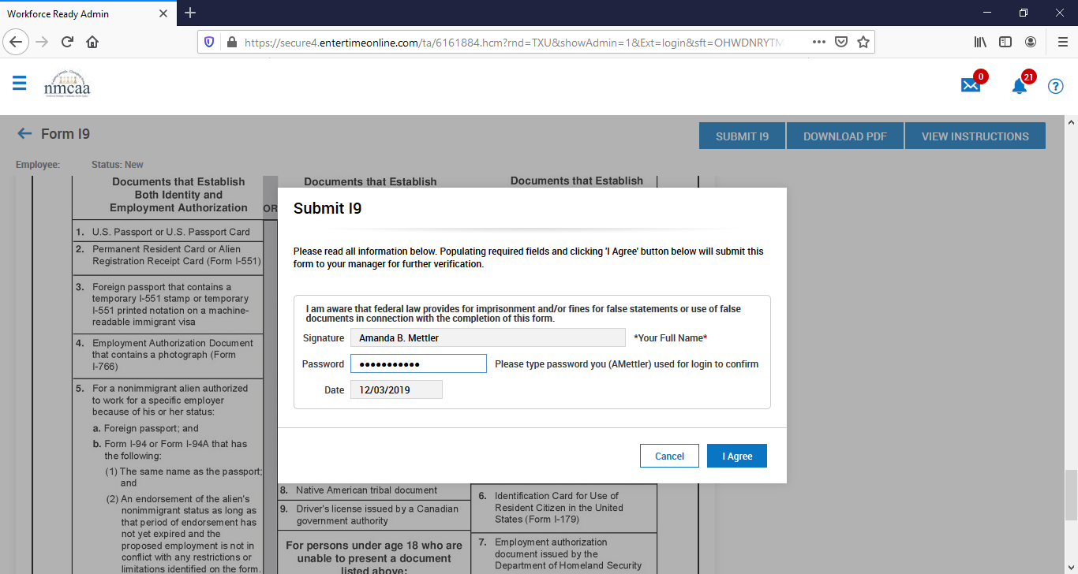

Once completed by the employee, their supervisor will receive an email requesting them to complete the I9 document for their new hire.

Dear (Supervisor’s Name),
Employee (employee’s name) who was hired on (date started) has submitted their I9. Please navigate to the new Employee's record>Forms>I9s to review the form (please make sure the DOB is correct for the employee - If the DOB is incorrect, please note the correct DOB on Page 3 under the notes box). Fill out section 2 (page 3) with the document information that has been presented by the employee. Click on the blue box on the top right "Verify (submit) I9". Enter the employee's start date and sign the document by entering your Kronos password. Once complete, open the pdf file and print page 1 and 3 and forward to HR along with a copy of the documents presented by the employee.
Thank you.
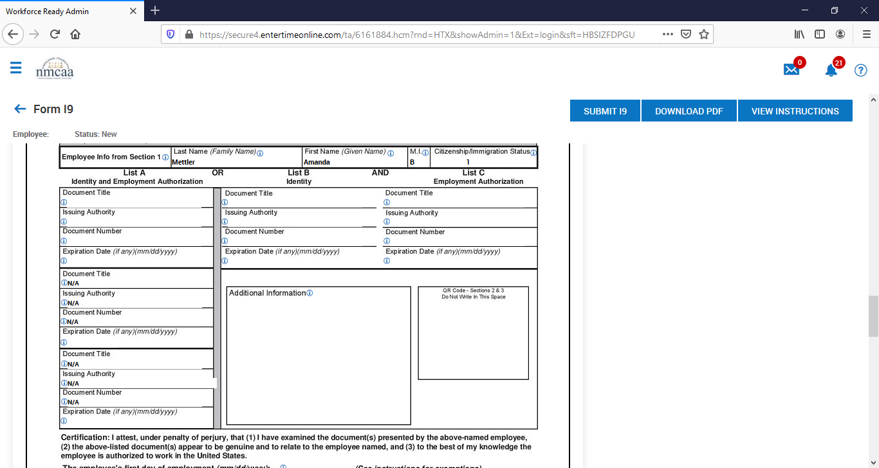
The supervisor will complete the document information from the employee by entering information from a List A document (usually a US passport) OR a List B document (usually a Driver’s License) AND a List C document (usually a Birth certificate or SSN Card). Page 4 lists the eligible documents that can be used and presented by the new employee. The I9 Checklist item will be checked off as complete once it is verified by the supervisor.
Complete Federal Withholding Form – the employee will click on the “Start Federal Withholding Form” link to start completing the form.

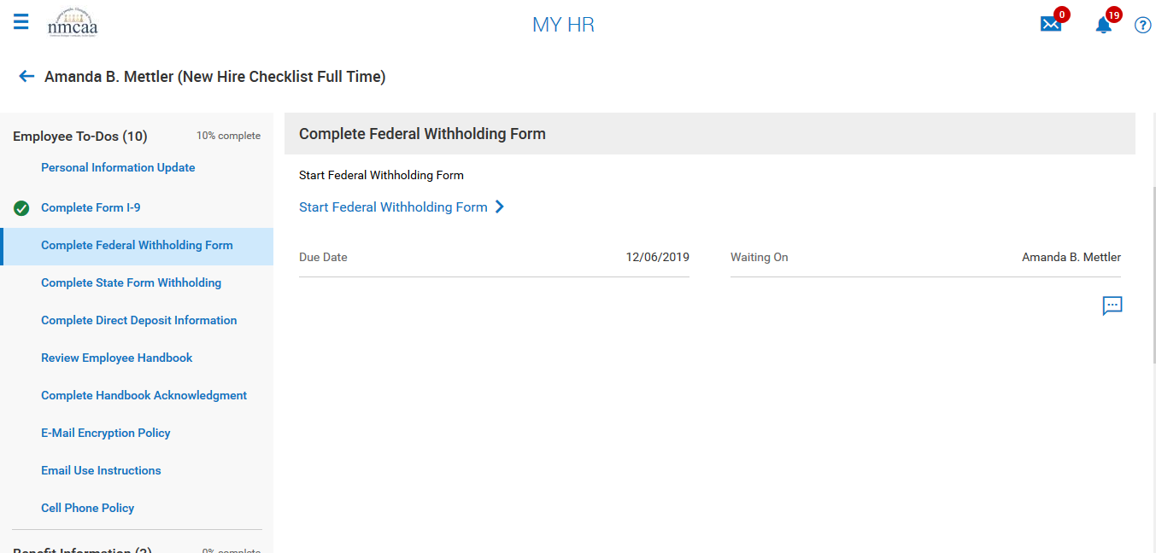

The form will populate the employee’s personal information, name, SSN, address, marital status. The employee will then enter the total number of allowances they wish to claim. When finished, the employee will submit the form and sign it electronically by entering their Kronos password.

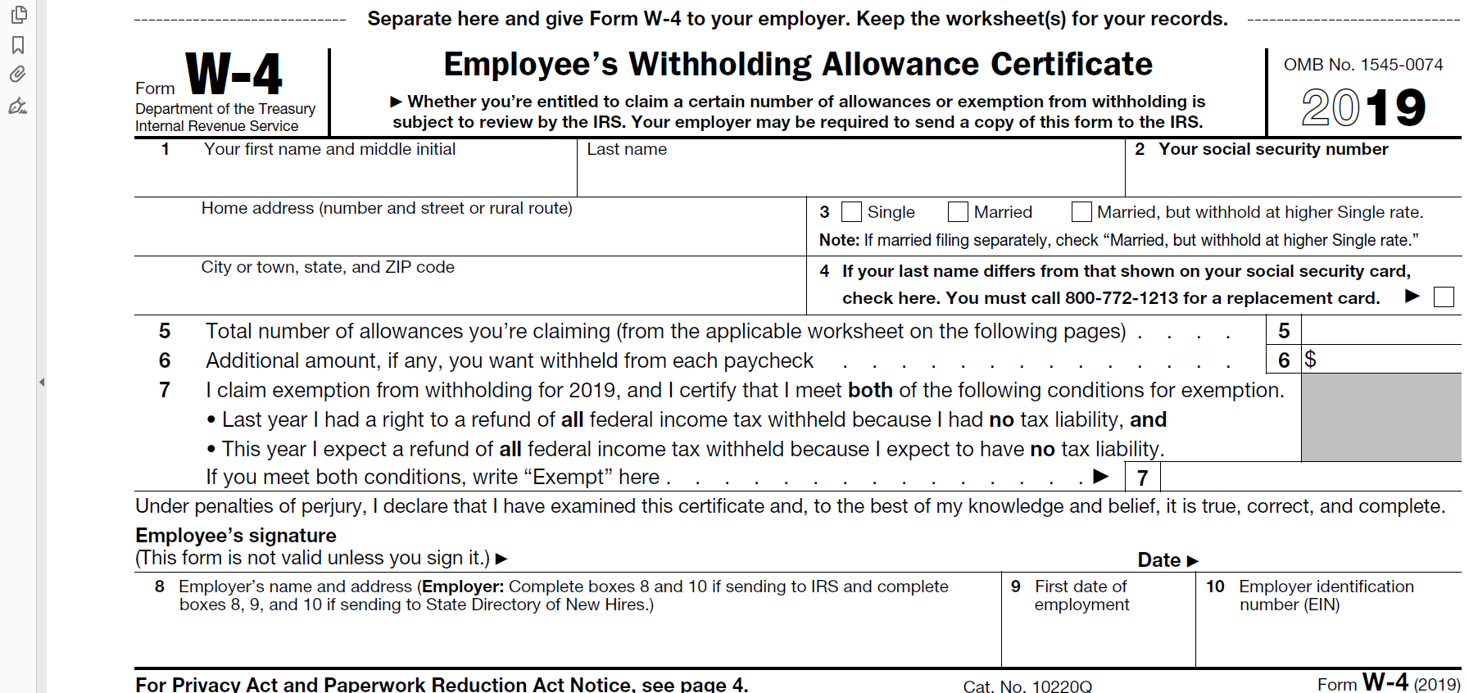

Once completed, the employee will click on the Blue back arrow at the top left to move on to the Michigan Withholding Form.

Complete State Form Withholding – the employee will complete the Michigan State Withholding Form by first clicking on the “View Your Withholding Forms”

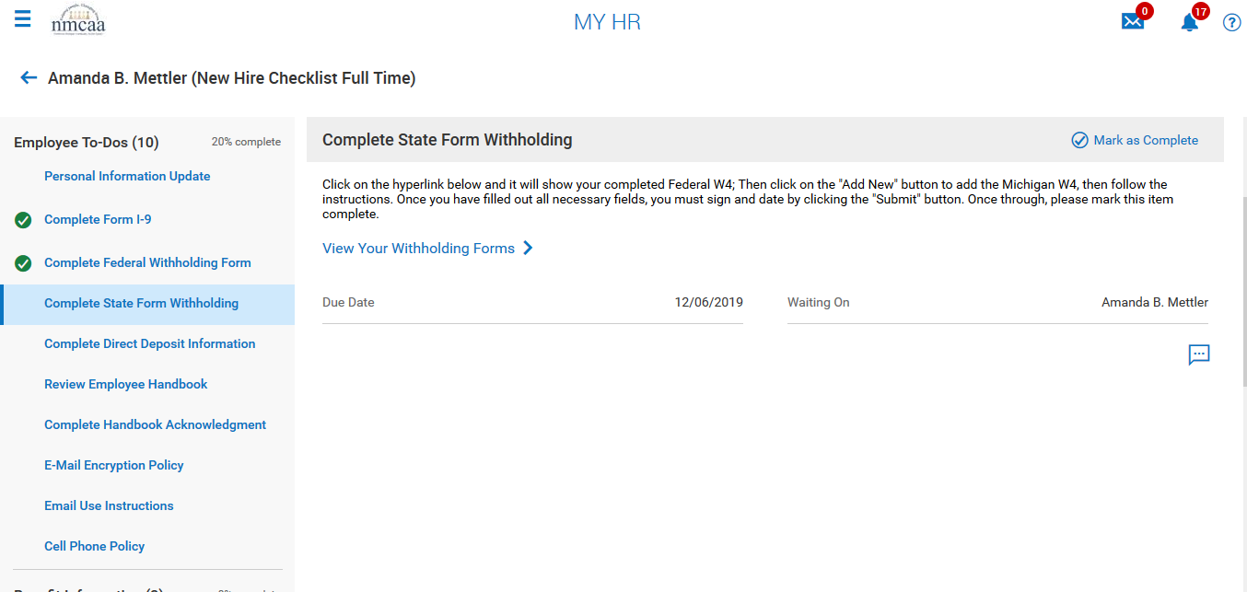

The next screen shows the already completed Federal form.
To complete the State Withholding form, the employee must click on “Add New”
Then the employee clicks on “+ Add’
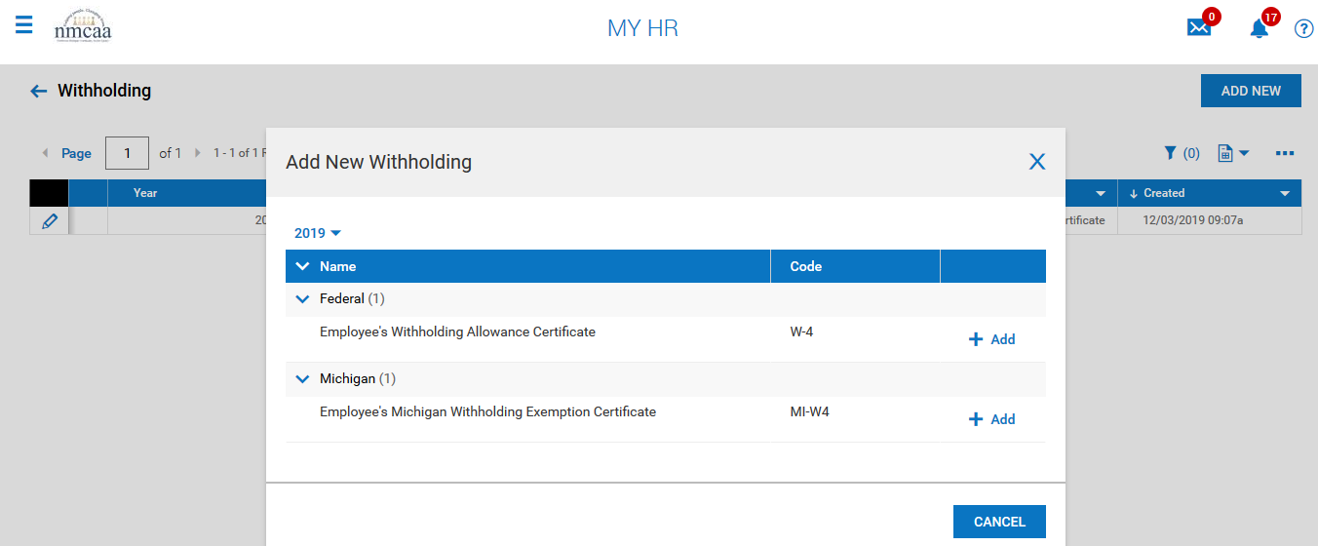
The Michigan form will be displayed and populated with the employee’s information. They will complete the form by adding their Driver’s License number, completing box 5 and entering the of personal and dependent exemptions.
The employee will then submit the form and complete it by signing it electronically. They will mark the checklist item as completed to proceed to the next item.

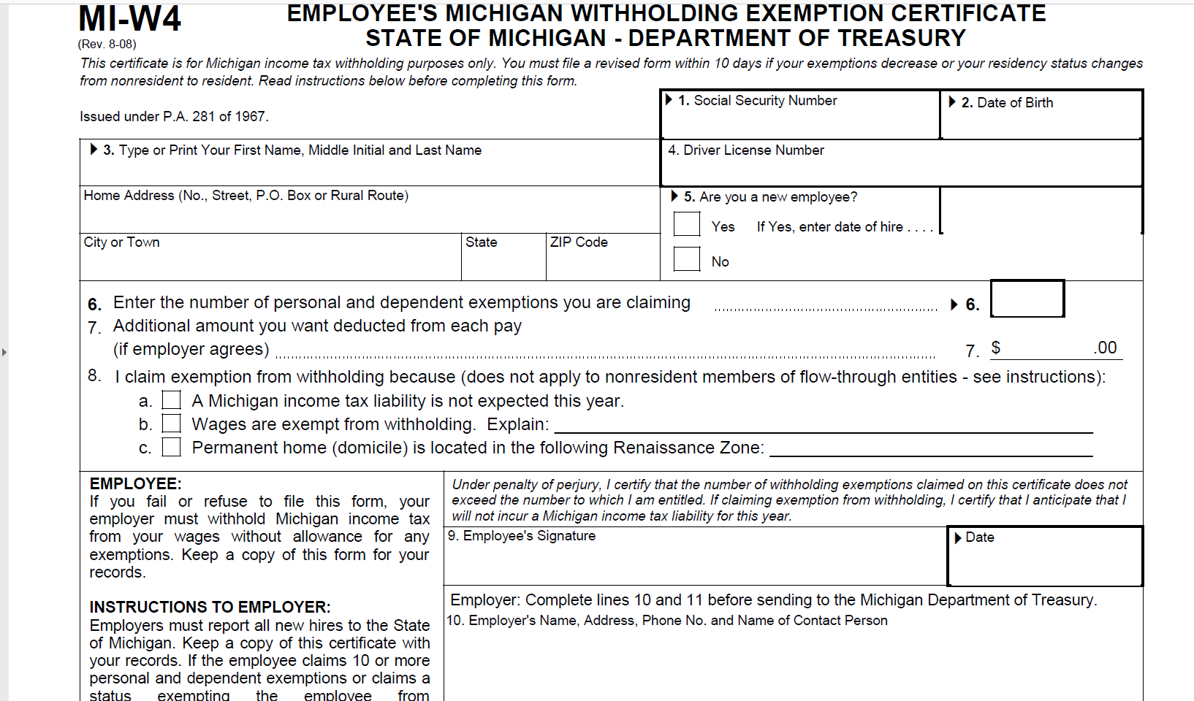

Complete Direct Deposit Information – this information must be completed by the employee and requires them to upload a document verifying the information that they have entered. HR is NOT able to enter this information.
After reading the instructions on the Direct Deposit Information, the employee clicks on “Direct Deposit Update”

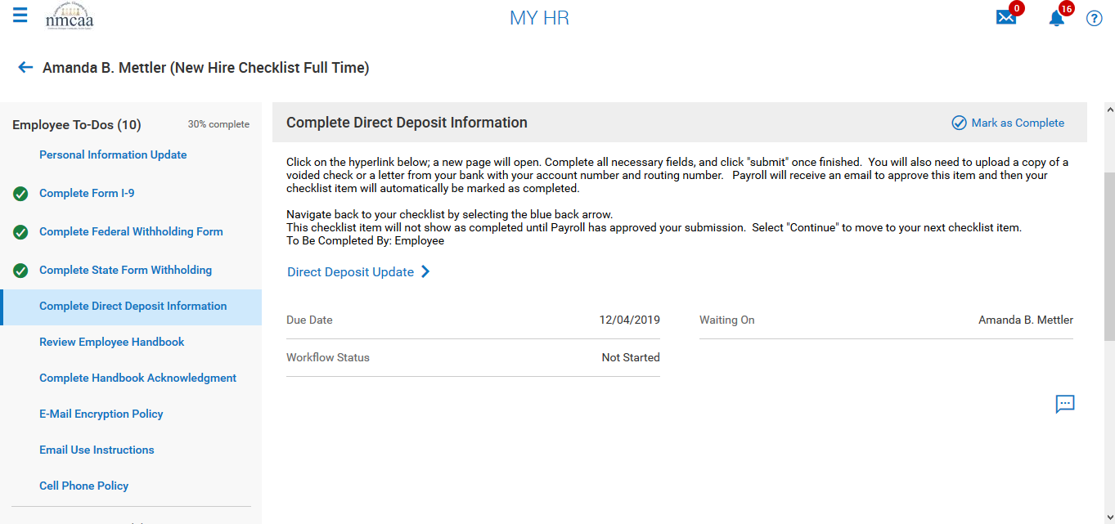

The employee will add their Direct Deposit information by clicking “+ Add”. After the information is added, they will click “save”. Additional accounts may be added by repeating the process.
The employee will then click “Continue” or they can click on “Upload Document” to add their bank information image/document.

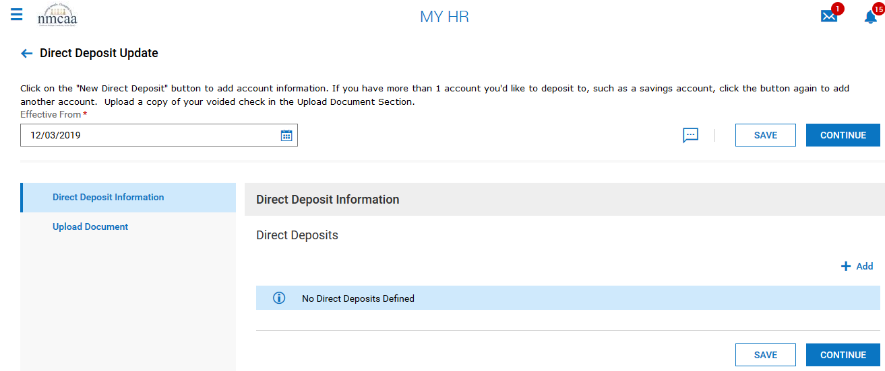

The employee will then select a file to upload by clicking on “Choose”.
For “Document Type”, the employee will select “document visible to all access levels”
Once the document is upload, the employee will submit the information. This will not show as complete on the checklist until Payroll approves the information.

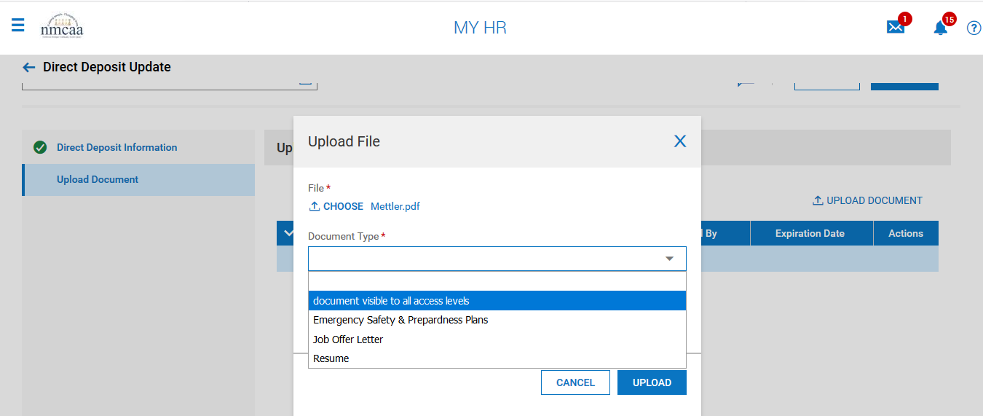

Review Employee Handbook – employee will click on the “Personnel Policies” link to review the document. Once the document review is complete, the employee will close the document and mark this checklist item as complete. They will do this by clicking on located on the checklist screen on the righthand side.

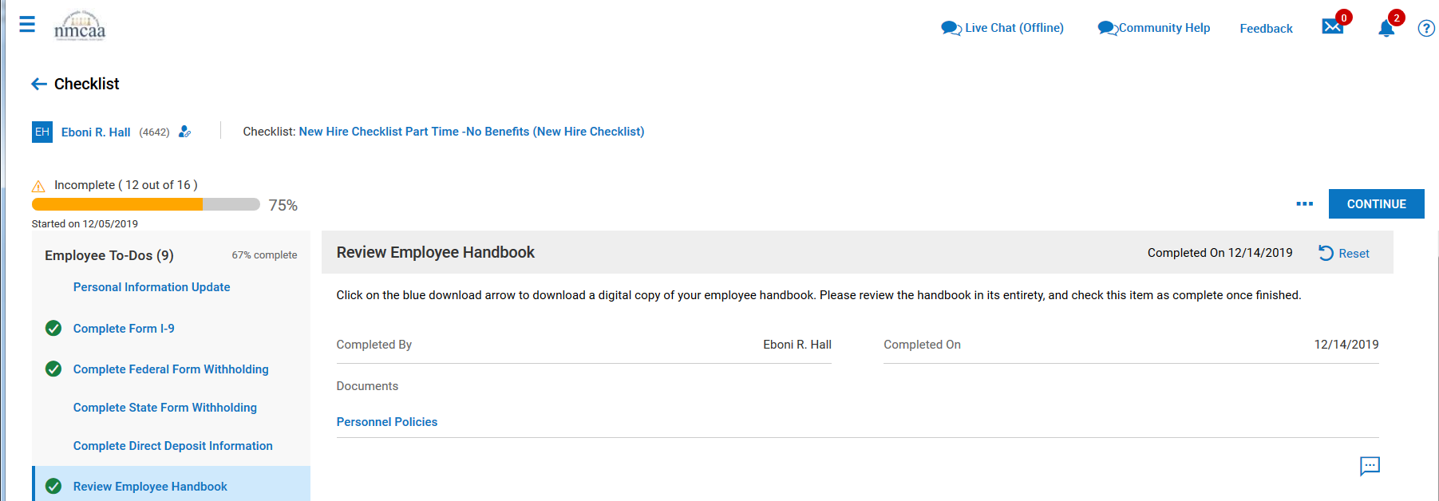

Complete Handbook Acknowledgement - The employee will click on the hyperlink “Handbook Acknowledgement Form”

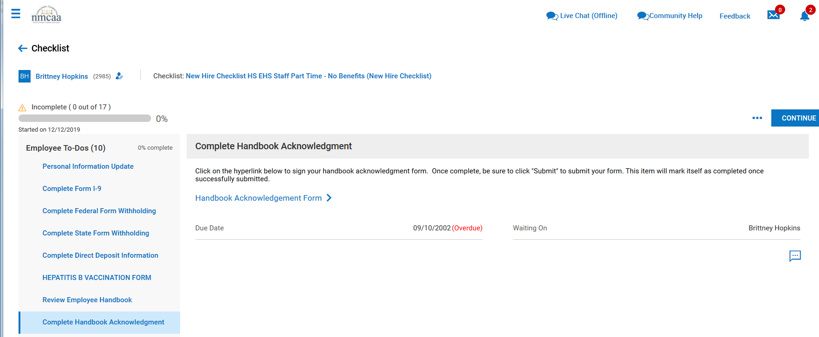

The employee will read the document and sign it by clicking on the “sign” box. It will be signed electronically by the employee’s Kronos password. Once completed, the form will need to be saved and submitted by clicking on “save” and then “submit”. Once finished, the item will be marked off automatically on the checklist.
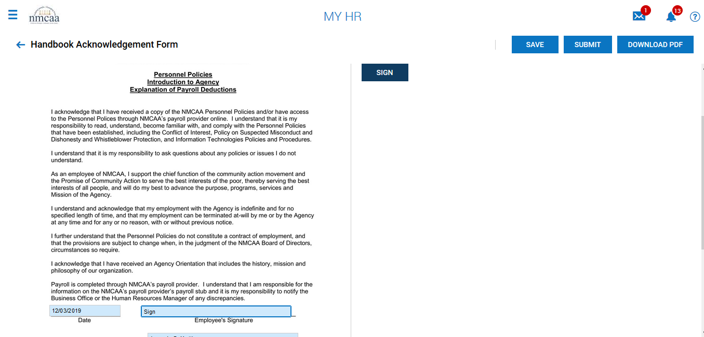

Cell Phone Policy - The employee will click on the hyperlink “Cell Phone Policy”

The employee will read the document and sign it by clicking on the “sign” box. It will be signed electronically by the employee’s Kronos password. Once completed, the form will need to be saved and submitted by clicking on “save” and then “submit”. Once finished, the item will NOT be marked off until HR has approved the submission. Select “continue” to move to the next checklist item.

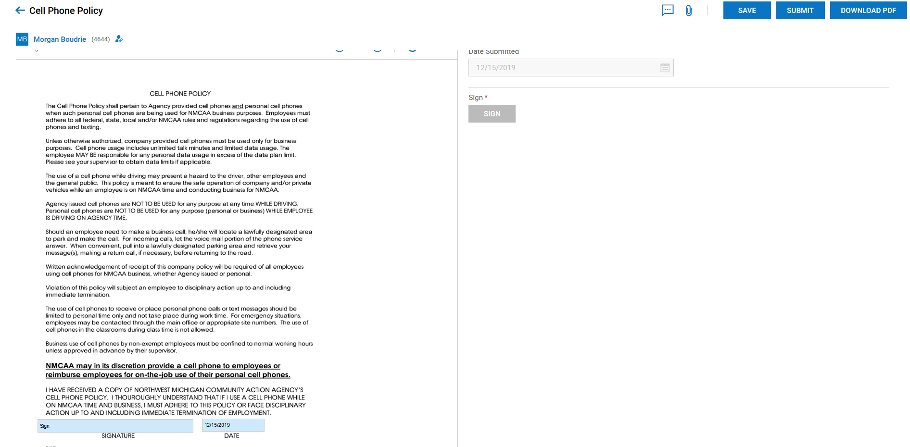

Email Encryption Policy - The employee will click on the hyperlink “E-Mail Encryption”, review the document and check this item as complete on the checklist. This document is available in Kronos by going to My Company > Documents.

Email Use Instructions - The employee will click on the hyperlink “E-Mail Instructions”, review the document and check this item as complete on the checklist. This document is available in Kronos by going to My Company > Documents.
Benefit Information
OMB Full Time – This is information that is provided to all employees upon hire. It advises them on how to answer questions that are asked of them if they are applying for health insurance through the marketplace. There is a version for full time and another one for part time. The employee will click on the hyperlink “OMB Full Time”, review the document and check this item as complete on the checklist. This document is available in Kronos by going to My Company > Documents.
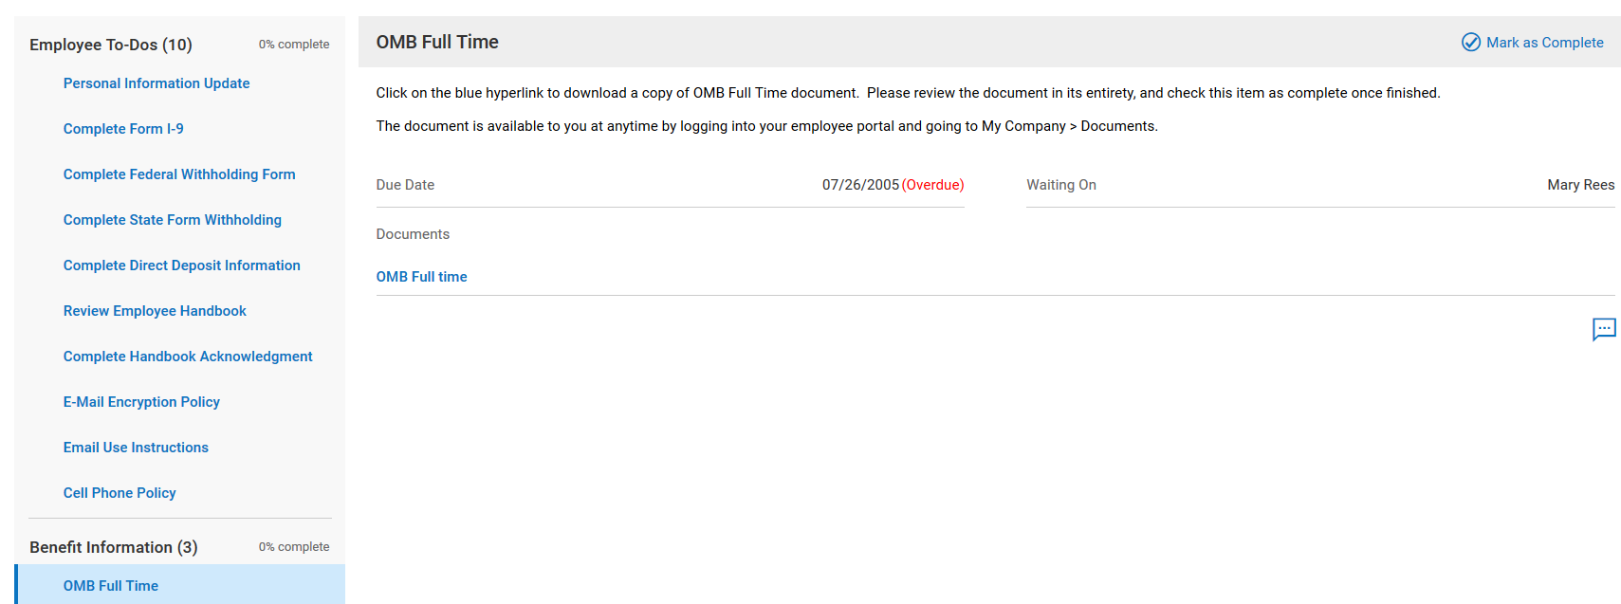
Section 125 Summary Plan Description - This is information that is provided to all employees upon hire. It advises them on the benefits through the Section 125 Plan (FSA information). The employee will click on the hyperlink “Sec 125 Plan Summary Plan Description”, review the document and check this item as complete on the checklist. This document is available in Kronos by going to My Company > Documents.
New Employee Benefit Enrollment - ). The employee will click on the hyperlink “Start Your Benefit Enrollment Process”. All eligible employees will need to complete this even if they are waving participation in a [particular benefit plan.

Employees will select the level of coverage they need or waive the benefit. They will be able to compare the plans and the pricing. Medical, Dental, Vision, and/or life insurance will be available to choose based on the employee’s status (full time, part time). Temporary and substitute employees are not eligible for any benefits.
Employees that have a “Qualifying Event” (birth of a child, adoption, marriage, divorce, etc.) may also change their benefits. They will go in to Kronos to My HR > My Benefits.
403(b) Information
Agreement for Salary Reduction 403(b) – All employees must either waive participation or sign up to participate in the NMCAA 403(b). By waiving it at the time of hire, does not mean that they cannot change to participation in the future. There is no waiting period to participate and ALL employees (substitutes and seasonal employees included) are eligible to participate. The employee will click on the hyperlink “Agreement for Salary Reduction 403(b)”.

The employee will enter information into the fields and then “sign” the document by entering their Kronos’ password. Then “save” and “submit” the sign document. This item will NOT be marked complete on the checklist until approved by payroll. Click continue to move on to the next checklist item.
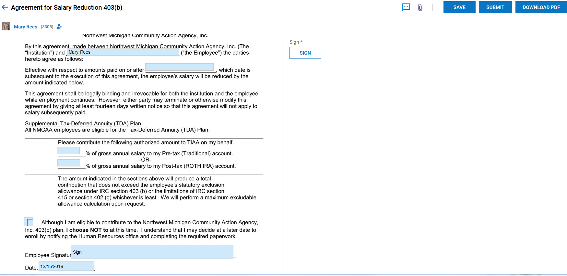

403(b) Instructions – Set up instructions for establishing a TIAA 403(b) account. The employee will click on the hyperlink “403(b) Instructions”, review the document and check this item as complete on the checklist. This document is available in Kronos by going to My Company > Documents.
403(b) Summary Plan Description – Summary Description of the 403(b) plan. The employee will click on the hyperlink “403(b) Summary Plan Description”, review the document and check this item as complete on the checklist. This document is available in Kronos by going to My Company > Documents.

403(b) TIAA Investment Options – Investment options currently available in the TIAA 403(b) plan. The employee will click on the hyperlink “403(b) TIAA Investment Options”, review the document and check this item as complete on the checklist. This document is available in Kronos by going to My Company > Documents.

NMCAA Orientation - NMCAA Orientation includes history of NMCAA, general Board information, and department services information. The employee will click on the hyperlink “NMCAA Orientation”, review the document and check this item as complete on the checklist. This document is available in Kronos by going to My Company > Documents.

