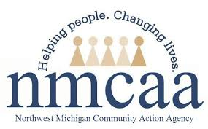
COVID-19 UPDATES & EMPLOYEE RESOURCES
May 28, 2021

COVID-19 News & Resources

COVID-19 Vaccine Dashboard
- State of Michigan: 58.5% (first dose completed)
- United States: 49.9% (first dose completed)

** Data as of 5/27/2021

June 1, 2021 Gatherings and Face Mask Order

FAQs for the June 1, 2021 Gatherings and Face Mask Order

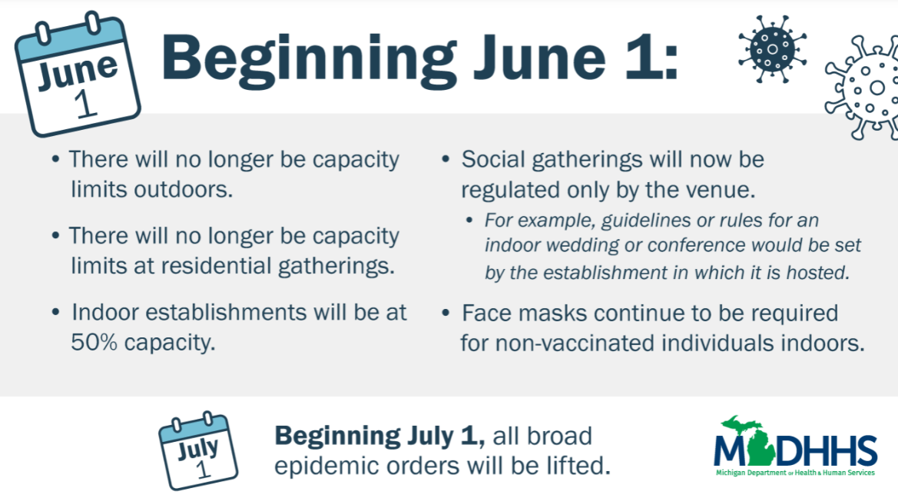

Community Based Pop-Up Rapid Antigen Testing Events
Increasing access to quick reliable testing is a priority to the Michigan Department of Health and Human Services. Community Pop-up testing sites are free and open to the public. Many of these are executed in partnership with Michigan's Intermediate School Districts (ISDs), school districts, local health departments, churches, and other important community organizations. These events are open to all, including but not limited to educators, students, and community members.
*** Click on the title above for more information regarding testing events. ***
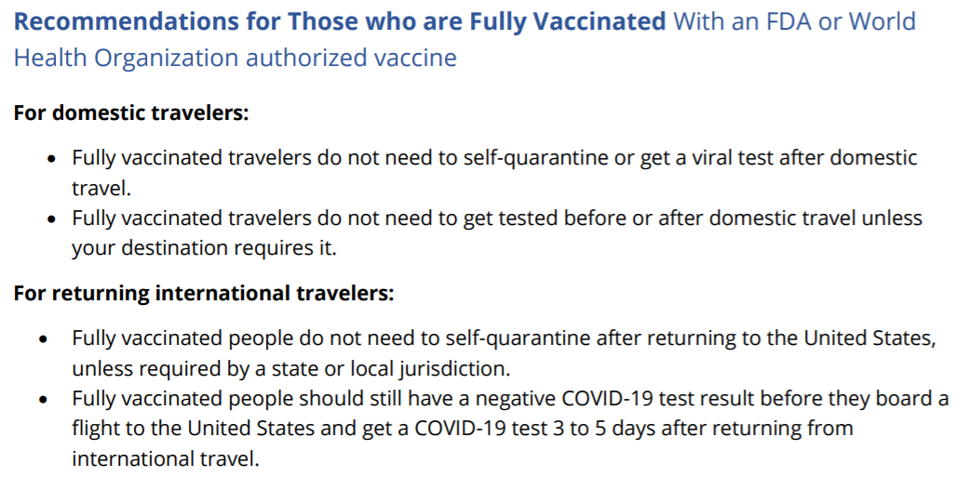

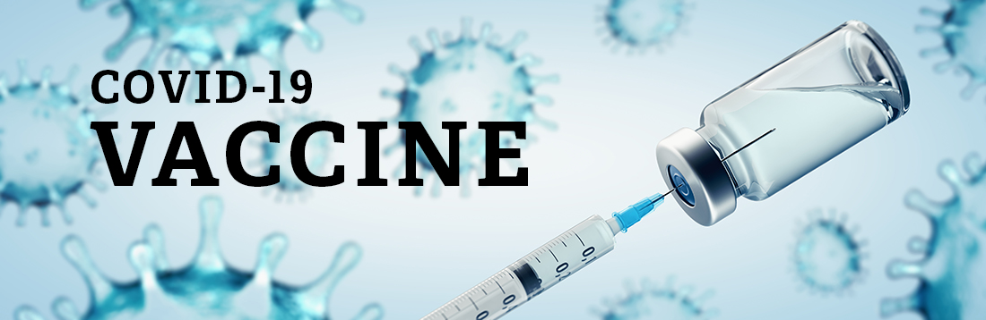
Health departments and other organizations have appointments available and ready to be scheduled ASAP. Please refer to the links below for places in your community providing appointments and off-site clinics.
- Grand Traverse County Health Department
Seniors who do NOT have internet access or
need additional help can call 231-715-5557
for help scheduling.

- Health Department of Northwest Michigan
- Benzie-Leelanau Health Department
- District Health Department #10
- Central Michigan District Health Department
- NMHSI
- Rite Aid
- Meijer
- Family Fare

Have questions?? Call Munson’s “Ask a Nurse” at 231-935-0951

Human Resources
Return to Work: The “work from home” orders were lifted with MIOSHA’s most recent Emergency Rules. NMCAA is currently working to revise our COVID Response and Preparedness Plan as well as protocols for employees returning to in office work. Please look for more information to come in the near future as we move forward with this process.

We are currently working on a new Human Resources Weebly site. This is intended to be a resource for employees for forms, policies, etc. Included within this site is a Staff Directory. The plan is to attach a profile picture to your contact information as a way for us to connect faces with names!
PLEASE send a personal picture of YOU to connect to your information. If you currently have a personal picture on your email, that picture can be attached (but feel free to send in an updated picture if you would rather). Pictures may be sent to kruckle@nmcaa.net.
If you haven’t already attached a picture of yourself to your email, now is the time to do that, too!

A video sure to make you smile!

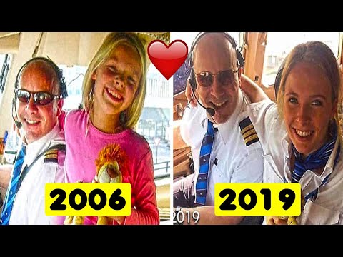

Thank you for all you do!

