COVID-19 UPDATES & EMPLOYEE RESOURCES
March 2021

Thank you for all you do each and every day to be someone’s rainbow. YOU all make a difference!

COVID-19 News & Resources
VACCINE BREAKDOWN

 | MODERNA | PFIZER | JOHNSON & JOHNSON
How well does it prevent illness? | 94.1% effective at preventing symptomatic infections, 100% effective at preventing severe infections, after two doses. | 95% effective at preventing symptomatic infections, nearly 100% effective at preventing severe infections, after two doses. | 66% effective at preventing moderate to severe infections, 85% effective at preventing severe infections, after a single dose.
How well do the shots prevent hospitalizations and death? | Zero hospitalizations or deaths 14 days after the 2nd shot. | Zero hospitalizations or deaths seven days after the 2nd shot. | Zero hospitalizations or deaths 28 days after the 2nd shot.
How do they work? | mRNA | mRNA | Adenovirus
How do you take them? | Two shots in the arm, given 28 days apart. | Two shots in the arm, given 21 days apart. | One shot in the arm.
What are the side effects? | Arm pain (92%), fatigue (68%), headache (63%), muscle pain (60%), joint pain (45%), and chills (43%). | Arm pain (85%), fatigue (63%), headache (55%), muscle pain (38%), chills (32%), joint pain (24%), and fever (14%). | Arm pain (49%), headaches (39%), fatigue (38%), and muscle aches (33%).
How long until I’m protected? | Some protection from infection begins 10-14 days after the 1st shot, with full protection achieved two weeks after the 2nd shot. | Some protection from infection begins 10-14 days after the 1st shot, with full protection achieved one week after the 2nd shot. | Some protection begins as early as 14 days after the shot, with full protection measured 28 days after the shot.

Get vaccinated.

Get your smartphone.

Get started with v-safe.
Use your smartphone to tell CDC about any side effects after getting the COVID-19 vaccine. You’ll also get reminders if you need a second vaccine dose.

REGISTER HERE

Click HERE for more information regarding the
v-safe process.

Vaccine rollouts continue to occur across all 10 counties of our service area. While the agency completed interest/planning surveys with each health department back in January, we are still waiting to hear back with any scheduling information from some. There have been recent updates and changes to each health department’s scheduling platform. If you are interested in receiving the vaccine, you are encouraged to visit your local health department’s scheduling page and pre-register as an individual.
- Grand Traverse County Health Department
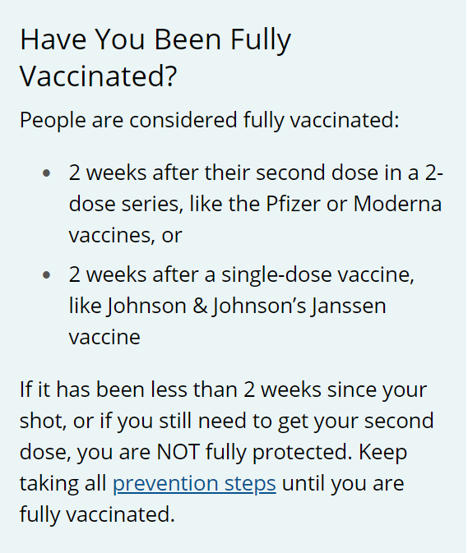
- Health Department of Northwest Michigan
- Benzie-Leelanau Health Department
- District Health Department #10
- Central Michigan District Health Department
Other options:
- Meijer
- Rite Aid

Seniors who do NOT have internet access or
need additional help can call 231-715-5557
for help scheduling.

Human Resources
Q | The Employee Enhancement Newsletter Helpful Resources from Your Employee Assistance Program, sponsored by Catholic Human Services.
March Quarterly Newsletter
In This Issue  A Quick Exercise to Keep Your Mind Grounded  Are You Being Too Hard on Yourself?  We are committed to Employees, Building a Collaborative Environment, Promoting Dialogue & Implementing Solutions  Contact Us  Catholic Human Services EAP Program  (231) 947-8387  We welcome your inquiries.  The EAP provides counseling, information and referrals for employees and their immediate family members. This program is ideal for people experiencing personal distress or simply seeking to improve health and well-being.  - It’s free.  - It’s confidential.  - It’s short-term, solution focused counseling.  If you want to talk, vent, or need support please reach out to EAP.  We can help you with outpatient mental health services.  We are here to assist you.  Every contact is confidential! | A Quick Exercise to Keep Your Mind Grounded  Do you feel like your mind is constantly racing? It’s like a train running through a million thoughts, thinking about the past, the future, or all the things that went wrong or could go wrong. As people struggling with anxiety or trauma, instead of staying grounded on the platform, we run and launch ourselves on the anxiety train and our minds go somewhere else.  When this happens, it’s hard to sleep, to stay focused or be around others.  The following exercise is designed to help you calm down and retrain your body and mind to stay grounded in the moment. The goal is to fill your brain with thoughts on the here and now. The more you practice the faster you’ll notice your body and brain responding well.  Sometimes we literally have to tell our minds, “STOP IT!” After you do that, practice either of the 2 strategies below.  - Stay Grounded Physically  Keep an object that can help you refocus. Keep it on hand and pull it out if you need it.  Use your surroundings. If you’re on a walk, touch a fence or a wall. If you are in the car, feel your seat or the door. If you’re trying to sleep, feel the pillow on your face.  How does it feel? Describe it in your mind or out loud. Describe it in a calm, rhythmic way. Talk through it until you feel your mind and body calm down.  Feel Free to interrupt your thoughts with words of affirmation like, “I’ve got this” or “I’m going to be ok.”  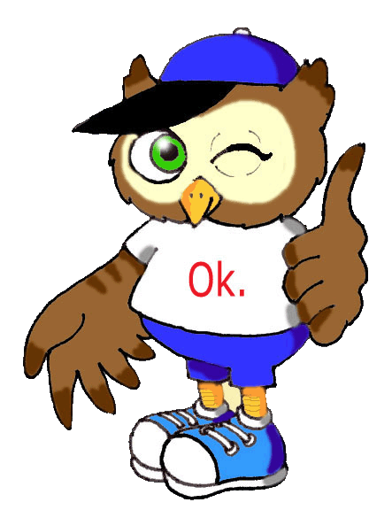 2. Get in Touch with Your 5 Senses  This Photo by Unknown Author is licensed under CC BY-S-NC  You can talk through each of the 5 senses. You don’t have to do them in order or do all five. You don’t even need to make sense. As long as your mind is talking through any of the statements above and not on anxious thoughts, you’re good. Try to find a calm, rhythmic patter. Talk through it until you feel your mind and your body calm down. “I’m going to be ok.”  - I feel ____________________ (example: I feel my toes)  - I hear ____________________ (example: I hear the cars)  - I smell ___________________ (example: I smell the flowers  - I taste ___________________ (example: I taste my drink)  ARE YOU BEING TOO HARD ON YOURSELF?  - Does it have to be done now?  Does it have to be done at all?  If possible, schedule another time, ask for help or eliminate it completely. You don’t have to be perfect; you just have to be you.  - Defuse negative thinking by asking yourself the following questions:  How does this make me feel?  Is it contributing to my stress, unhappiness or fear?  Where did this thought come from?  Whose voice am I really hearing?  Is it my mother, father, teacher, a friend and an ex-boyfriend or girlfriend?  Is it rational?  Was everyone looking at me like when I did/said (whatever) OR  Was it my overactive imagination?  Is it realistic?  Will I really lose my job if I refuse to work late on the night of my 10th wedding anniversary next week?  Can I reach a compromise with my boss/supervisor?  How can I turn this negative thought around?  How can I change this thought to foster greater happiness and well-being?  - Identify what stresses you out the most and come up with realistic solutions for minimizing or eliminating this stress in your life.  Example: If you run late in the mornings, lay out your clothing at night. Put your purse and keys out the night before.  This Photo by Unknown Author is licensed under CC BY-NC-ND  EAP LINE: 231-947-8387

