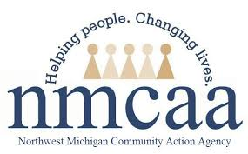
COVID-19 UPDATES & EMPLOYEE RESOURCES
February 2021

The COVID-19 struggle has been long and hard. NMCAA employees have been strong, resilient, and resourceful through almost one year! The world is making progress and the vaccines are getting distributed! Don’t give up, keep the faith, and we will get past this and be even stronger on the other side. You are amazing employees who are doing amazing work. Thank you!

COVID-19 News
Local health departments continue to work hard to administer 1st and 2nd doses of the COVID-19 vaccine. Here are how the numbers are shaping up across our region:

Grand Traverse County Health Department
- 11,053 total doses as of 2/12/2021
- 25,275 doses administered across all of Grand Traverse County
District Health Department #10
- 27,525 total doses as of 2/16/2021
Benzie-Leelanau District Health Department
- 3,910 total doses as of 2/17/2021
Central Michigan District Health Department
- 10, 257 total doses as of 2/9/2021
Health Department of Northwest Michigan
- 11,000 total doses as of 2/15/2021

CDC Guidance for Vaccinated Persons
Vaccinated persons with exposure to someone with suspected or confirmed COVID-19 are not required to quarantine if they meet all the following criteria:
- Are fully vaccinated (i.e., ≥2 weeks following receipt of the second dose in a 2-dose series, or ≥2 weeks following receipt of one dose of a single-dose vaccine)
- Are within 3 months following receipt of the last dose in the series
- Have remained asymptomatic since the current COVID-19 exposure
Persons who do not meet all 3 of the above criteria should continue to follow current quarantine guidance after exposure to someone with suspected or confirmed COVID-19.

Human Resources
Employee Assistance Program
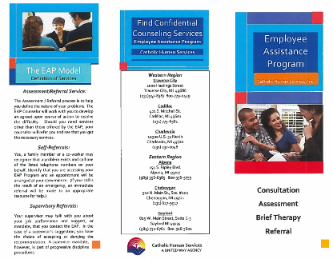
The Employee Assistance Program (EAP) through Catholic Human Services is a confidential, free program for all NMCAA employees and their immediate family members.
This program is designed to support individuals with job-related or personal situations: stress, anxiety, mental health issues, and other concerns. Please reach out for assistance. Remember that “any problem worth losing sleep over is worth seeing the EAP about.” Click on the picture for additional information.

Fighting the Winter Blues
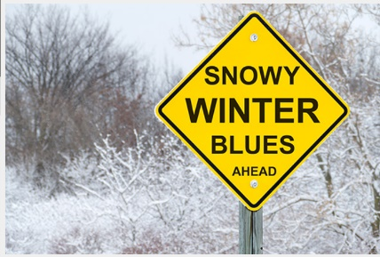
The days are getting longer, although it doesn’t seem like they are much warmer. Spring is hopefully around the corner despite what Punxsutawney Phil says! Click on the picture for some tips to ward off any lingering winter blues.

A Little Pep Talk (click to watch the video)

