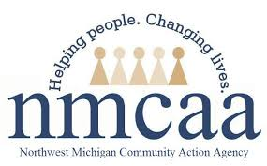
COVID-19 UPDATES & EMPLOYEE RESOURCES
April 1, 2021

COVID-19 News & Resources

COVID-19 Vaccine Dashboard

LOCATION | POPULATION | AT LEAST ONE DOSE | % COMPLETE | FULLY VACCINATED | % COMPLETE
State of Michigan | 8,096, 917 | 2,733,713 | 33.8% | 1,625,690 | 20.1%
Antrim County | 19,759 | 7,308 | 37.0% | 4,427 | 22.4%
Benzie County | 15,011 | 5,817 | 38.8% | 3,811 | 25.4%
Charlevoix County | 21,940 | 9,948 | 45.3% | 6,856 | 31.2%
Emmet County | 27,953 | 13,289 | 47.5% | 8,548 | 30.6%
Grand Traverse County | 76,703 | 35,472 | 46.2% | 25,845 | 33.7%
Kalkaska County | 14,756 | 4,918 | 33.3% | 3,399 | 23.0%
Leelanau County | 18,737 | 7,407 | 39.5% | 5,286 | 28.2%
Missaukee County | 11,740 | 3,633 | 30.1% | 2,222 | 18.9%
Roscommon County | 20,911 | 8,361 | 40.0% | 5,301 | 25.4%
Wexford County | 26,734 | 9,848 | 36.8% | 6,029 | 22.6%
United States | 328,200,000 | 97,593,290 | 29.4% | 54,607,041 | 16.4%

*** Data as of 3/30/2021

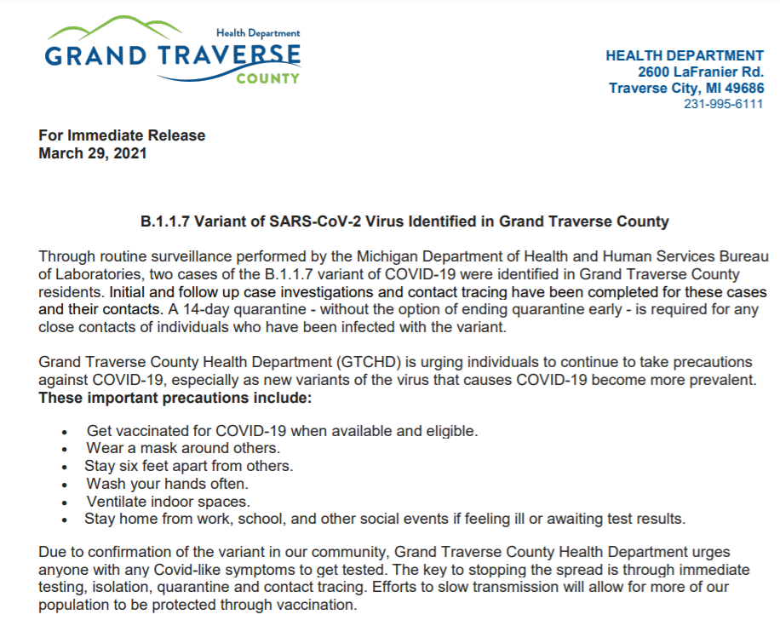

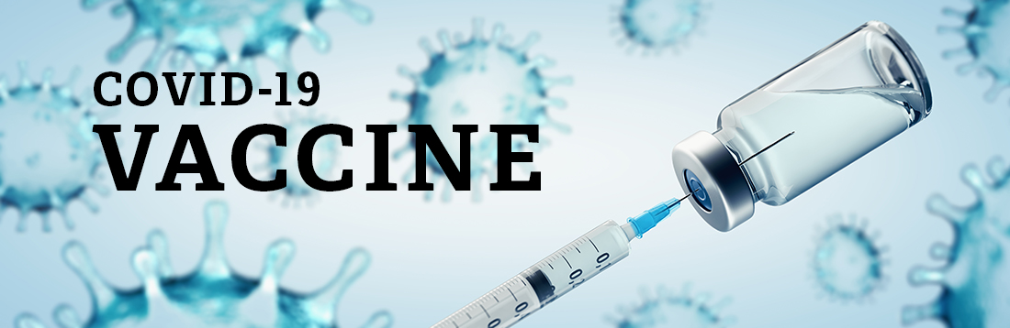
- Grand Traverse County Health Department
Seniors who do NOT have internet access or
need additional help can call 231-715-5557
for help scheduling.

- Health Department of Northwest Michigan
- Benzie-Leelanau Health Department
- District Health Department #10
- Central Michigan District Health Department
- NMHSI
- Rite Aid
- Vaccine Finder
- Meijer

Nervous About COVID-19 Vaccination? Read This
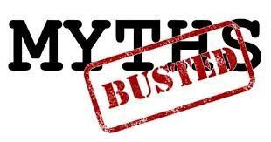

MYTH: Development of COVID-19 vaccines were rushed.
FACT: While it was done quickly, the vaccines were not rushed. The term “rushed” suggests something was done differently than normal or that corners were cut. In fact, tens of thousands of participants were studied in the safety and efficacy trials. In a normal vaccine trial, enough people have to get the disease to know whether it works or not. This often means waiting for a long time. With COVID-19, because the virus was so widespread, and disease occurs soon after infection, it was possible to complete the studies much sooner. The development of these vaccines was also based on a wealth of scientific work that had been done previously in the laboratory and in animals.

MYTH: One vaccine (Pfizer/BioNtech, Modera, Johnson & Johnson) is better than the other.

FACT: The Pfizer/BioNtech and Moderna vaccines are very similar and based on the same mRNA technology. Both vaccines require two doses for full protection. The Johnson & Johnson vaccine is a viral vector vaccine (not live virus) and has been shown to prevent COVID-19 in a single dose. People should get whichever vaccine is offered to them as soon as possible.
MYTH: mRNA cannot be trusted because it’s a new type of vaccine.
FACT: Messenger RNA is a small molecule that is made by cells in your body and by bacteria and viruses. It’s a blueprint for how to make a protein. The Moderna and Pfizer/BioNTech vaccines consist of mRNA that’s been made in the lab. When it gets in your cells, the mRNA instructs them to make a version of the spike protein that SARS-CoV-2 makes. This small, harmless piece of the virus cannot cause COVID-19, and mRNA vaccines do not change your DNA in any way. This is just a clever way of introducing the spike protein into your body so the body can learn how to fight it off. It’s similar in that way to a tetanus shot, where instead of mRNA you actually inject the tetanus protein. Currently, these vaccines are effective, safe, and the best option to prevent millions of infections and deaths.

MYTH: The second dose of the Pfizer/BioNTech and Moderna vaccines is not needed.
FACT: You need two doses of the Pfizer/BioNTech and Moderna vaccines because that is what was studied and shown to work for immunity. We don’t know how effective or durable protection from a single dose would be. When you first get exposed to a vaccine or a foreign substance, your body generates cells that can recognize that foreign substance. The second time you get exposed, you develop a stronger immunity and build long-term immunity. What you generally find is the response after the second dose is much larger in magnitude and longer lasting.

MYTH: You don’t need to get the vaccine if you’ve already had COVID.
FACT: Those who already had COVID-19 should get vaccinated. Duration of immunity from natural infection of the virus is not known at this time. In some cases, people have reported getting COVID-19 twice. The CDC recommends getting the vaccine due to the severe health risks associated with COVID-19 and the fact that re-infection with COVID-19 is possible.

Human Resources
American Rescue Plan Act (ARPA)
ARPA allows employers to VOLUNTARILY extend the Emergency Paid Sick Leave (EPSL) through September 30, 2021. NMCAA WILL once again extend the EPSL through September 30, 2021 while there are so many of us trying to get vaccinated and move beyond the COVID-19 pandemic!
Here are the details:
- Effective April 1, 2021 the balance of the 10 days or up to 80 hours of EPSL resets, meaning employees can take a new 10 days or 80 hours of EPSL as of April 1st.
- ARPA also adds the following to the permissible reasons for taking EPSL and Extended Family Leave (EFL): (i) time off for employees to obtain the vaccine; (ii) time off for employees to recover from complications of the vaccine; and (iii) time off while employees are waiting for results of COVID test or diagnosis.
There is still a maximum of 12 weeks of leave that can be taken within a 12-month period, starting from the time of the first request. Also note that EPSL and EFL are NOT available for recovering from complications of the vaccine prior to April 1. The updated Emergency Sick Leave form is available on UKG under the announcements on the home page.

Because YOU matter!!!! Click on the image above for some great “self-care” tips!

