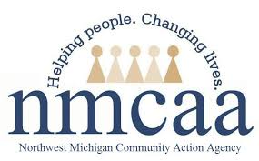
COVID-19 UPDATES & EMPLOYEE RESOURCES
April 15, 2021

COVID-19 News & Resources
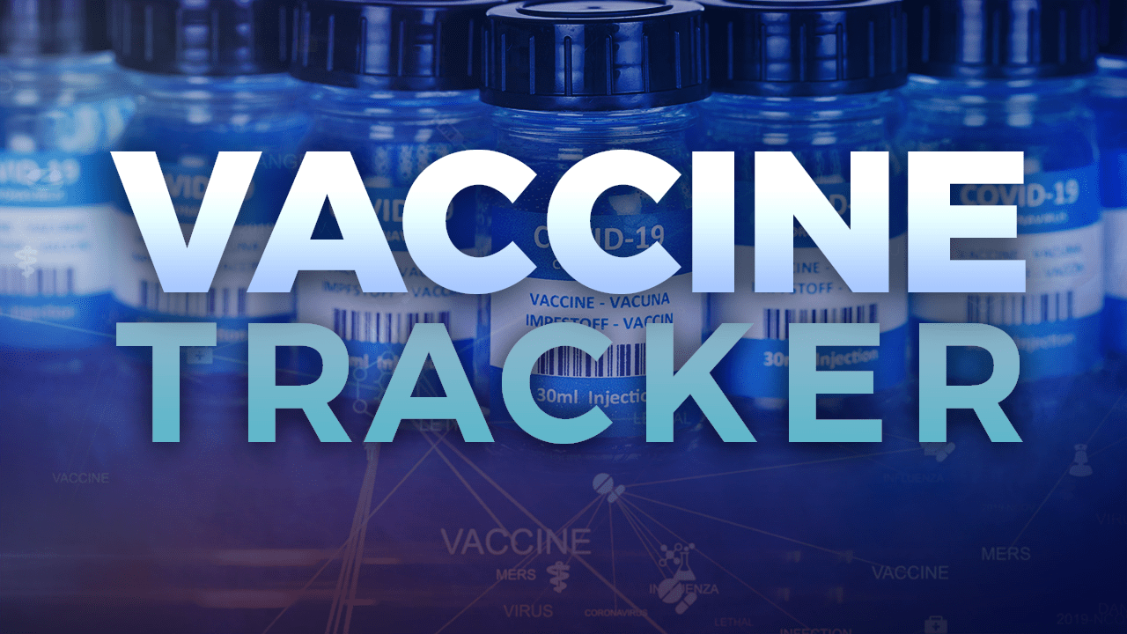

COVID-19 Vaccine Dashboard

LOCATION | POPULATION | AT LEAST ONE DOSE | % COMPLETE | FULLY VACCINATED | % COMPLETE
State of Michigan | 8,096, 917 | 3,444,851 | 42.5% | 2,278,052 | 28.1%
Antrim County | 19,759 | 9,353 | 47.3% | 6,866 | 34.7%
Benzie County | 15,011 | 7,667 | 51.1% | 5,344 | 35.6%
Charlevoix County | 21,940 | 11,564 | 52.7% | 8,735 | 39.8%
Emmet County | 27,953 | 15,290 | 54.7% | 11,799 | 42.2%
Grand Traverse County | 76,703 | 40,629 | 53.0% | 31,196 | 40.7%
Kalkaska County | 14,756 | 5,590 | 37.9% | 4,210 | 28.5%
Leelanau County | 18,737 | 10,932 | 58.3% | 8,118 | 43.3%
Missaukee County | 11,740 | 4,597 | 38.1% | 3,336 | 27.7%
Roscommon County | 20,911 | 9,268 | 44.3% | 6,684 | 32.0%
Wexford County | 26,734 | 11,242 | 42.1% | 8,038 | 30.1%
United States | 328,200,000 | 123,917,385 | 37.3% | 76,681,252 | 23.1%

*** Data as of 4/13/2021
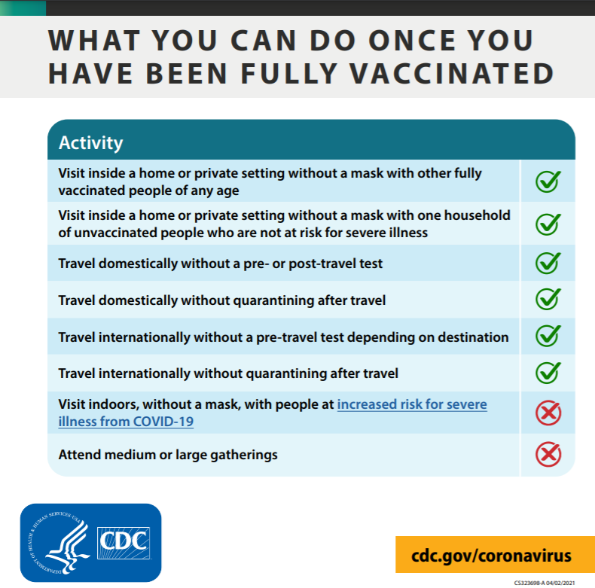

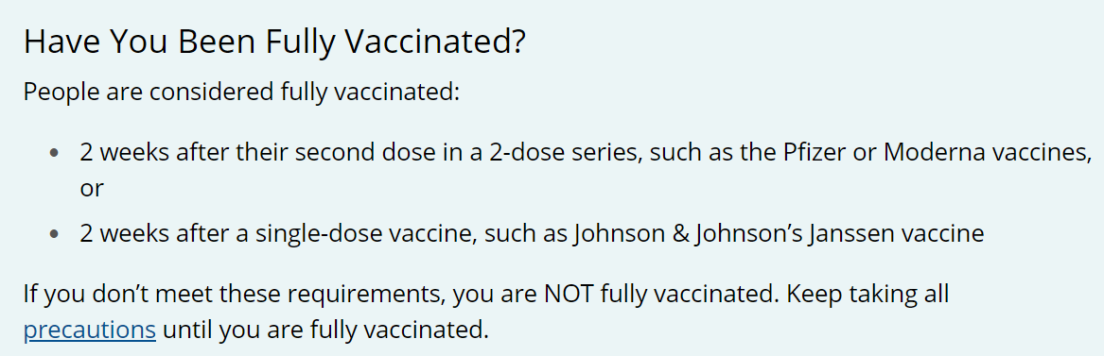

*** Click on the picture for more information!

#10: It’s FREE!!
#9: It’s highly effective.
#8: It’s safe!
#7: The vaccine protects you from getting seriously ill.
#6: It protects those around you.
#5: It protects YOU!
#4: It helps to keep your cash flow strong!
#3: The vaccine DOES NOT give your COVID-19!
#2: It’s the right thing to do.
#1: It’s the quickest way we can all GET BACK TO NORMAL!

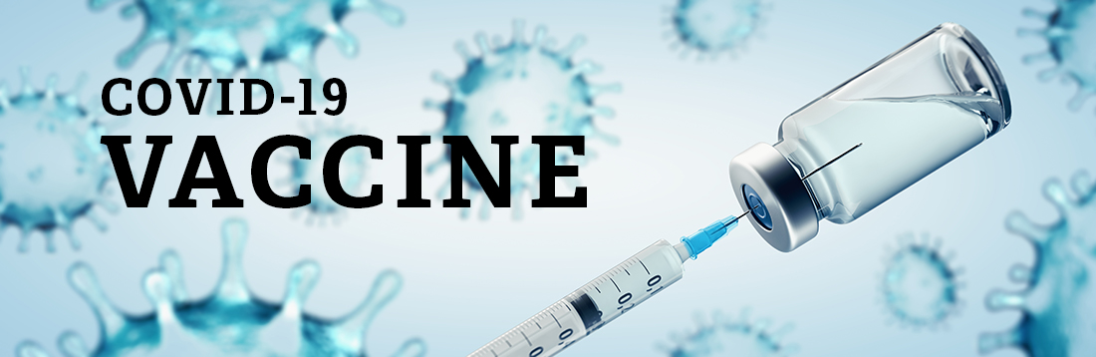
- Grand Traverse County Health Department
- Health Department of Northwest Michigan
Seniors who do NOT have internet access or
need additional help can call 231-715-5557
for help scheduling.

- Benzie-Leelanau Health Department
- District Health Department #10
- Central Michigan District Health Department
- NMHSI
- Rite Aid
- Vaccine Finder
- Meijer
- Family Fare
- Walgreens
Have questions?? Call Munson’s “Ask a Nurse” at 231-935-0951
UPCOMING CLINICS IN YOUR AREA
Benzie-Leelanau District Health Department
- Wednesday, April 21 (Second Dose May 12- Must be available)
Suttons Bay Old Middle School, 310 S. Elm Street, Suttons Bay
Time: 11:00- 6pm
Vaccine: Pfizer (open to 16 or older, parent/guardian must accompany minor)
To schedule an appointment: Click Here
- Thursday, April 22 (Second Dose May 13- Must be available)
Frankfort High School, 534 11th St, Frankfort, MI 49635
Time: 1:00- 5:45pm
Vaccine: Pfizer (open to 16 or older, parent/guardian must accompany minor)
To schedule an appointment: Click Here
- Friday, April 23 (Second Dose May 14- Must be available)
Glen Lake School Gymnasium, 3375 W Burdickville Rd, Maple City, MI 49664
Time: 1:00- 5:45pm
Vaccine: Pfizer (open to 16 or older, parent/guardian must accompany minor
To schedule an appointment: Click Here
- Saturday, April 24 (Second Dose May 15- Must be available)
Benzie Central Gymnasium, 9222 Homestead Rd, Benzonia, MI 49616
Time: 10:00- 2:00pm
Vaccine: Pfizer (open to 16 or older, parent/guardian must accompany minor)
To schedule an appointment: Click Here
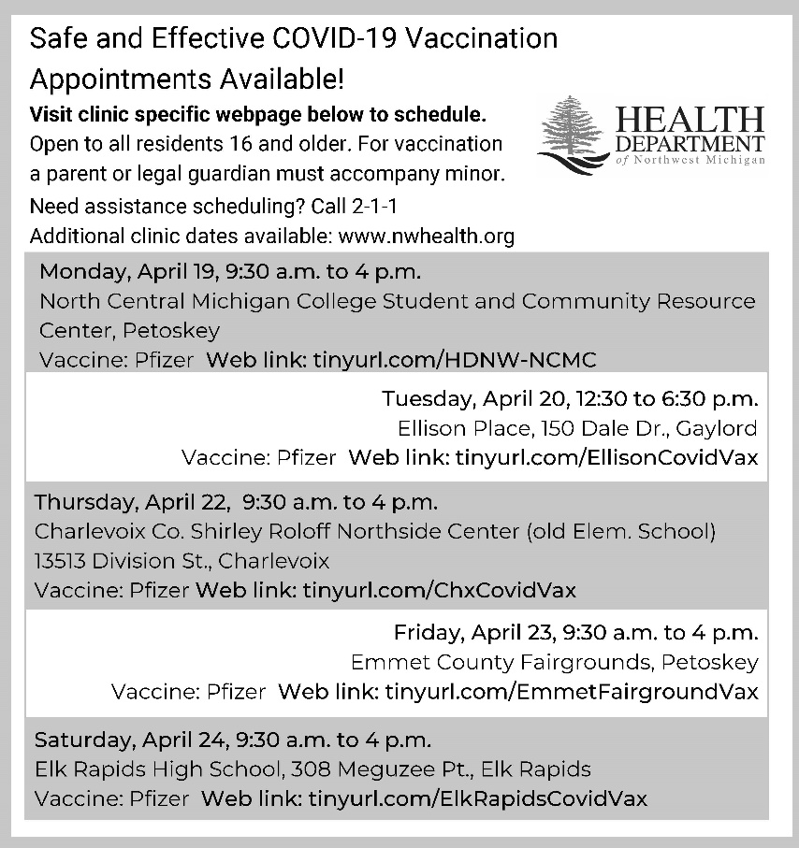
Health Department of Northwest Michigan

Grand Traverse County Health Department
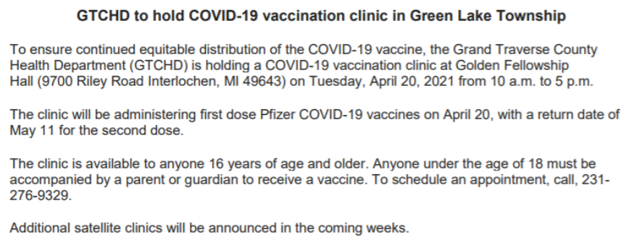
Satellite Clinic: Fife Lake Township Hall
- Friday, April 16th from 10 AM to 5 PM
- To make an appointment, call 231-879-3963 (M - F from 9 AM to 1 PM)
Central Michigan District Health Department
- Thursday, April 15, 2021 at Gladwin Knights of Columbus Hall (ages 18 and above)
- Friday, April 16, 2021 at Hayes Township Hall in Harrison (ages 16 and above)
- Monday, April 19, 2021 at Hayes Township Hall in Harrison (ages 16 and above)
- Monday, April 19, 2021 at Gladwin Knights of Columbus Hall (ages 18 and above)
- Monday, April 19, 2021 at Reed City Church of the Nazarene in Reed City (ages 18 and above)
- Monday, April 19, 2021 at Good Shepherd United Methodist Church in Roscommon (ages 18 and above)
- Tuesday, April 20, 2021 at Good Shepherd United Methodist Church in Roscommon (ages 18 and above)
- Tuesday, April 20, 2021 at Divine Shepherd Church in Standish (ages 18 and above)
- Wednesday, April 21, 2021 at Hayes Township Hall in Harrison (ages 16 and above)

Human Resources
Emergency Sick Leave (ESL) and Emergency Family Leave (EFL)
As a friendly reminder, if you are in need of ESL or EFL due to COVID-19 concerns or for vaccine-related purposes, an Emergency Sick Leave request form must be completed and submitted for our files.
MIOSHA Extends COVID-19 Workplace Safety Rules…Without Changes
Advocacy News – April 13, 2021
Governor Whitmer moved today to extend the Michigan Occupational Safety and Health Administration’s (MIOSHA) Emergency COVID-19 Workplace Safety Rules (“Emergency Rules”).
The Emergency Rules require employers to “create a policy prohibiting in-person work for employees to the extent that their work activities can feasibly be completed remotely.” They also govern workplace controls, including social distancing, mask-wearing and sanitation practices. The Emergency Rules can be found here and the extension order can be found here.

Below are some tips for a strong and healthy immune system:
- DIET: Be sure to incorporate lots of fruits, veggies, whole grains, and lean proteins.
- EXERCISE: Aim for 30 minutes of moderate exercise most days of the week.
- SLEEP: Try to get 7 to 8 hours of sleep each night.
- ALCOHOL: Keep alcohol to a minimum; one drink for women and two for men per day.
- HYGIENE: Wash those hands for at least 20 seconds frequently!
- STRESS: Breathe, mediate, call loved ones. Stress causes your body to release cortisol, which in turn suppresses your immune system.
- VACCINATE: Make your appointment today! Vaccination is a safe and effective way to help you, your loved ones, and the community stay safe….and the quickest way to return to normal!!

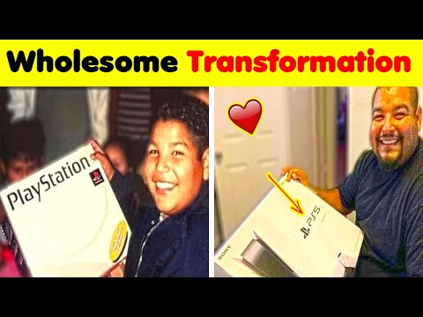
Watch the video below to put a smile on your face!

