Performance Evaluations – Instructions for Supervisors
- Contact the HR Director to release an evaluation; indicate whether it’s a 90 to 120-day or annual review. Once released, the employee will receive a notification and To Do Item in UKG and will move forward with their piece of the process.

- Once submitted by the employee, the supervisor will be notified by email and by a notification in UKG to complete a To Do task for the evaluation. Click on “REVIEW” to start the evaluation.

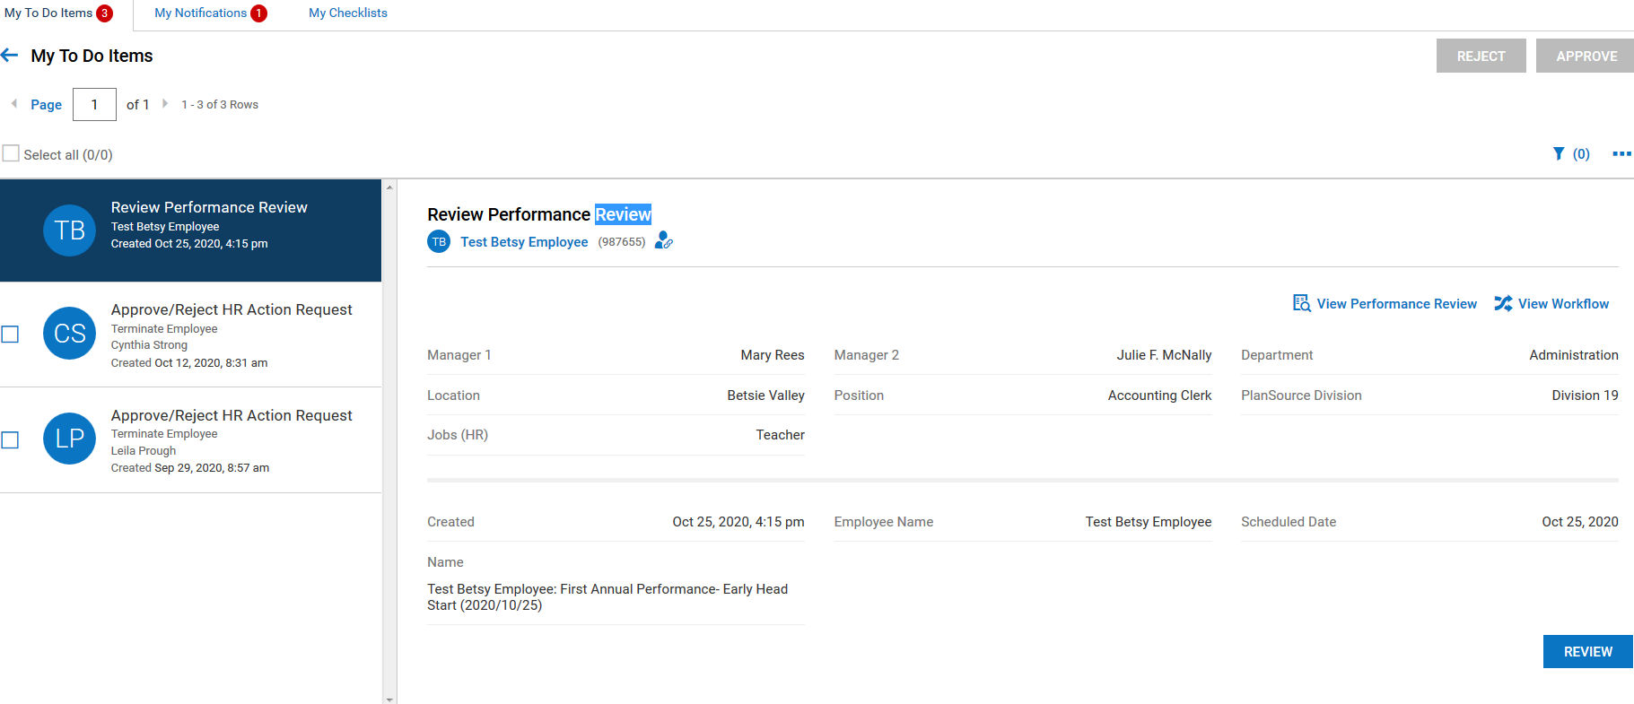

- The instruction page will display; click on the “Entry” tab to review the employee ratings/comments and to complete the supervisor’s ratings/comments.
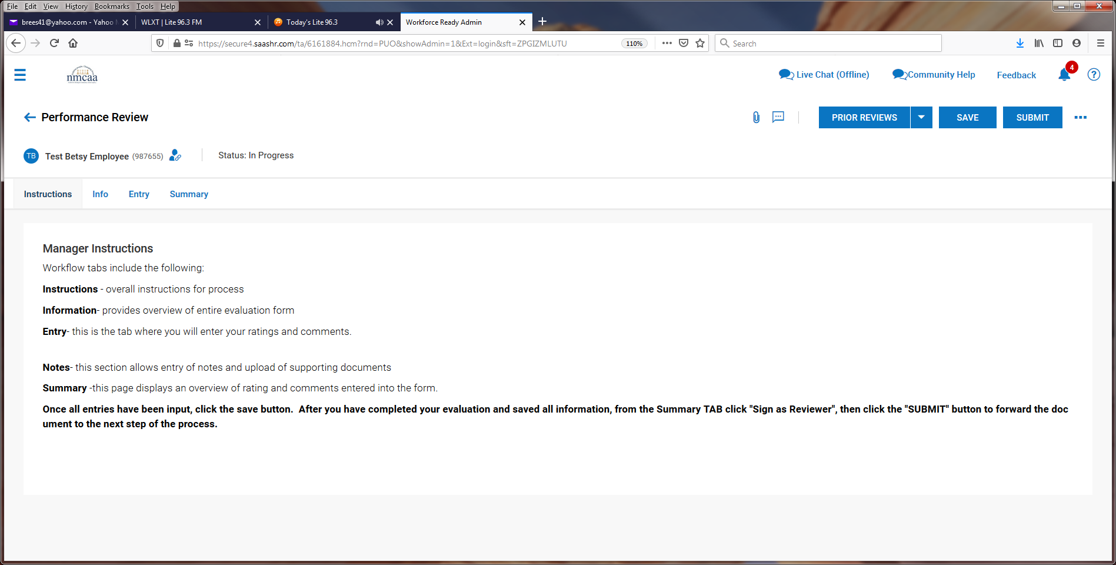
- The employee’s entered information is visable.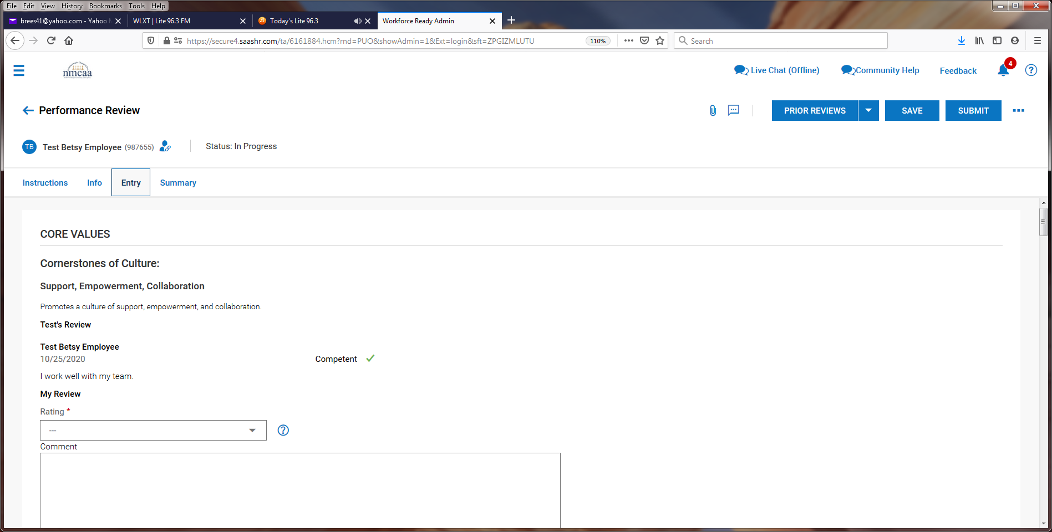
*** After reviewing the employee’s information, the supervisor may choose to proceed with their entries or “reject” the evaluation, which sends the evaluation back to the employee. This may need to occur if the employee missed a rating, did not complete the “comments” section, etc.
- The supervisor then enters their rating (Competent or Focus Area) and comments that they have for the employee.

*** It is recommended to “SAVE” progress after completing each section.

- This process is repeated for each of the other four areas for the Cornerstones of Culture.

- The Supervisor will complete the remaining areas just like the employee did for the evaluation.

- Supervisor’s Recommendations: Select the appropriate response from the drop-down box and add comments.

- Goals may be added now or after meeting with the employee. Click on “+ Add Goal” to add a goal.

- The final section can be used for General Comments but is not required.

- Once entry is complete, click on “SAVE” and then “SUBMIT.” The evaluation is then sent to the Supervisor’s Supervisor for review.
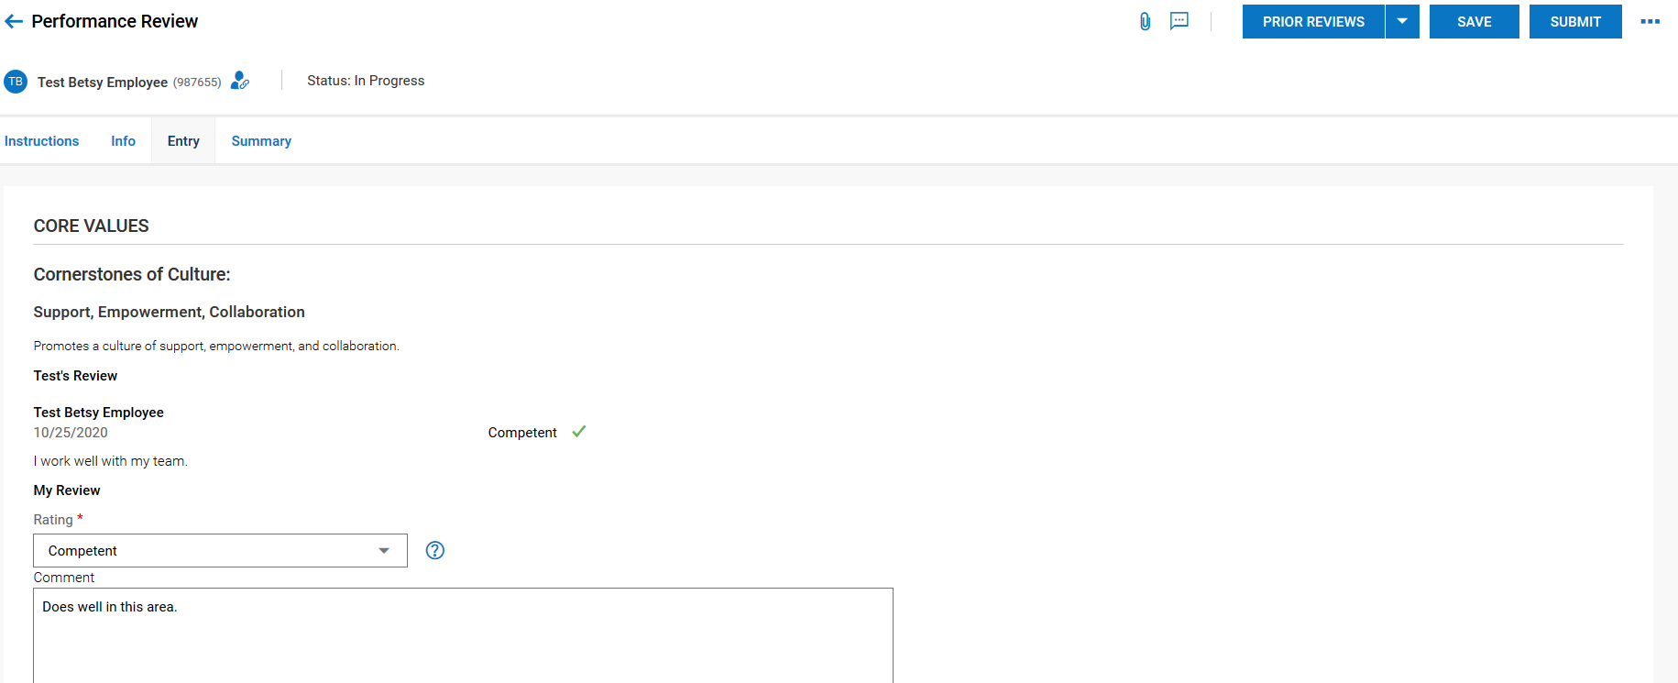

- Supervisor 2 will then receive a To Do Item to review the employee’s evaluation. Click on “REVIEW” to begin.

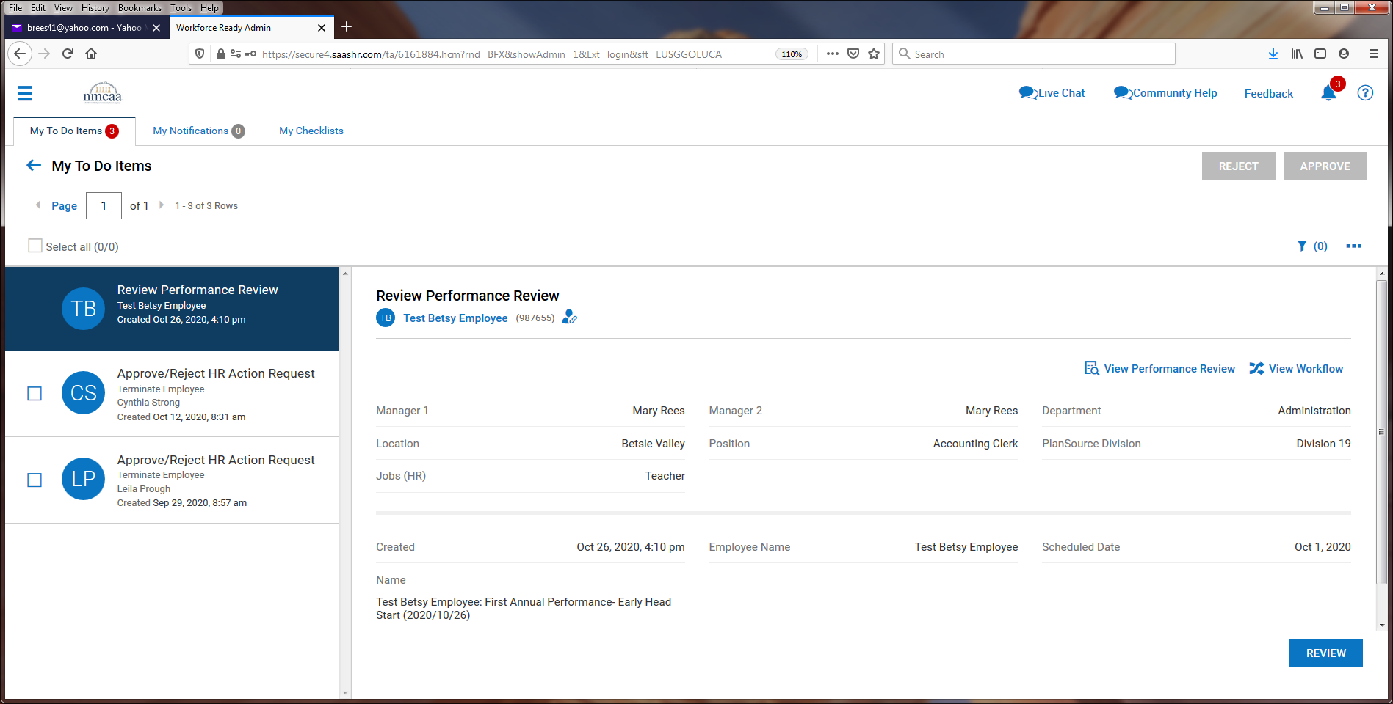

- The next screen will have instructions to review and the “Entry” tab should be clicked to begin.
- The next screen shows the responses by the employee and Supervisor 1. Supervisor 2 MAY add entries if they like. After review, click on “SAVE” and then “SUBMIT.” ** Supervisor 2 may choose to “reject” the evaluation after review, which will send the evaluation back to Supervisor 1 for any needed changes.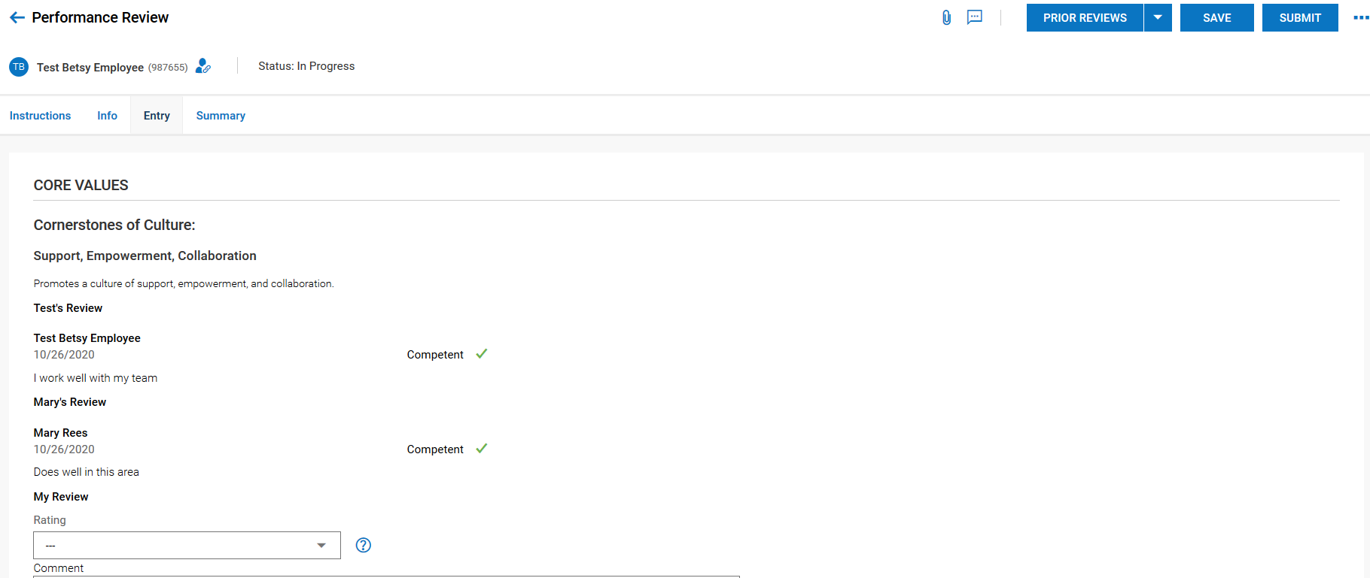
- Once this is complete, the evaluation goes back to Supervisor 1 and they receive this notification with instructions:
- The supervisor meets with the employee to present the review. Following (or during) the presentation, the supervisor proceeds to the To Do Item by clicking on “COMMENT.”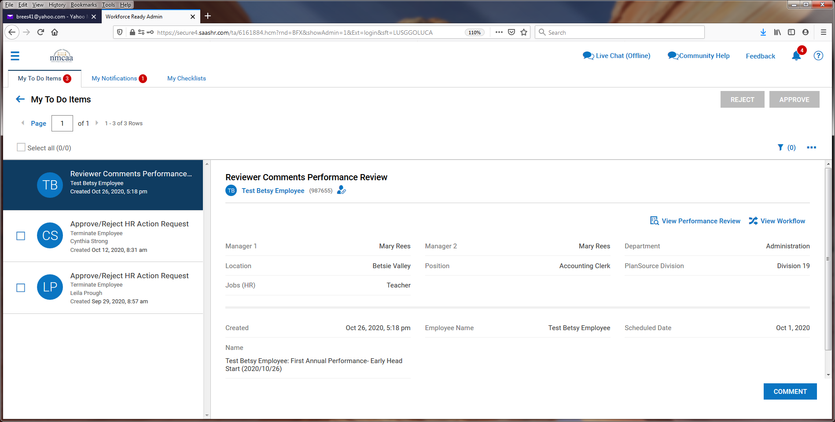
- Supervisor 2’s comments can now be seen (probably will not be many, if any) and goals can added by clicking on “+ Add Goal.”

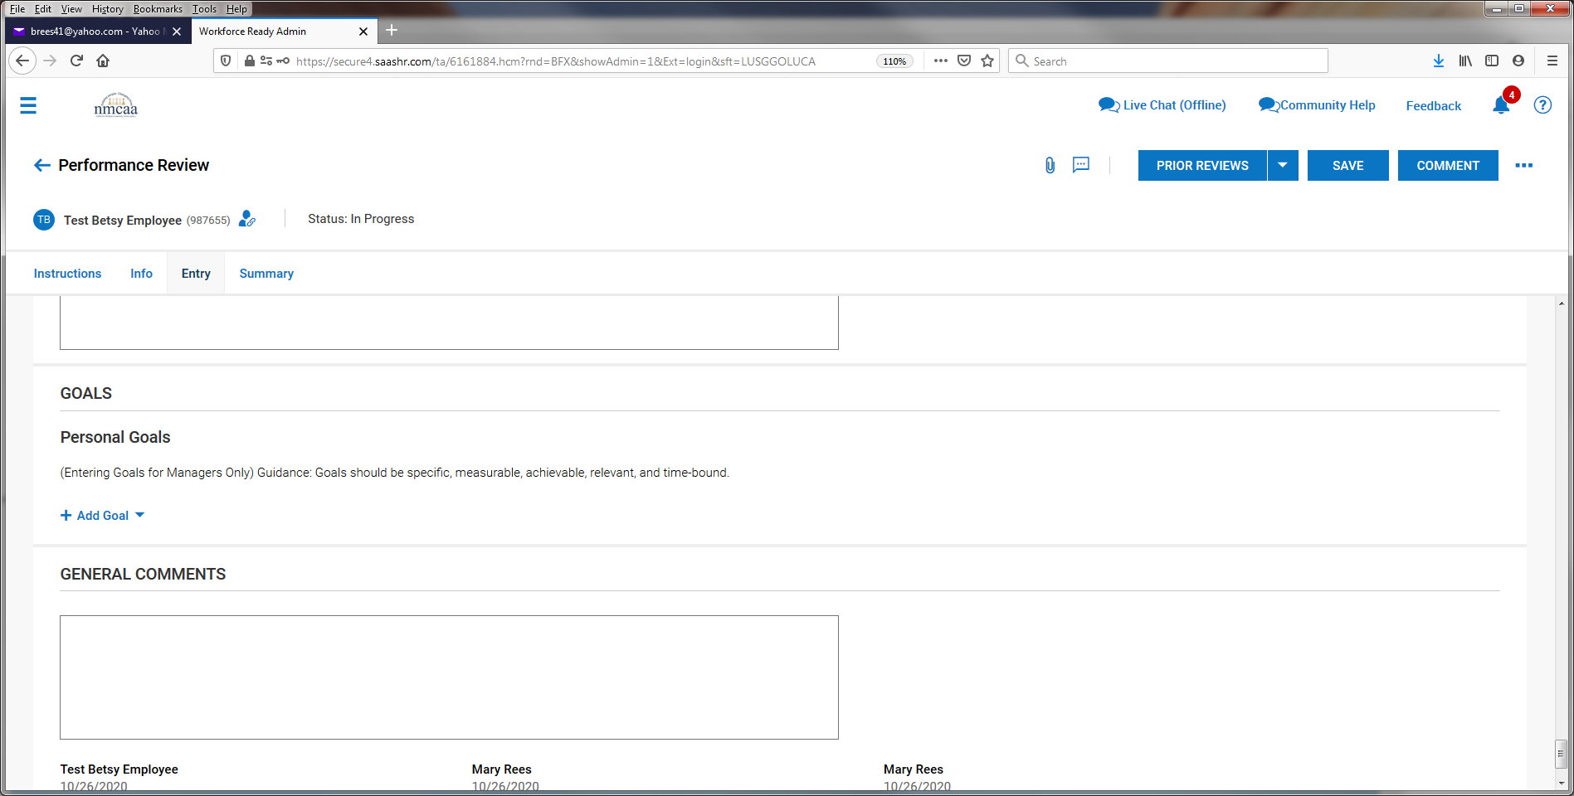

- Enter in the goal information and “SAVE.” Repeat for additional goals.
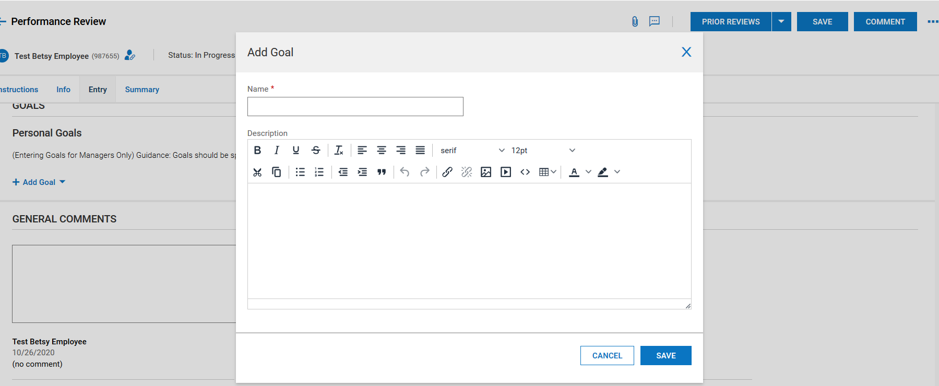
- Goals will then display, and general comments can be added. When finished, click on “SAVE.” 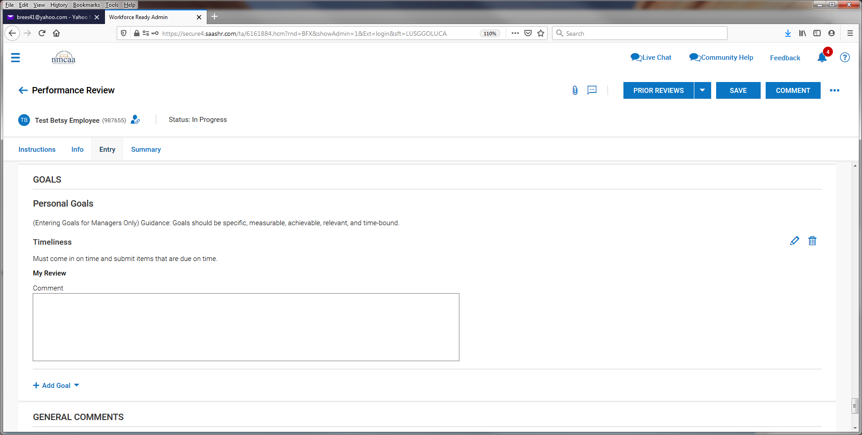

- After saving, click on “COMMENT” and then click on “YES.”
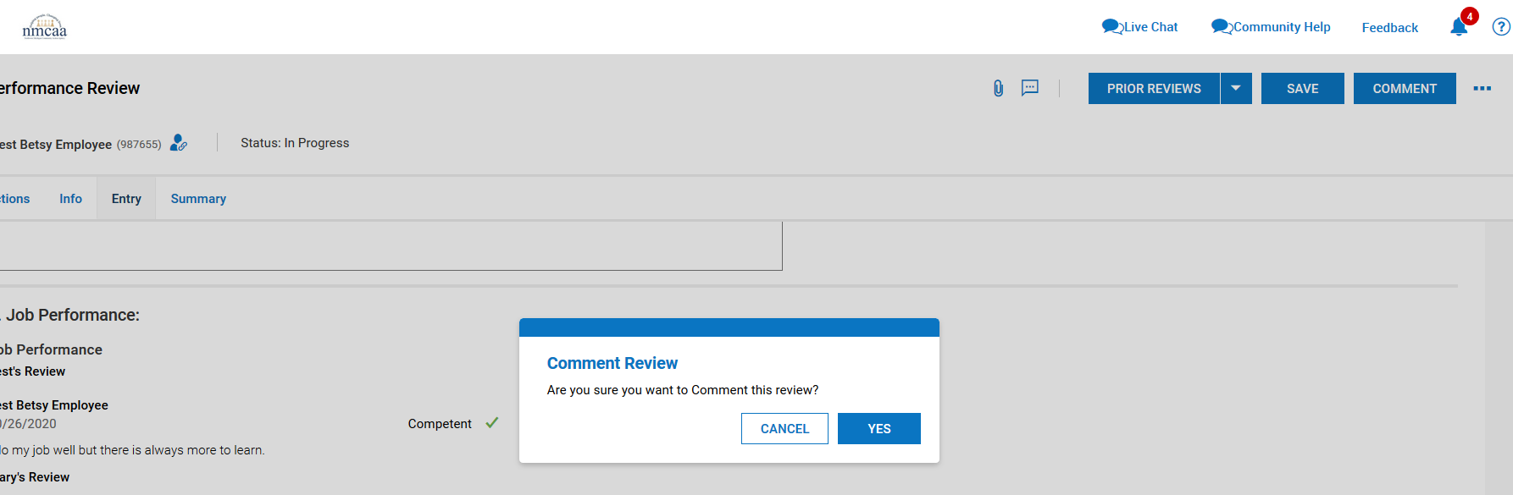

- Click on the “SUMMARY” tab and then “SUBMIT.”
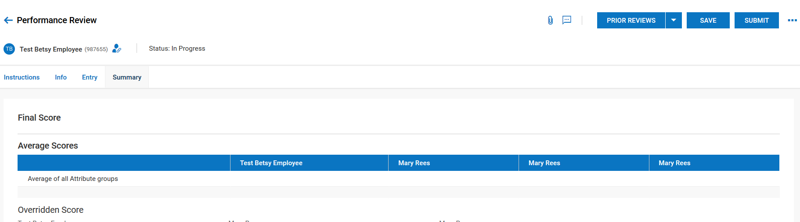

- Click “YES” to submit the evaluation. Once submitted, it will send the evaluation back to the employee to sign.

- After the employee has electronically signed their evaluation, Supervisor 1 will receive this notification and click on “To Do Items” to proceed:

- From the To Do List, the Supervisor clicks on “FINALIZE.”
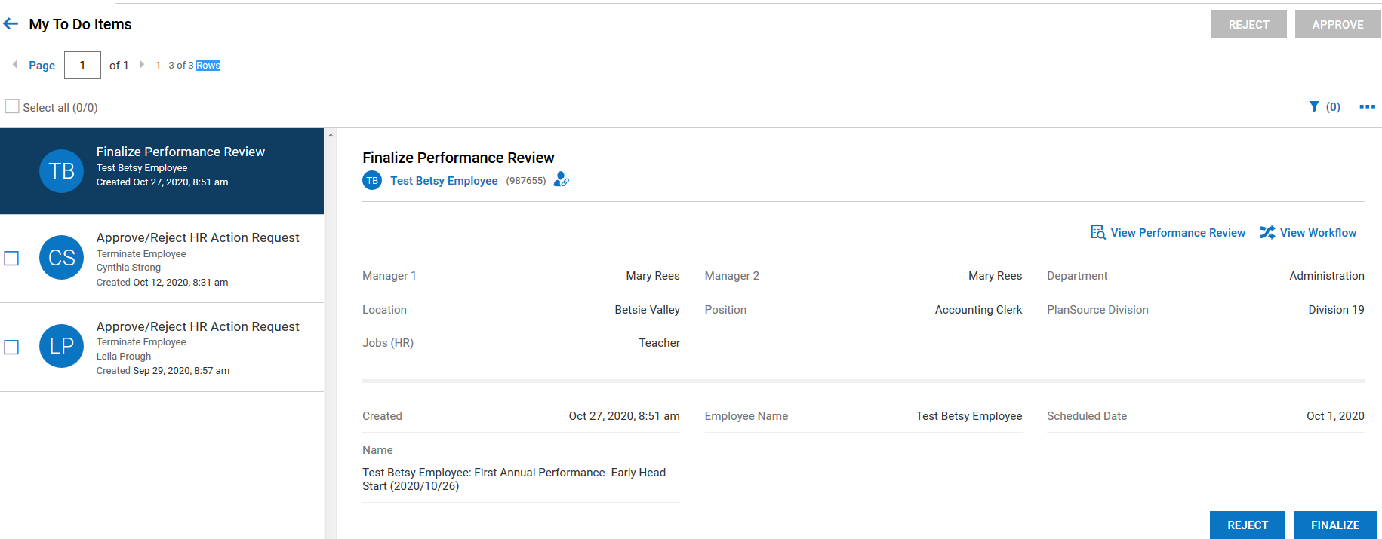
- From this screen the Supervisor will click on “Summary.”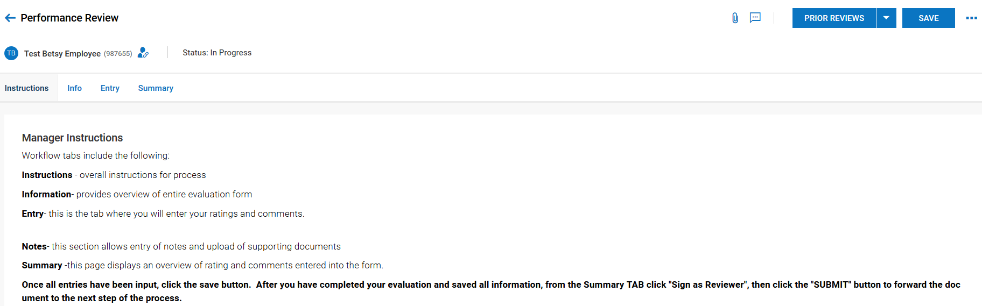

- If the Supervisor wants a copy of the evaluation, they can click on the 3 dots to download the document and print it out or save it.
- To sign the evaluation, they click on “SIGN AS FINALIZER.”

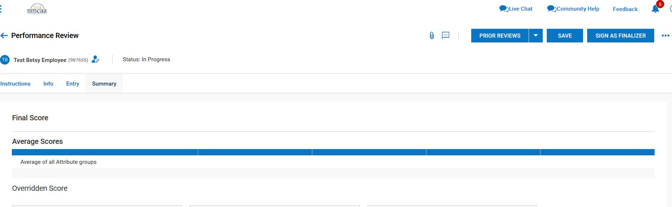
- The Supervisor will electronically sign the evaluation by entering their UKG password and clicking on “I AGREE.”
- Then click on the 3 dots and click on “Finalize.”

- Click on “YES.”
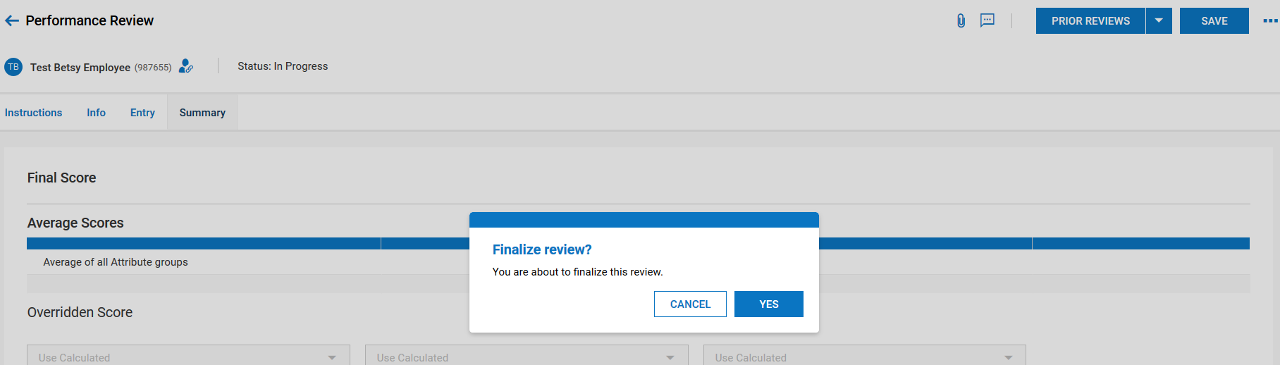

- Supervisor will receive a notification that the evaluation has been finalized.

