Q | The Employee Enhancement Newsletter Helpful Resources from Your Employee Assistance Program, sponsored by Catholic Human Services.
June Quarterly Newsletter
In This Issue  Building Positive Relationships at Work  Feelings  We are committed to Employees, Building a Collaborative Environment, Promoting Dialogue & Implementing Solutions  Contact Us  Catholic Human Services EAP Program  (231) 947-8387  We welcome your inquiries.  The EAP provides counseling, information and referrals for employees and their immediate family members. This program is ideal for people experiencing personal distress or simply seeking to improve health and well-being.  - It’s free.  - It’s confidential  - It’s short-term, solution focused counseling.  If you want to talk, vent or need support please reach out to EAP,  We can help you with outpatient mental health services.  We are here to assist you.  Every contact is confidential!  This Photo by Unknown Author is licensed under CC BY-SA-NC  Nothing but good vibes &  blue skies. --unknown | Over the last year we have been changed by a pandemic that we had no control over. Here are some reminders as we work together. Not only are positive relationships at work essential for career success, they also enhance the meaningfulness of our work, our sense of connection, and quality of life.  Building Positive Relationships at Work  To create positive relationships at work, target the following:  - Develop Your People Skills. Look at how you communicate. Do you take turns in conversations? Are you flexible? Are you friendly, pleasant to be around, and collaborative? Do you say thank you; make eye contact? These gestures go a long way in showing you value others.  - Project Positive Energy. If you find yourself grumbling and complaining a lot, others could find you difficult to be around. People tend to bond over a sense of “being in the trenches together”, but if you dwell on the negative you will close yourself off from others.  - Demonstrate Etiquette. Watch your boundaries at work. Respect the hierarchy even if you think you and your superiors are friends and always act with professionalism. People are constantly watching and assessing others’ character.  - Be a Team Player. Step up and help out when you can. Make an effort to do something nice for someone, compliment them when they do a good job, and offer to help co-workers when you see they are struggling. This helps build community and connection.  - Be Trustworthy. You establish trust by being consistent, following through, coming through in a pinch, and being reliable. Also, by admitting to mistakes when you’ve goofed up. Avoid gossiping in the workplace too; this always backfires even if it seems harmless in the moment.  - Practice Mindfulness. Try your best to remain cool in heated situations. There will be times when you have to handle a dissatisfied customer, upset co-worker, or supervisor. Focus on maintaining your composure by pausing and reflecting before responding. The situation will pass; you don’t want to get a reputation for being “hot under the collar.” Showing that you can be calm under pressure is going to go far in fostering your relationships with others.  Feelings; an important function to our daily lives.  Feelings are large influencers to our thoughts and actions. Learning to identify how we are feeling can help our mental health, relationships and bring a self-awareness. Feeling serve an important function to all our lives. From the beginning to modern day, feelings stem from a survival mechanism. We are wired with feelings to adapt our bodies to handle anything from simple situations to catastrophic chaos. Feelings often direct our thinking; leading us down paths of what we choose to do or not do. How we express our feelings is linked to our external surroundings. It’s important to connect with and express our feelings in a mutually respectively way. The inability to do so will cause problems in relationships, communications and overall satisfaction in life. Take control of your feelings with these tips:  - Check your emotional “temperature” by asking – “How am I feeling?”  - Avoid vague answers like good or bad, fine or okay. These tend to be more judgements than actual feelings.  - Probe a bit further. Ask yourself, “What kind of good?” or “What kind of bad?” Good can mean happy, relaxed, satisfied, etc. Bad might mean scared, sad, nervous or mad.  - Our physical bodies often give us clues as to what we are feeling. Be mindful of how you are breathing, if your stomach hurts, or your muscles are tense. Maybe we have a nervous laugh or bite our fingernails. Tune into your body and what is it telling you.  - Keep in mind that feelings are not good or bad but rather an experience. Some feelings are more pleasant than others, but what we do with our feelings is more important than the actual emotion itself. Consider reframing feelings with words, “are they helpful or hurtful?” This perspective removes judgement and focuses on the outcome that our feelings may influence.  Empower yourself to identify your feelings and take control of what you do with them.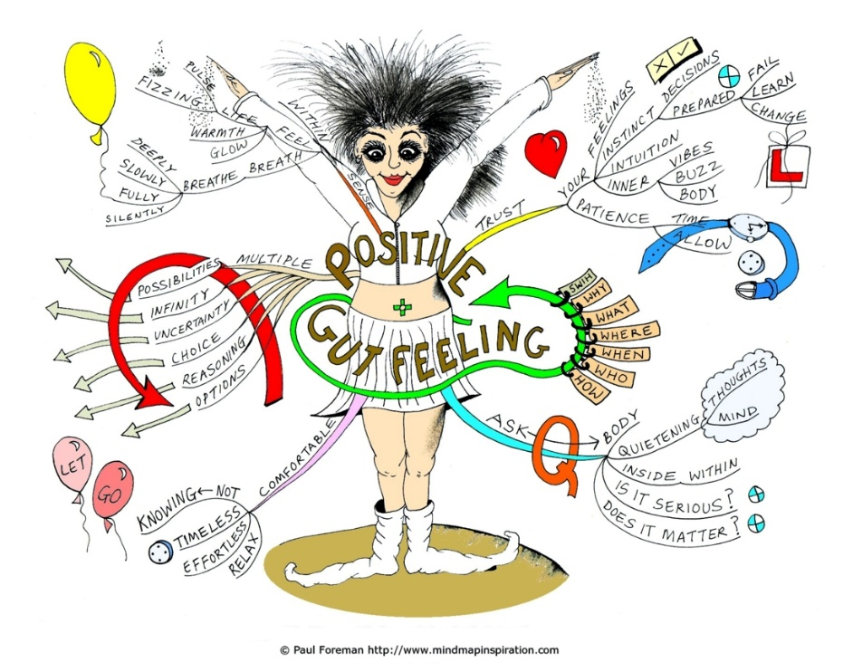  This Photo by Unknown Author is licensed under CC BY-SA  It’s OK not to have all the answers. Seek help you need to:  EAP LINE: 231-947-8387

