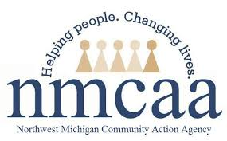
COVID-19 UPDATES & EMPLOYEE RESOURCES
May 6, 2021

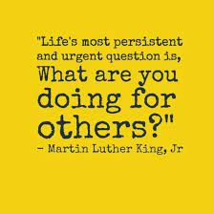

COVID-19 News & Resources
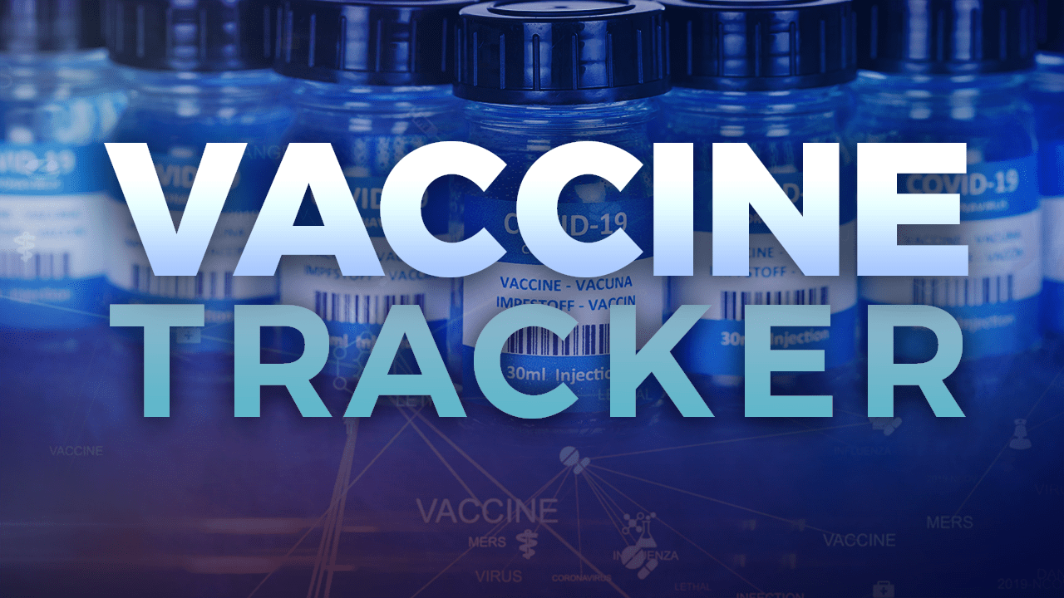

COVID-19 Vaccine Dashboard

LOCATION | POPULATION | AT LEAST ONE DOSE | % COMPLETE | FULLY VACCINATED | % COMPLETE
State of Michigan | 8,096, 917 | 4,121,924 | 50.9% | 2,234,285 | 39.9%
Antrim County | 19,759 | 10,767 | 54.5% | 8,841 | 44.7%
Benzie County | 15,011 | 8,858 | 59.0% | 7,292 | 48.6%
Charlevoix County | 21,940 | 12,951 | 59.0% | 11,018 | 50.2%
Emmet County | 27,953 | 17,229 | 61.6% | 14,520 | 51.9%
Grand Traverse County | 76,703 | 47,819 | 62.3% | 39,155 | 51.0%
Kalkaska County | 14,756 | 6,539 | 44.3% | 5,567 | 37.7%
Leelanau County | 18,737 | 12,935 | 69.0% | 11,062 | 59.0%
Missaukee County | 11,740 | 5,491 | 45.5% | 4,610 | 38.2%
Roscommon County | 20,911 | 10,392 | 49.7% | 8,245 | 39.4%
Wexford County | 26,734 | 13,019 | 48.7% | 10,670 | 39.9%
United States | 328,200,000 | 148,562,891 | 44.7% | 107,346,533 | 32.3%

*** Data as of 5/5/2021

May 6, 2021 Gatherings and Face Mask Order

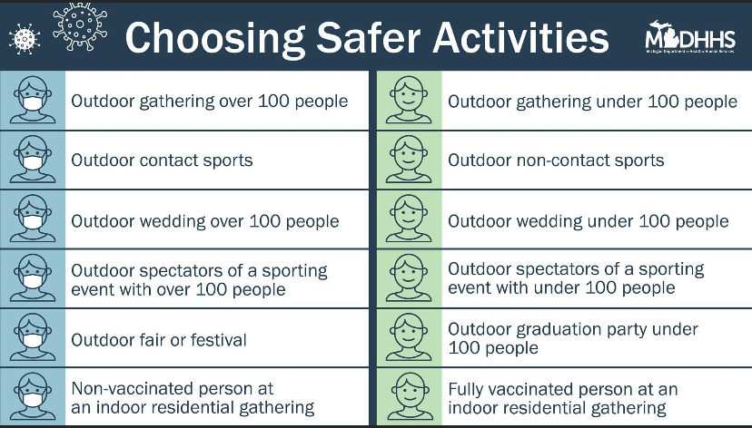
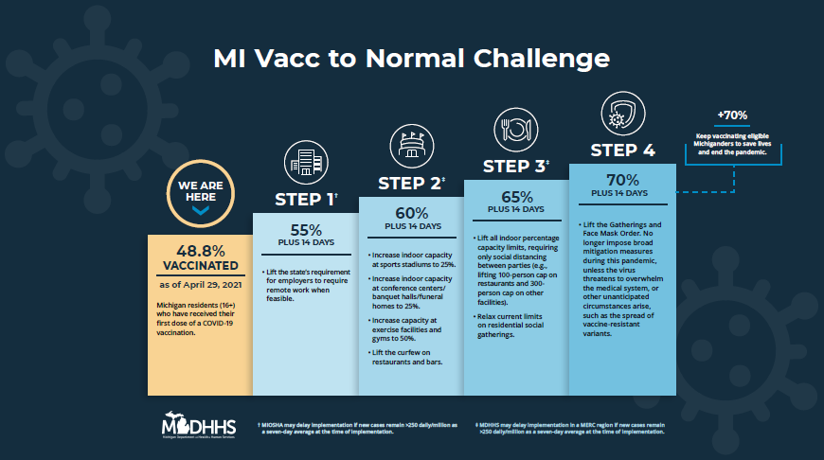
What exactly is “herd immunity” and will we ever get there?
- Herd immunity is described as the point in which enough people in our community are sufficiently resistant to an infectious agent; this will make it difficult for infection to spread to others. This may happen as both a result of natural infection and vaccination.
- Experts suggest that up to 80% of the population will need to be vaccinated in order to reach the needed level of herd immunity: That equates to over 250,000,000 people.
Which produces a stronger immune response: Vaccination or Natural Immunity?
- Vaccination: They have predicably prevented illness and are a far safer bet. Research shows those who received the vaccine have more antibodies than those who were naturally infected. Vaccine-induced immunity seems to resemble those with natural immunity who had a severe case of COVID-19.
- Natural Immunity: Infection will produce some antibodies, but the range is far and wide; there are lots of variables depedent on the severity of one’s infection, their immune system, etc.
I’m young and healthy….why not take my chances with getting sick?
- Vaccination: This is a much safer alternative. The vaccines carry little known risk. Side effects are rare, and defintely more rare than the adverse effects caused by COVID-19.
- Natural Immunity: This is a chancier option as there is much more risk with natural infection. Nobody is immune to severe disease, and even if you are not as high risk, you likely have family and friends who are.
Is protection from the vaccine only good for three months?
- The medical field is not sure how long actual protection will last from the COVID vaccine. Length of protection is based on the clinical trials, which is where the three-month timeframe came from. It will take time to see how long the vaccine is effective, and whether or not individuals will need a booster in the future.
I’ve had COVID-19 in the past. I don’t need to get vaccinated, do I?
- Yes, you should be vaccinated regardless of whether you already had COVID-19. That’s because experts do not yet know how long you are protected from getting sick again after recovering from COVID-19. Even if you have already recovered from COVID-19, it is possible—although rare—that you could be infected with the virus that causes COVID-19 again. Learn more about why getting vaccinated is a safer way to build protection than getting infected.
- If you were treated for COVID-19 with monoclonal antibodies or convalescent plasma, you should wait 90 days before getting a COVID-19 vaccine. Talk to your doctor if you are unsure what treatments you received or if you have more questions about getting a COVID-19 vaccine.
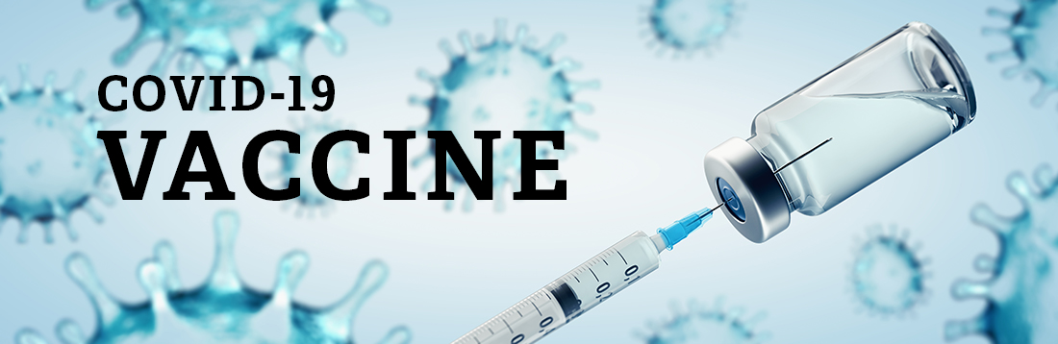
Many health departments and other organizations have appointments available and ready to be scheduled ASAP. Please refer to the links below for places in your community providing appointments and off-site clinics.
- Grand Traverse County Health Department
Seniors who do NOT have internet access or
need additional help can call 231-715-5557
for help scheduling.

- Health Department of Northwest Michigan
- Benzie-Leelanau Health Department
- District Health Department #10
- Central Michigan District Health Department
- NMHSI
- Rite Aid
- Vaccine Finder
- Meijer
- Family Fare
- Walgreens
Have questions?? Call Munson’s “Ask a Nurse” at 231-935-0951
CDC and FDA Resume Use of Johnson & Johnson COVID-19 Vaccine After Review
After a brief pause to review possible health risks of Johnson & Johnson’s COVID-19 vaccine, the FDA and the CDC resumed the use of the vaccine. Below is some information from the CDC’s website that discuss the highlights of the pause and the decision to resume vaccination.
What you need to know:
- CDC and the U.S. Food and Drug Administration (FDA) recommend use of Johnson & Johnson’s Janssen (J&J/Janssen) COVID-19 Vaccine resume in the United States, after a temporary pause.
- Reports of adverse events following the use of J&J/Janssen vaccine suggest an increased risk of a rare adverse event called thrombosis with thrombocytopenia syndrome (TTS). Nearly all reports of this serious condition, which involves blood clots with low platelets, have been in adult women younger than 50 years old.
- A review of all available data at this time shows that the J&J/Janssen COVID-19 Vaccine’s known and potential benefits outweigh its known and potential risks.
- However, women younger than 50 years old should be aware of the rare but increased risk of this adverse event and that there are other COVID-19 vaccine options available for which this risk has not been seen.
- CDC and FDA will continue to monitor the safety of all COVID-19 vaccines.
- Seek medical care right away if you develop any of the symptoms here after receiving the J&J/Janssen COVID-19 Vaccine.
- If you have any questions or concerns, call your doctor, nurse, or clinic.

Human Resources

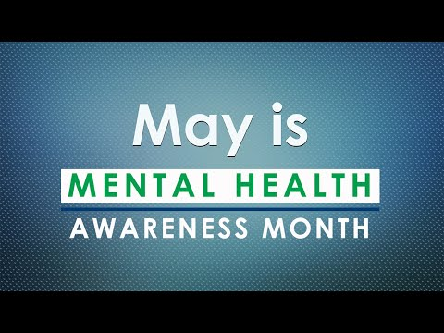
Enjoy this brief video from MDHHS about the importance of Mental Health and taking care of you!

PROFESSIONAL DEVELOPMENT OPPORTUNITY
Addressing Burnout (for direct supervisory staff) - Tuesday, May 11 at 1:00 p.m.
As the pandemic wears on, burnout among direct care workers is on the rise. If you are a clinician, case management staffer or supervisor trying to manage your own pandemic-related stress while also supporting your team, consider registering for this free, 1-hour webinar on compassion fatigue and professional burnout.
