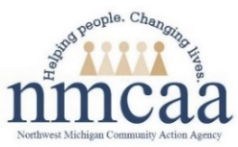
Child and Family Development
Hiring Requirements
Congratulations and welcome to
Northwest Michigan Community Action Agency!
Before NMCAA can continue the hiring process, there are several steps that must be completed. Please refer to the requirements and instructions below. Use this checklist to keep track of your progress.
Pre-Employment Requirements
☐ Child Care Background Check (CCBC)
- You will be contacted by the Human Resources Administrative Coordinator regarding this process. You must complete and return the Consent and Disclosure forms ASAP. After completion of this step, the Human Resources Administrative Coordinator will assist you with scheduling your fingerprinting appointment.
  - CCBC appointment date:
☐ Medical and TB Clearance
- You must have a signed medical clearance from a physician as well as a negative TB test. Both must have been completed within one (1) year of hire. The necessary forms will be sent with your CCBC paperwork and should be returned to the Human Resource Administrative Coordinator upon completion.
  - Medical clearance date:
  - TB test date:

Additional Hiring Requirements
After completion and submittal of the pre-employment requirements, you will be contacted by your supervisor to schedule a starting date of employment.
Please gather the following documentation. These may be submitted prior to your first day of employment. Any documents not previously submitted must be provided to your supervisor on your first day of employment.
☐ Valid driver’s license or State ID
☐ Current proof of auto insurance
☐ I-9 documentation: SS card OR birth certificate OR current passport
☐ Transcripts or credentials, as applicable
☐ Voided check or letter from the bank (may upload in UKG ahead of time)
*** Please bring any documents from the checklist above that were not previously submitted. These must be provided to complete the hiring process. ***

After Hire - Required Trainings
The following are required trainings that must be completed by all staff. Please work with your supervisor to develop a plan for completing these.
☐ APOT: Annual Pre-service Orientation Training - 4 hours
- APOT is required of all new staff prior to working with children in the classroom.
- Your supervisor will schedule a day and time for APOT when determining your first day of employment.
  - Date APOT scheduled with supervisor:
- There are several trainings that must be completed before working with children. In order to register and complete these trainings you must create an account in MiRegistry: Creating-a-MiRegistry-Account.pdf
☐ Michigan Virtual/Professional Learning Portal
- These are required trainings for all new employees; modules must be completed prior to working with children in the classroom.
- Please CLICK HERE for instructions on creating a Michigan Virtual account and for course registration.
- Health & Safety for Licensed Child Care Providers, Module A (2 hrs)
  - Date module A completed:
- Health & Safety for Licensed Child Care Providers, Module B (3 hrs)
  - Date module B completed:
- Health & Safety for Licensed Child Care Providers, Module C (2 hrs)
  - Date module C completed:
- Transportation Training for Child Care Providers (1 hr)
  - Date Transportation training completed:
*** If you have already completed Health & Safety Training for Licensed Child Care Providers Course 1 and Course 2, you do not need to complete the courses noted above. You MUST complete the Michigan Ongoing Health & Safety Training Refresher for the current year.
☐ MiRegistry Infant Safe Sleep for Childcare Providers - 1 hour
- This is a required training for employees working with infants and toddlers and must be completed prior to working with children in the classroom.
- Go to www.miregistry.org and log into your account.
- From the black tabs along the left-hand side, click on “Search Training Events.”
- In the “Course Title” box type Infant Safe Sleep for Child Care Providers. MiRegistry is the sponsor and primary trainer of this course.
- Click on “Register” and follow the prompts to sign up for the course.
- Complete the course. Be sure to complete the course to the very end.
  - Date Infant Safe Sleep training completed:

☐ Safety Practices Training - 6 hours for the team training and 2.5 for the new staff mid-
year training.
- Safety Practices Training is required for all staff prior to working with children in the classroom.
  - Active Supervision
  - Pedestrian & Transportation Safety Training
  - Safe Environment Checklist & Required Postings Training
  - Grab & Go Binder/Safety and Emergency Preparedness Plan
- Date Safety Practices training completed:
☐ Child and Adult Care Food Program (CACFP) - 3 hours of training
- CACFP Training must be completed within 30 days of hire.
- CACFP Training date:
☐ CPR and First Aid
- CPR and First Aid must be completed within 90 days of hire.
  - If you have not taken this training prior, you will work with your supervisor to schedule a training.
  - If you have current certification in CPR and First Aid, please submit a copy of your training records to your supervisor.
    - Current CPR date:
    - Current First Aid date:

Final Steps
- Scan the QR code to document training attendance.
- Confirm course completion on your MiRegistry Learning Record.

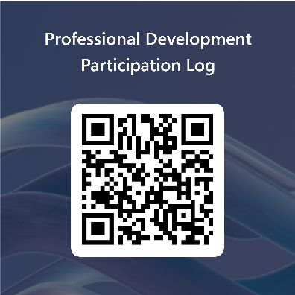

Reference: HSPPS 1302.47(4)(5), HSPPS 1302.92(b)(2); Licensing R 400.8131(2)(3)(4)(5)
11/23 Human Resources\Supervisor’s Manual\1-Hiring\CFD\Child and Family Development Hiring Requirements

